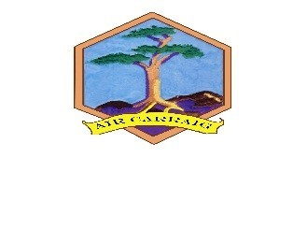

Firrhill High School Extra-Curricular Sports Membership

There are three weeks of sports tasters provided for pupils starting on Monday 22nd August.

Firrhill have a Sports Membership fee of £24 for all pupils participating in our extra-curricular clubs/teams. This enables each pupil to attend as many of these clubs as they wish over the course of the year (the exception to this is the hockey club which is managed by parents). It is our aim to use this contribution to continue to develop and improve extra-curricular opportunities for all pupils in Firrhill High School.

There may be an additional payment for pupils playing for certain school teams to cover the cost of officials and transport. This will be communicated to any pupils selected for specific school teams and should be paid via Parent Pay. More information regarding this will be provided.

At Firrhill we are committed to ensuring all children can access sporting opportunities. Pupils who are in receipt of a free school meal entitlement will not be asked to pay to attend clubs. If you have any concerns regarding paying for Sports Membership, please speak to PE staff.

The Sports Membership registration is online at www.joininedinburgh.org
In the green Activity Search box enter the booking code FIR-73. Please note – this goes live from 1st September.

Here you can pay the membership fee or pupils on Free Schools Meals can tick the box which entitles them to a free place. Pupils can also register for the clubs they wish to attend. There are restricted numbers for some clubs i.e. tennis and these are allocated on a first come, first served place.

All pupils joining the Sports Membership will be provided with a Sports Members t-shirt. This will be handed out by either PE staff or the coach at their club.

Firrhill aim for our activities/clubs to be inclusive to all pupils. If your child needs additional support, we will be happy to discuss with you and the coach how your child can be supported to take part.

Should you wish to know more about the Firrhill high school extra-curricular programme or if you have any questions regarding the Sports Membership please do not hesitate to contact Morag Carmichael, Curriculum Leader morag.carmichael@firrhill.edin.sch.uk 0131-441-4501 or Lorna Norman, Active Schools Co-ordinator email: lorna.norman@ea.edin.sch.uk phone: 07884-191761.

