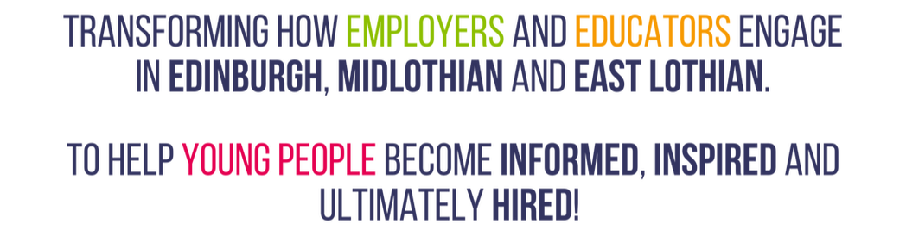

Developing the Young Workforce (DYW) is the Scottish Government’s Youth Employment strategy to better prepare young people for the world of work.

The employer-led Developing the Young Workforce Regional Groups set up across Scotland are connecting employers with education.
Your school now has a dedicated DYW School Co-ordinator who will work alongside the entire school team and other partners to build strong and lasting relationships between the school and employers.
These links will provide the opportunity for young people to learn more about the world of work directly from industry experts. Their knowledge of the breadth of jobs available will increase, as will their understanding of the types of skills that are relevant to and sought-after by employers.

DYW School Co-ordinator – Firrhill High School
roxanne.nicol@edinburghchamber.co.uk

