N5 Lifeskills Mathematics
Practice Exam 4
Non Calculator
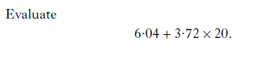
1.
2

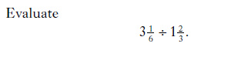
2.
2

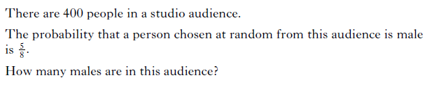
3.

2
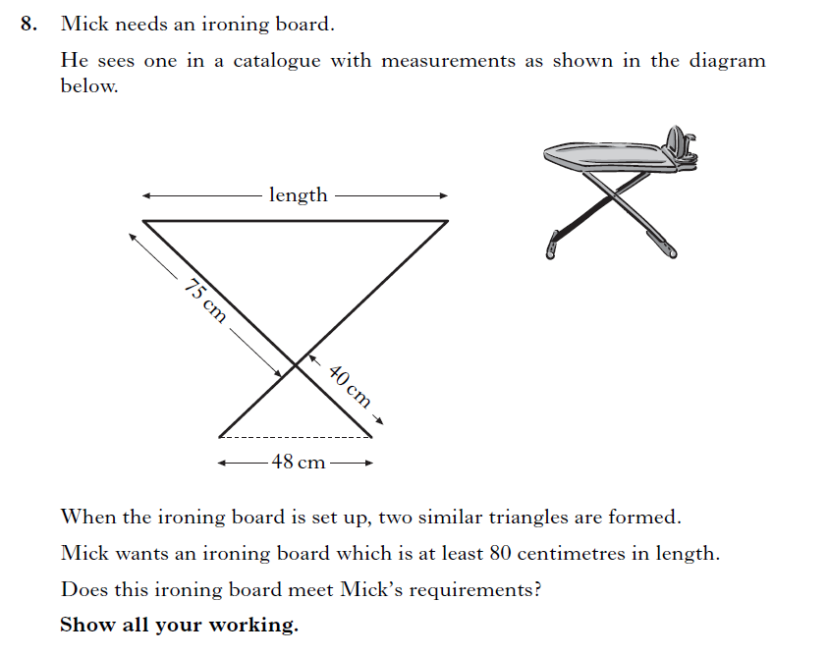
4.

3
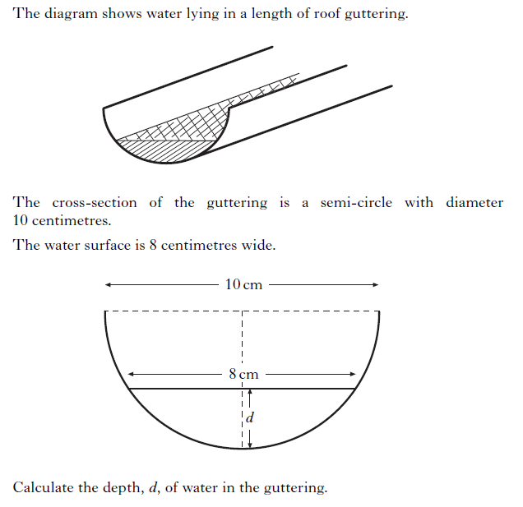
5.

Calculator
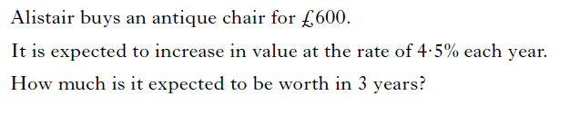
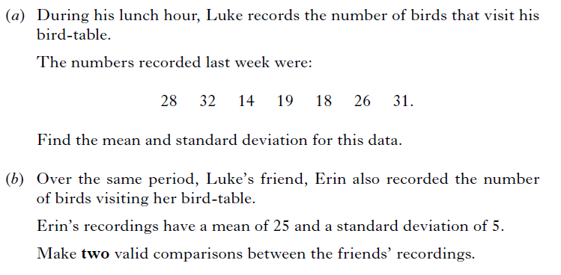
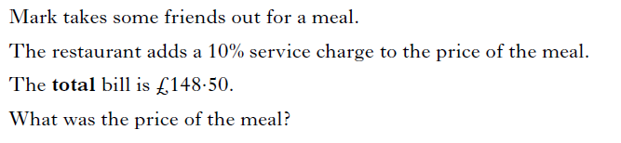
1.
2.
3.

3

4

2

3
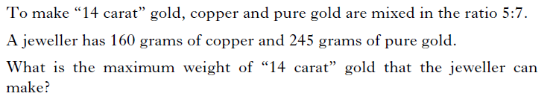
4.

3

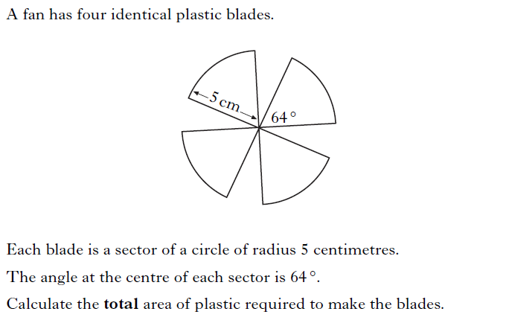
5.

3

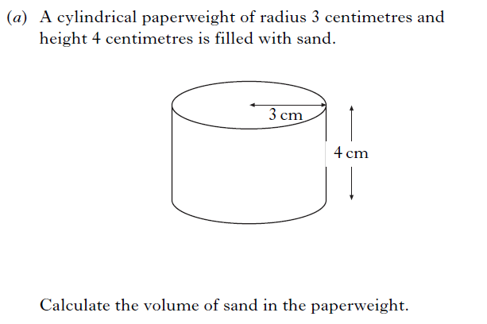
6.

2

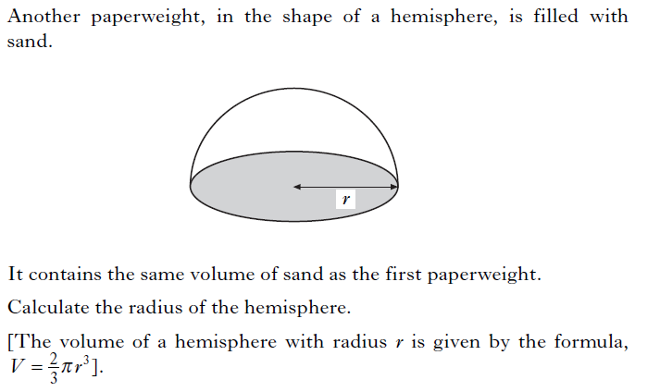
(b)

3

Non- Calculator
Question | Marking Scheme | Evidence
1. | ANS :80.44  - Know to multiply first  - Complete calculation | - 3.72 x 20 = 74.4  - 74.4 + 6.04 = 80.44
2. | ANS : $1\frac{9}{10}$  - Start to divide fractions  - Multiply fractions and simplify | - $\frac{19}{6}$ x $\frac{3}{5}$  - $\frac{57}{30}$ = $1\frac{9}{10}$
3. | ANS :250 males  - Know to divide by 8  - Know to multiply by 5 | - 400/8 = 50  - 50 x 5 = 250
4. | ANS :yes, 94cm > 80cm  - Calculate scale factor  - Know how to find length  - Calculate length  - Conclusion with justification | - 75/40 = 1.875  - 1.875 x 48  - 94  - Yes because 94cm > 80cm
5. | ANS :2cm  - Identify radius  - Know to use Pythagoras  - Complete Pythagoras  - Calculate depth | - 5cm  - 5² - 4²  - 3  - 5 – 3 = 2cm

Calculator
1. | ANS : £684.70  - Know to increase by 4.5%  - Calculate value  - Round to nearest penny | - 1.045  - 600 x 1.045 = 684.699…  - £684.70
2.(a) | ANS : mean 24, S.d 7  - Know how to calculate mean  - Calculate  - Substitute into formula  - Calculate standard deviation | - (28 +32 +14 +19 +18 +26 +31)/7 = 24  - 16,64,100,25,36,4,49  - $\sqrt{294/7}$  - 7
(b) | ANS : two valid statements  - Statement about mean  - Statement about s.d | - On average more visited Erin’s table (higher mean)  - S.d for Erin was lower so number of birds each day is more consistent
3. | ANS : £135  - Know what % total bill is of price of meal  - Know how to calculate price of meal  - Calculate price of meal | - 110  - 148.5/110 x 100  - £135
4. | ANS : 384g  - Calculate weight of 1 part  - Calculate weight of gold used  - Calculate total weight | - 160 / 5= 35  - 35 x 7 = 224  - 160 + 224 = 384g
5. | ANS :55.85 cm²  - Know to find angle of sector  - Find area of sector  - Find total area of blades | - 64/360 or equivalent  - π x 5² x 64/360  - 4 x 13.96… = 55.85cm²
6.(a) | ANS :113.1 cm³  - Substitute values correctly  - Calculate volume | - π x 3² x 4  - 113.1 cm³
(b) | ANS :3.78cm  - Substitute values correctly  - Start to evaluate  - Complete evaluation for r | - 113.1 = $\frac{2}{3}$ x π x r³  - r³ = 113.1 /π x (3/2)  - r = $\sqrt[3]{54}$=3.78 cm

