Practice Exam 2

- A local council recycles 42 000 tonnes of waste a year.
The council aims to increase the amount of waste recycled by 8% each year.
How much waste does it expect to recycle in 3 years time?
Give your answer to three significant figures.
4 marks

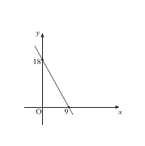
- A straight line cuts the x-axis at the point (9, 0) and the y-axis at the point (0, 18) as shown.

Find the equation of this line.
3 marks

- The heights, in centimetres, of seven netball players are given below.
173 176 168 166 170 180 171
For this sample, calculate:
(a) the mean; 1 mark
(b) the standard deviation. 3 marks
Show clearly all your working.

- Jamie works as a potter for a company which makes china ornaments.
He earns a basic salary of £218 per week plus 80 pence for every ornament he makes.
Jamie saves $\frac{2}{5}$ of his gross pay every week.
One week he makes 40 ornaments.
Calculate how much Jamie saves that week.
3 marks
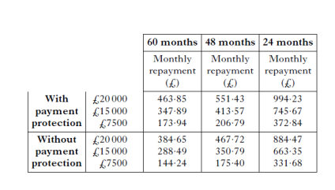
- The table shown below is used to calculate loan repayments.

Samir wishes to borrow £15 000.
How much will the loan cost him if he repays it over 48 months, with payment protection?
3 marks

- Anna earns £42 000 per year. She has tax allowances of £5425.
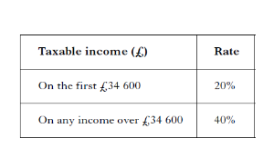
The rates of tax applicable for the year are given in the table below.

How much is Anna’s monthly tax bill?
5 marks

- A cylindrical container has a volume of 3260 cubic centimetres.
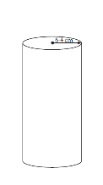
The radius of the cross section is 6·4 centimetres.
Calculate the height of the cylinder.
3 marks

Question | Marking Scheme | Evidence
1. | ANS : 52900 tonnes  - Know how to increase 8%  - Know how to calculate amount  - Calculate amount of waste  - Round to 3 significant figures | - 1.08  - 42000 x 1.08³  - 52907.904  - 52900  4 marks
2. | ANS: y = -2x + 18  - Know how to calculate gradient  - Know how to find y intercept  - Equation of the line correct | - m = $\frac{18-0}{0-9}$ = -$\frac{18}{9}$ = - 2  - c = 18  - y = -2x +18  3 marks
3. (a) | ANS :172  - Calculate the mean | - 172  1 mark
(b) | ANS: 4.8cm  - Calculate  - Substitute into formula  - Calculate standard deviation | - 1, 16, 16, 36, 4, 64, 1  - $\sqrt{\frac{138}{6}}$  - 4.8  3 marks
4. | ANS: £100  - Know how to calculate gross pay  - Know how to work out savings  - All calculations correct | - 218 + 40 x 0.8 (=250)  - 250 ÷ 5 x 2  - 100  3 marks
5. | ANS: £4851.36  - Interpret loan table  - Calculate total repayment  - Calculate cost of loan | - 413.57  - 413.57 x 48  - 19851.36-15000  = 4851.36  3 marks
6. | ANS: £642.50  - Know how to calculate taxable income  - Know how to calculate lower rate of tax  - Know how to calculate upper rate of tax  - Know how to calculate monthly tax  - Calculate monthly tax bill | - 42000-5425  - 34600 x 0.2  - (36575-34600) x 0.4  - (6920 + 790) ÷ 12  - 642.50  5 marks
7. | ANS :25.3cm  - Know how to find expression for volume of cylinder  - Equate volume to 3260  - State value for h | - π x 6.4² x h  - π x 6.4² x h = 3260  - 25.3  3 marks

