Volume Past Paper Questions

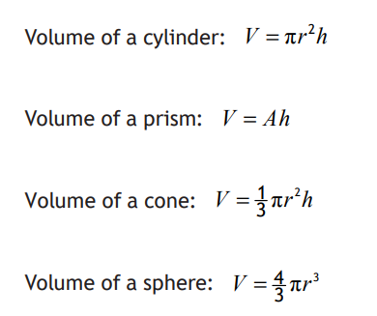
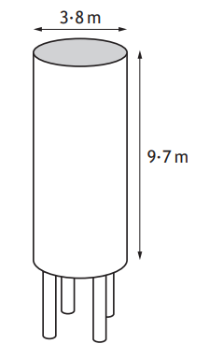
2018

- A storage container for sheep food is the shape of a cylinder and has the following dimensions.

Calculate the volume of the storage container.

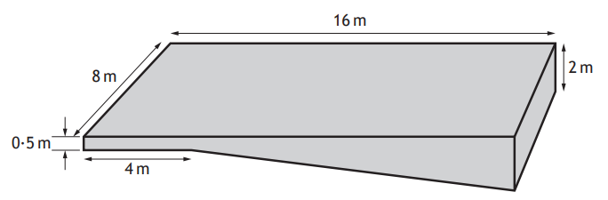
- A swimming pool is a prism with dimensions shown below. Calculate the volume of the swimming pool. Give your answer in litres.

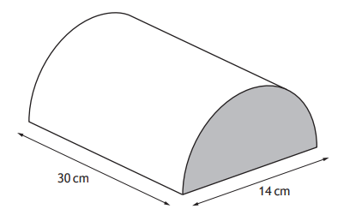
2017

- The Victorians used stoneware hot water bottles. They were semi-circular prisms as shown. The diameter of the bottle is 14cm and the length is 30cm. Calculate the volume of the hot water bottle.

2016
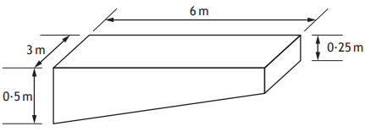
- Regulations state that a 10m high diving platform must be
- 6m in length
- 3m in width
- 0.25m deep at front edge and 0.5m at the back edge

The diagrams shows one such platform

Will 7m³ of concrete be enough to build the platform? Explain your answer.

2014 – Non Calculator
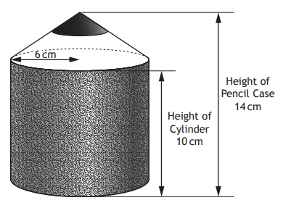
- Robbie has a tub for his pencils. It is in the shape of a pencil as shown.
It consists of a cylinder with a cone on top.

Show that the volume of the tub is 408π cm³.

Specimen Paper
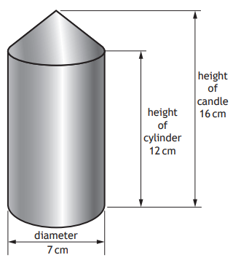
- Brendan makes candles in the shape of a cylinder with a cone on top as shown.

He buys blue wax in blocks of volume 12000 cm³.

Brendan thinks he can make 25 candles from one block of wax.

Is he correct? Justify your answer.

Mark Scheme

2018
Cylinder:
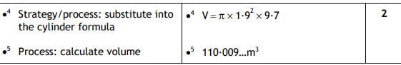

Swimming pool:

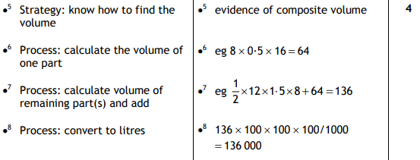

2017
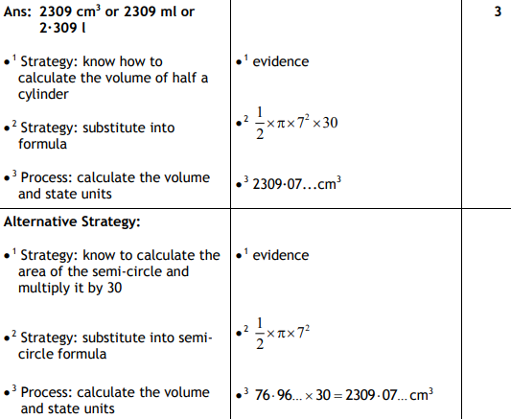

Specimen
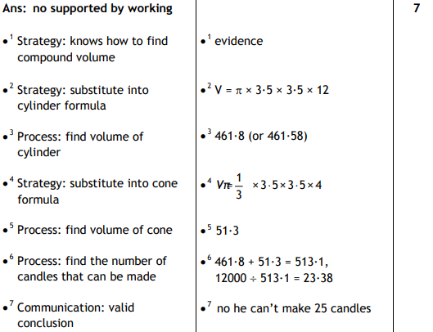

2015
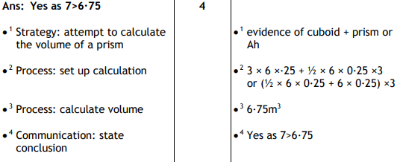
2014
