Applications of Mathematics National 5
Container Packing Exam Questions

2018 Calculator
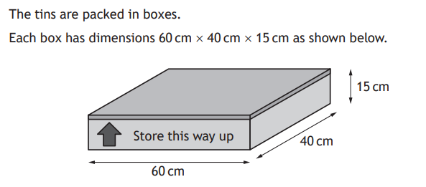

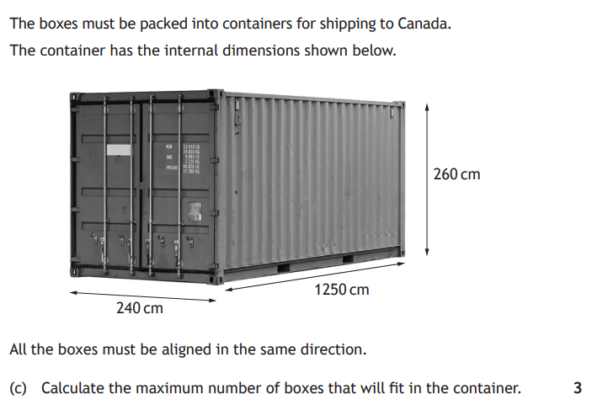

2017 Calculator
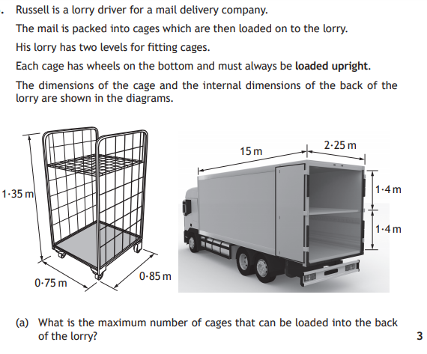

2015 Non-Calculator
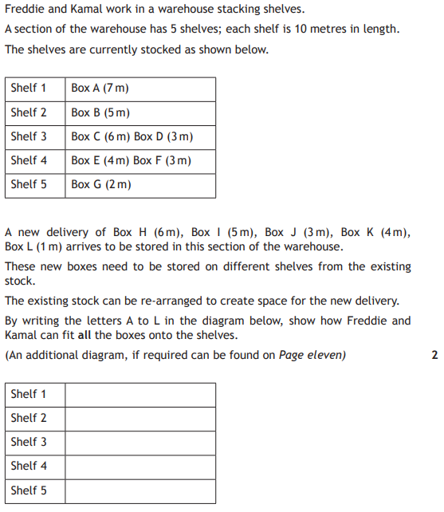

Answers

2018 Calculator
2108 boxes

2017 Calculator
102 cages

2015 Non-Calculator
