National 5 Applications of Maths - Statistics Past Paper Questions

2014 (Non-calculator)
This back to back stem and leaf diagram represents the numbers of hours a class spends on social networking websites in one week.
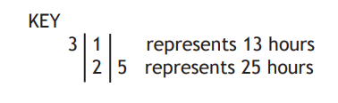
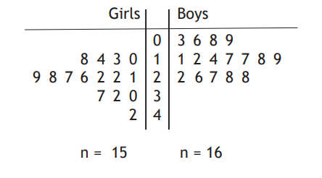
- A boxplot is drawn to represent on of the sets of data. Does this represent the data for the boys or the girls? Give a reason for your answer.
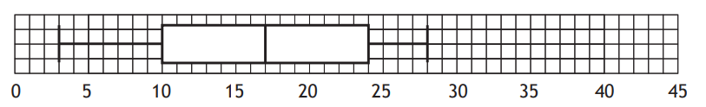[1]
- For the other set of data state;
- The median
- The lower quartile
- The upper quartile
[2]
- Construct a box plot for the other set of data

2014 (Calculator)
Over an eight month period Goran records how much he spends on his pay-as-you-go mobile.

£32 £23 £43 £40 £27 £35 £15 £25

Calculate the mean and standard deviation for this data.
[4]

2015 (Calculator)
Patryk is a cyclist. Before his next cycle he checks the recommended air pressure for his tyres using the graph below. Patryk weighs 73kg and he is using 700 x 23C tyres.

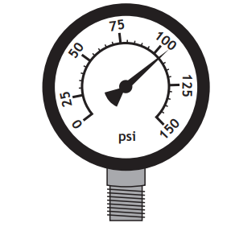
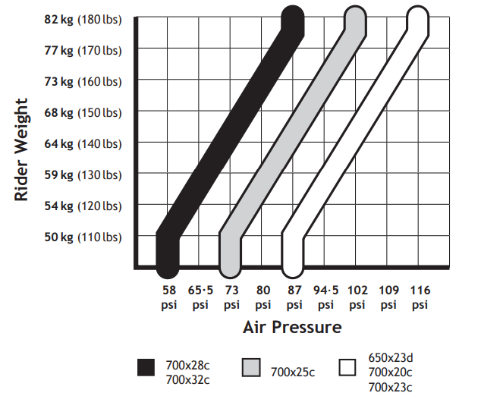
The gauge below shows the reading when he checks his front tyre.

- State any adjustments he should make so that his tyre has the correct pressure.
[3]
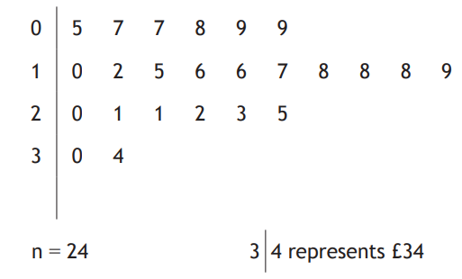
2015 (Non-calculator)
The local youth club runs a tuck shop. Any profit that is made is donated to a local charity.
The stem and leaf diagram show their weekly taking for the first 6 months of the year.
- State the
- Median
- Upper quartile
- Lower quartile
[2]
- Using the above data construct a box plot.
[2]
- The monthly profits, in pounds, for the second six months of the year are recorded below
22 16 25 19 18 20

Calculate the mean monthly profit and the standard deviation giving your answer to the nearest penny.
[4]
d) The mean profit and standard deviation for the same period the previous year was £16.26 and £2.40 respectively. Make 2 valid comparisons between these.
[2]
e) The youth club think the donations have increased by 25%. Are they correct?
[2]
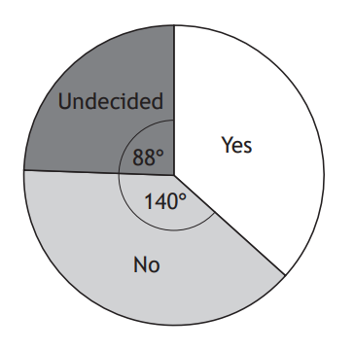
2016 (Calculator)
In September 2014 there was a referendum to decide the future of Scotland.
An opinion poll was taken in December 2013. The question asked was “Should Scotland be an independent country?”. The results are shown in the pie chart.

Another opinion poll was taken in April 2014.
1208 people were asked the same question as in December 2013.
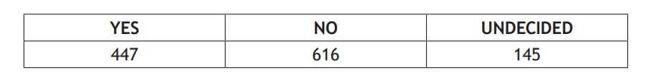
The results of the poll are in the table below.
Compare the two opinion polls and make one relevant comment on the differences between them.
[3]

2016 Calculator
Fraser tests motorcycle tyres on racing circuits.
On Monday he tested Goodhold tyres. His lap times, in seconds, are given below.
81.8 81.7 81.6 81.0 80.3 80.2

- For Fraser’s time on Godhold tyres calculate the mean and standard deviation.
[4]
- Fraser then changed to Megagrip tyres and recorded his times for another six laps. These times produced a mean on 81.6 and a standard deviation of 0.65 seconds.
Make two valid comments comparing the two types of tyres.
[2]
- Another rider completed one lap of the circuit in 81 seconds. The track is 3.6 kilometres long.
Calculate his average speed in kilometres per hour.
[3]

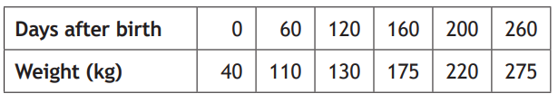
2017 (Non-Calculator)
Scott is a farmer. He records the weight of a calf from birth.
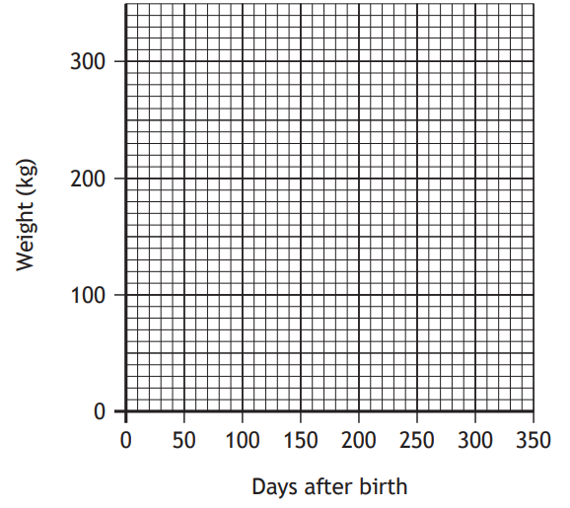
The weight of his calf is shown in the table.

- Copy the grid and draw a scatter graph to show this data.
[2]
- Draw a line of best fit on the diagram.
[1]
- Use the line of best fit to estimate the age of this calf in days when it weighed 240 kilograms.
[1]

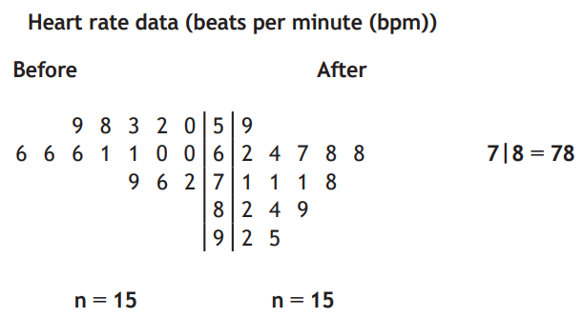
2017 (Calculator)
The back to back stem and leaf diagram shows data gathered at a gymnasium before and after walking on a treadmill.

- State the most common heart rate (bpm) after walking on the treadmill.
[1]
- What is the difference in the median heartrates (bpm) before and after walking on the treadmill.
[2]
- Construct a box plot to show the heartrate data after exercise.
[4]

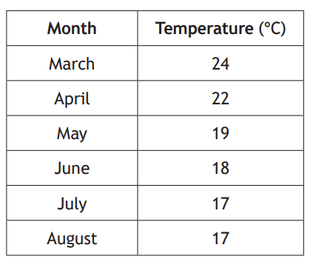
2017 (Calculator)
Mr Mackenzie has decided to move to South Africa with his family. He has been offered jobs in both Durban and Cape Town.
The typical monthly temperatures from March to August in Durban are recorded in the table.

- For typical monthly temperatures in Durban calclulate the mean and standard deviation.
[4]
- In Cape Town the mean monthly temperature for the same period is 15.5ᵒC and the standard deviation is 1.87ᵒC. Make two valid comments comparing the temperatures in both cities.
[2]

2017 (Non-calculator)
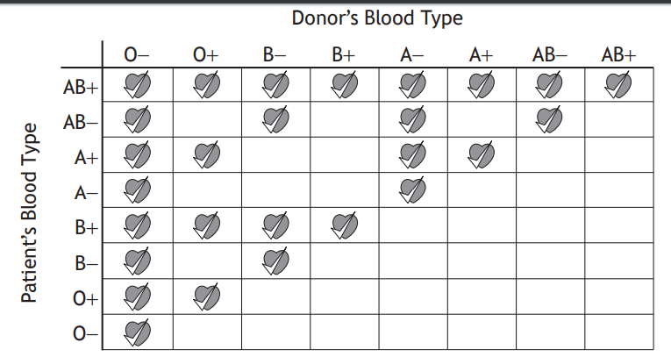
Natalie is donating blood. Whilst donating she noticed a chart. The chart shows that not every blood type can be given to every patient. The table shows which patients each blood type can help. Blood type can either be positive (+) or negative (-).

For example, the blood of a donor with blood type AB- can only be given safely to a patient with blood type AB+ or A-.

Natalie then notices a graph showing the blood type of a random sample of 100 people in Scotland.
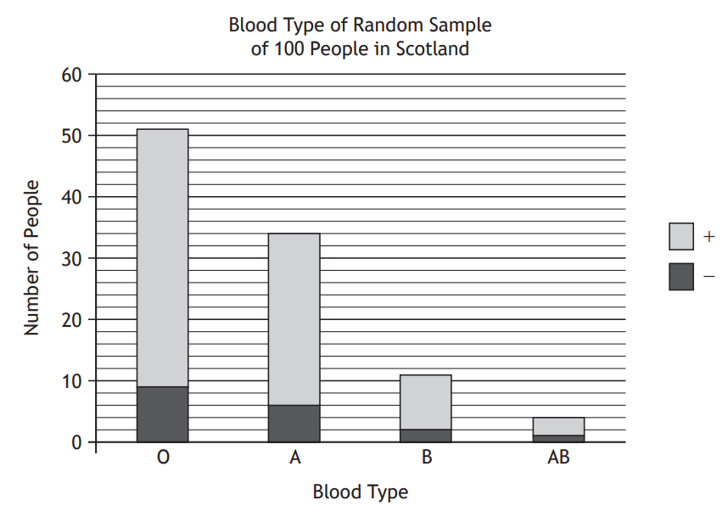

Natalie’s blood type is B+.
What fraction of the people sampled could safely be given Natalie’s blood?
[3]

2018 (Non-Calculator)
The heights and weights of eight children ages six are show in the table below.
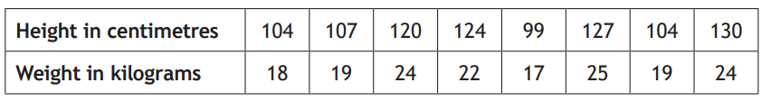
- Draw a scattergraph to show this data.
[2]
- Draw a line of best fit on the graph.
[1]
- Use your line of best fit to estimate the height of a child who weighs 20kg.
[1]
2018 (Calculator)
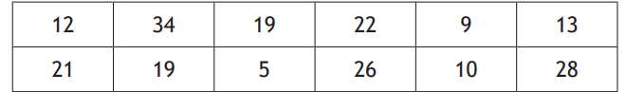
The number of podcasts Omar downloaded each month for a year is shown in the table.

- For this data calculate the
- Median
- Upper quartile
- Lower quartile
[2]
- Construct a boxplot for this data
[2]
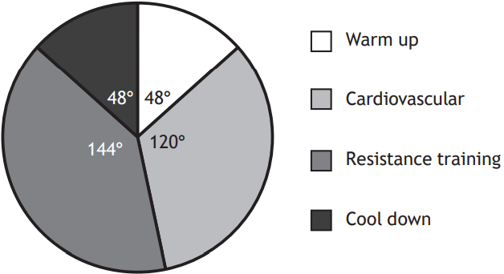
2018 (Calculator)
Nicola has joined a gym. The pie chart shows the proportion of time that Nicola will spend on each type of workout.

Nicola spent 1 hour and 45 minutes exercising in the gym.

- Calculate how long in minutes she spent on resistance training.
[2]
- Nicola spent 21 minutes exercising on the treadmill. Her average speed was 6.6km/h. Calculate the distance she ran on the treadmill.
[2]
2018 Calculator
- Scott trains at the velodrome on his new bike. He records his top speed, in kilometres per hour, for each lap. Six of the speeds are shown below.
61.2 58.3 59.1 58.8 60.4 59.8

For these speeds calculate the mean and standard deviation
[4]
- Scott had a mean top speed on his old bike of 57.3 km/h and a standard deviation of 1.21 km/h. Makes two valid comments comparing his top speed on the two different bikes.
[2]
Specimen Paper (Calculator)
A garage sells 150 cars in a month. The bar chart shows how many of each type of car are sold.

Construct a pie chart to show is information.
[3]
