Applications of Mathematics National 5
Time and SDT Exam Questions

2018 Non Calculator
Steven flew to Hong Kong to start a new job.
The flight included a stop in Doha.
He flew from Edinburgh to Doha then from Doha to Hong Kong.
- The flight from Edinburgh to Doha took 6 hours 35 minutes
- The flight from Doha to Hong Kong took 7 hours 20 minutes.
- Hong Kong is 8 hours ahead of Edinburgh.
Steven’s plane took off from Edinburgh at 9:15 am local time.
It landed in Hong Kong at 8:50 am local time.
How long was the stop in Doha?
[3]
2018 Calculator
It take 277 hours to sail from the UK to Canada.
The local time in Canada is 5 hours behind the local time in the UK.
The ship leaves the UK at 2200 on 3rd June.

Calculate the date and local time that the ship will arrive in Canada.
[3]

2017 Calculator
Mr Mackenzie accepts a job in Durban.
As part of his job he is in contact with the London, New York and Mumbai offices of the company he works for.
He is planning a conference call at 3:30pm from his office in Durban.
At 17:25 he noticed the clocks on the wall of the office showed the times below.

All offices work 08:00 to 18:00 local time.
Which offices are available to take part in the conference call?
[3]

2016 Calculator
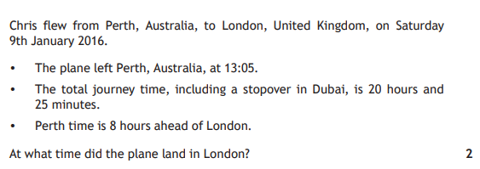

2015 Non-Calculator
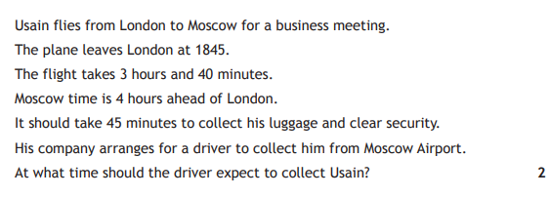

2014 Non-Calculator
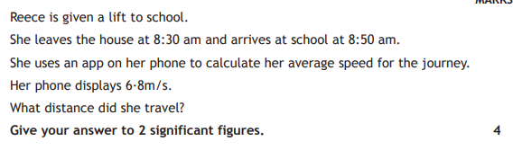

2014 Calculator
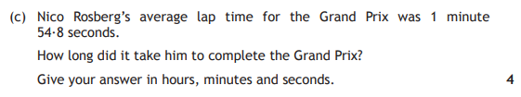

Answers

2018 Non-Calculator
1 hour 40 minutes

2018 Calclator
15th June at 0600

2017 Calculator
New York and London

2016 Calculator
0130

2015 Non-Calculator
0310

2014 Non-Calculator
8200 m

2014 Calculator
- 0.9s
- 179km/hr
- 1 hour 47 minutes 8.8 seconds

