Income and Wages Past Paper Questions

2014 (Non-calculator)
Adam works for 40 hours per week as a tractor driver on a farm.
His basic wage is £7.40 per hour.
Each week he pays £28.43 In come Tax and £8.57 in National Insurance.

- Calculate his take home pay.
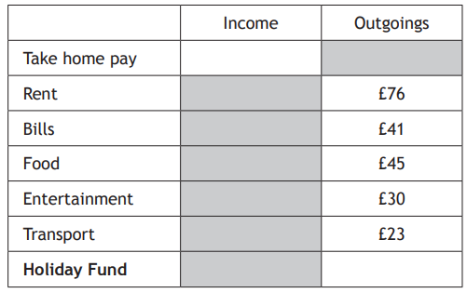
Adam is going on holiday in 13 weeks.
The holiday costs £320 and Adam wants to take £200 spending money.
He makes a table to show is weekly income and outgoings.
He puts the balance in to his holiday fund.

Will he have enough to cover the cost of his holiday and his sending money?
Justify your answer.
[4]
2015 (Calculator)
Mrs Smith is getting her roof re-slated. The roof has an area of 15 square metres. The builder quotes the following costs for the job.
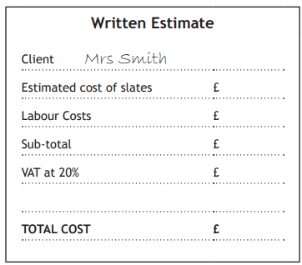
- Strip and clean roof – 8 hours
- Replace slates – 1 square metre per hour
- Rate - £22 per hour

- How much will labour costs be?

Mrs Smith will go ahead with the work if the written estimate is less that £2,500.

- Complete the written estimate below.

- Will Mrs Smith go ahead with the work?
[4]

2016 (Non-calculator)
Seonaid is saving up to buy a tablet computer costing £388.
She earns £7·30 per hour and works for 30 hours each week. Seonaid is paid at the end of each week.
She pays £5·32 in Income Tax and £7·68 in National Insurance each week.
Her living expenses are £86 per week.
Seonaid saves half of the money that she has left each week towards the tablet computer.
How many weeks will it take her to save up enough money to buy the computer?
[3]

2016 (Calculator)
Grace works for a company selling fitted kitchens.
She is paid a basic monthly salary of £500.
She is also paid a 5% commission on all her sales above £8000.
In January Grace sells £23,000 worth of goods.
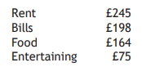
Her monthly deductions are 12% of her gross income.
Grace writes down her budget for the month

She saves any extra money left over.

- Calculate Grace’s net pay for January.
- Calculate the surplus that Grace will have for January.
- Grace’s rent increases by £260 per month. Calculate the percentage increase in her rent.
[7]
2017 (Non-calculator)
Anna works as a sales person for a computer company.
She is paid a basic monthly salary of £2450 plus commission of 2.5% on her monthly sales over £3000.
- Calculate her gross salary when her sales totalled £9000.

In her April payslip she had the following deductions
- Income tax £334.67
- National Insurance £230.20
- Pension £164.74

- Calculate her net salary for April
[5]

2017 (Calculator)
Russel works night shift as a lorry driver.
- He works from 2300 until 0900 the next day
- His rate of pay is £14.40 per hour
- He gets paid time and a half between 2200 and 0730
- He works 5 shifts each week
Calculate his weekly gross pay.
[3]

2018 (Non-Calculator)
Jennifer is planning a 4 night city break. The costs are shown in the table.
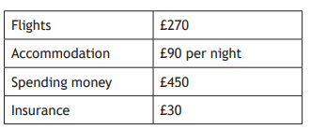

She earns £400 per week.
She saves 1/8 of her earnings each week towards her city break.
Calculate the minimum number of weeks it will take Jenifer to save enough money for her city break.
[3]

2018 (Calculator)
Fiona is a vet. She has started a new job and her new salary is £42,000.
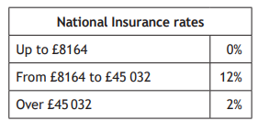
National insurance is calculated on a person’s salary before deductions such as pension contibutions.

- i) Calculate Fiona’s annual National Insurance payment

Fiona’s annual Income Tax payment is £5427.96
She pays an annual contributions of £3360 into her pension.
Fiona is paid in 12 equal monthly instalments.

ii) Calculate Fiona’s monthly net pay.

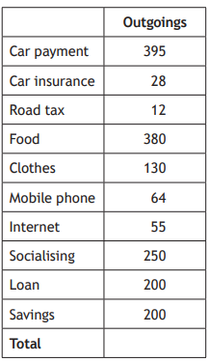
Fiona plans to rent accommodation. She needs to work out how much she can afford to spend on rent electricity and council tax. The table shows her monthly outgoings.

- Calculate how much she will have available for rent, electricity and council tax.

