Applications of Maths Nat 5
Foreign Currency Past Paper Questions

2018 Non-Calculator
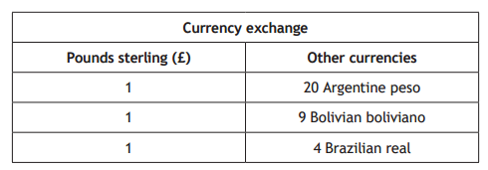
Gavin is going to South America to do charity work. He changes £750 into Bolivian boliviano.

- How many Bolivian bolivianos will he receive?
[1]
He spends 2700 boliviano. He changes the remaining boliviano in to Argentine Peso.

- How many Peso will he receive?
[2]

2017 Calculator
Mr and Mrs Sibbald went on a cruise.
Part of the cruise involved sailing from Villefranche to Livorno.

Mr and Mrs Sibbald took £2400 spending money.

They exchanged 55% of their money into euro, to spend ashore.

The exchange rate was £1 : 1.15 euro.
By the end of the cruise they had spent 1379 euro
Calculate how many euro they had left at the end of the cruise.
[2]

2014 Non-Calculator
Elaine goes on a 5 day business trip to Osla in Norway.
She changes £750 to Norwegian Kroner for the trip.

- How many Norwegian Kroner will she receive?
[1]
- Elaine spends NOK 520 each day she is in Norway.
Her compay extends her trip by sending her to Munich in Germany for a further 3 days.

If she chages all her remaining Kroner to euros, how many euros will she receive?

She spends €135 each day she is in Munich.

How much money does she have left at the end of her trip?
Give your answer in pounds sterling.
[5]

Answers

2018 Non-Calculator
- 6750 boliviano
- 9000 pesos

2017 Calculator
139 euro

2014 Non-Calculator
- 6000 NOK
- £87.50

