Applications of Mathematics National 5
Area, Perimeter and Pythagoras Exam Questions

Circumference of a circle $C= πd$

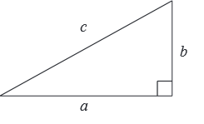
Area of a Cirlce $A= πr²$

Theorem of Pythagoras $a^{2}+b^{2}=c^{2}$

2018 Non-Calculator
Ribbon has to be placed around the outside of the love heart cake shown below.
The top of the cake is on the shape of an isosceles triangle with two identical semi-circles.
The ribbon needs to be the length of the perimeter of the top of the cake plus an extra 2.8 cm.
Calculate the length of ribbon needed for the cake.
Take $π$ = 3.14
[3]

2018 Non Calculator
A lawn is to be created in the shape of an isosceles triangle with dimensions as shown below.

Calculate the area of the lawn.
[3]

2018 Calculator
A new hotel is being planned in Benidorm.
The pool will have a walkway around three sides.
The walkway will be 1.5m wide as shown in the diagram.

- Calculate the total area of the walkway.
[2]
The walkway will be covered in tiles.
16 tiles are needed to cover 1 square metre.
The tiles are sold in boxes of 50.
Each box costs €71.95

- Calculate the cost of tiles needed for the walkway.
[2]

2017 Non-Calculator
Aneesa makes enamel badges.
Each badge is made from metal.
The shape of the badge is shown below.

- Calculate the area of the front of each badge.
[2]
The front of each badge is covered with enamel.
The enamel that Aneesa buys costs £90 for one pack.
One pack will cover 180 cm².
She makes as many badges as possible from one pack.
The metal that she uses costs £3 for each badge.
To make a profit Aneesa adds an extra £17 to the cost of each badge.

- Calculate her selling price for each badge.
[3]

2017 Non-Calculator
A new design is discussed for a glue dispenser.
It is to be made from two plates of plastic.
Each plate is in the shape of a right angled triangle and a semi-circle as shown.

Calculate the perimeter of each shape.
Take $π$ = 3.14
[4]

2017 Calculator
Suzanna is remodelling her shower room.
She considers two designs.
The first has a pentagonal shower tray.
The door will be fitted on the side of the tray as shown.
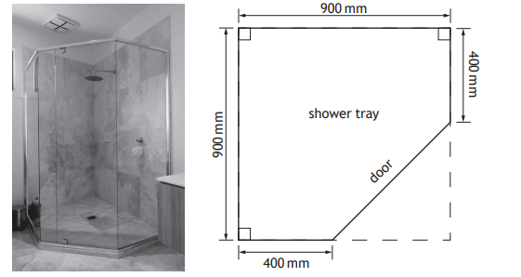

- Calculate the length of the side where the door will go.
[3]
- Calculate the area of the pentagonal shower tray.
[2]

The second design that Zuzanna is considering is the offset quadrant shower tray shown below.
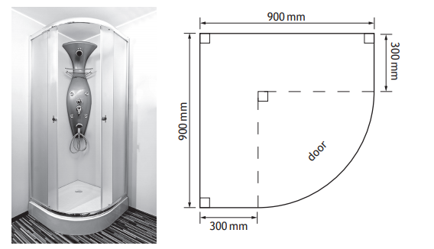
The offset quadrant design has a quarter of a circle forming part of the edge.

- Zuzanna will choose the design that gives the greater area.
Which design will she choose, the pentagonal or the offset quadrant shower tray?
Use working to justify your answer.
[4]

2016 Non-Calculator
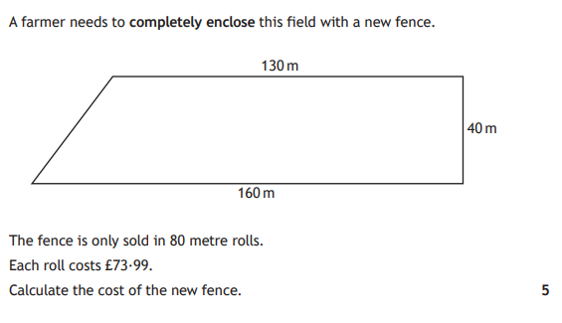

2016 Non-Calculator
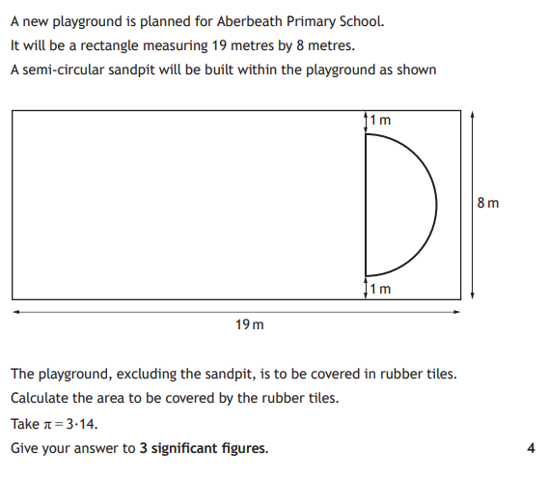

2016 Non-Calculator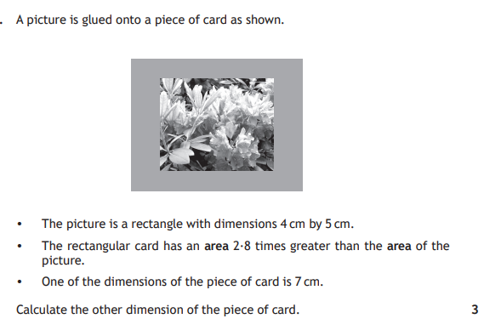

2015 Non-Calculator
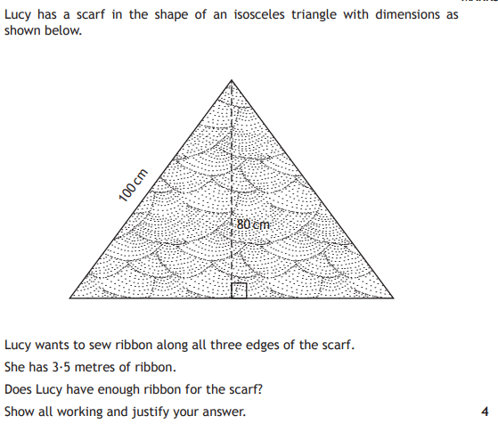

2015 Non-Calculator
A hotel is redecorating their function room which includes a semi-circular stage area.
They plan to lay a hardwood floor.
A sketch of the floorplan is shown below.

- Calculate the area of the floor in the hotel’s function room.
Take $π$ = 3.14

[4]

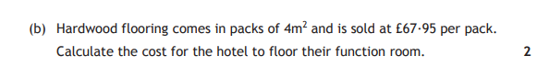

2014 Non-Calculator
A new sail is being design for a yacht as shown below. It consists of two right angled triangles.

- Calculate the length of AB.
[1]
- Calculate the total area of the sail.
[2]

2014 Calculator
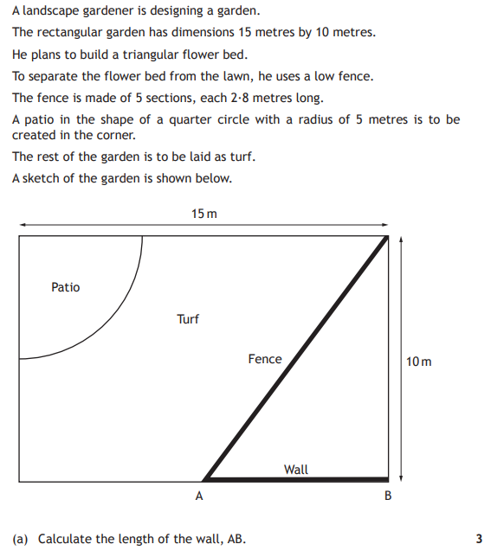
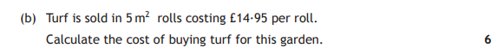

Answers

2018 Non-Calculator
133.6 cm

2018 Non-Calculator
48 m²

2018 Calculator
- 64.5 m²
- £1510.95

2017 Non-Calculator
- 20 cm²
- £30

2017 Non-Calculator
27.42 cm

2017 Calculator
- 707 mm
- 685000 mm²
- Suzanna should pick the offset quadrant as 732743 mm² > 685000 mm²

2016 Non-Calculator
£369.95

2016 Non-Calculator
138 m²

2016 Calculator
8 cm

2015 Non-Calculoator
Yes since 3.5m > 320 cm

2015 Non-Calculator
- 237.12 m²
- £4077

2014 Non-Calculator
- 5 m
- 21 m²

2014 Calculator
- 9.8 m
- £254.15

