**Firrhill Rights Respecting Schools Award – December 2017**

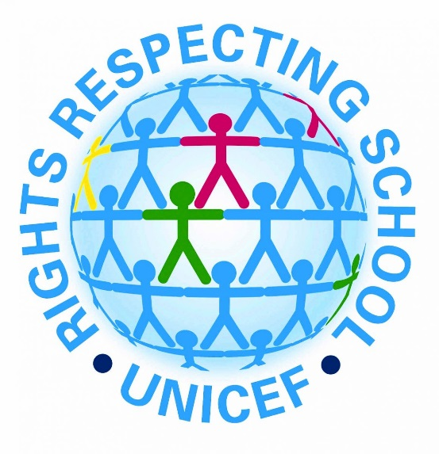

The Firrhill Rights Respecting Schools pupil and staff groups have spent the past few months designing and carrying out events as part of our action plan towards the Unicef Level 1 (Silver) Rights Respecting Schools Award.

Follow the progress of our group on Twitter- @firrhillrrsa

Further information on the Award and the UNCRC is available at:

<https://www.unicef.org.uk/rights-respecting-schools/>

<https://www.unicef.org.uk/what-we-do/un-convention-child-rights/>

<https://www.cypcs.org.uk/rights/uncrcarticles>

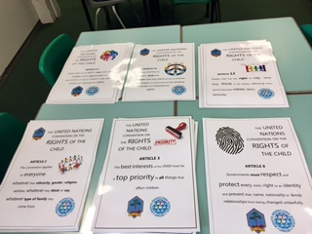

**Staff ‘adopt a right’**

Staff took part in a consultation on which right they would like to ‘adopt’ for their classrooms. The most popular staff right has been Article 29 – *Education must develop every child’s personality, talents and abilities to the full.*

[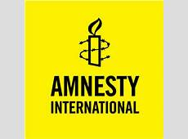](http://www.thesundaily.my/sites/default/files/thesun/Catalogue/Amnesty_International_Logo_001.jpg)

**Amnesty International**

November saw the launch of our Amnesty International pupil group in conjunction with RRS. Dr Hendry from the English department visited the RRS group to discuss the impact of working with Amnesty International on their Write for Rights campaign.

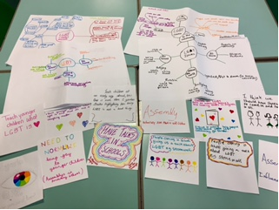**S3 PSE and Article 2**

Some of the S3 PSE lessons this term have focused on pupil voice and Article 2 of the UNCRC: *you have the right to protection against discrimination*.

Pupils explored how LGBT+ people are treated within school, the wider community and globally and discussed what changes they would like to see to stop discrimination from happening.

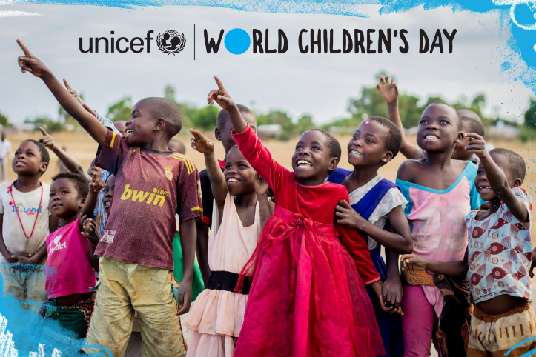**World Children’s Day**

As part of World Children’s Day, our RRS ambassadors took over S1 PSE lessons to deliver a lesson on children’s rights - #kidstakeoverschools. The pupil group designed and led House assemblies, promoting issues around child refugees and having your say in matters that affect you (UNCRC Article 12).

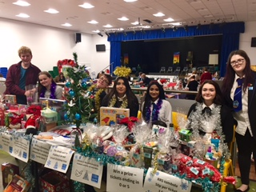**PTA Christmas Fair**

We held a UNICEF information stall and tombola at the PTA Christmas Fair to promote RRS across the school community as well as raise money for UNICEF global projects. Thank you to all the visitors that also wrote Christmas messages of hope for all children.

[](http://sweetclipart.com/multisite/sweetclipart/files/holidays_christmas_holly_1.png)**Look out for our RRS charter launch next term and monthly pupil website articles focusing on specific children’s rights. Merry Christmas and a Happy New Year!**