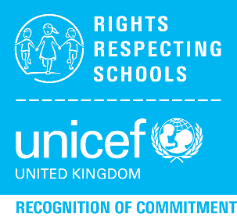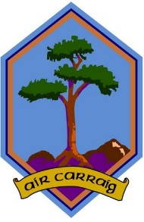

**Firrhill Rights Newsletter**

*January 2018*

By Craig Oliver, S4

**Firrhill’s Right of the Month**

January, it is a time of year often associated with celebration, a fresh start and a time to make amends. For others not so fortunate this month is a harsh and hostile time of year. However, no matter your situation we all have something that unites us and brings us closer. The **UN Convention on the Rights of the Child** allow us to live with peace of mind knowing leaders of the world unite and agree on equal rights for children. This month I have chosen **Article 14** as our right of the month as it allows children to have the right to their own thoughts and beliefs and have the choice to choose their own religion with parent’s guidance. This is important for young people as it allows them to explore different religions, cultures and heritages. Closer to home this right allows us to learn something about the culture and religious background of new and existing pupils who have joined Firrhill or come from a foreign country. The article also brings people together and promotes tolerance of others who may have different beliefs than your own.

Why not make **your** new year’s resolution to learn more about a culture or religion or to make a new classmate welcome at Firrhill!

**Holocaust Memorial Collaboration**

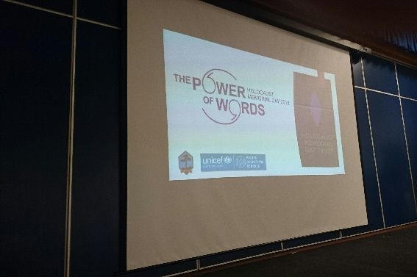

The Rights Group and the Holocaust Memorial Committee collaborated and hosted House assemblies about the holocaust theme ‘The Power of Words’. We highlighted Article 8 – the right to an identity as well as Article 14 of the UNCRC – the right to freedom of thought and belief.

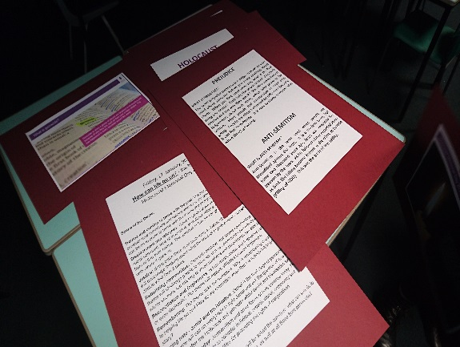

We also created a display for the local Colinton Church community café about the events of the holocaust and the importance of how we use words to empower, and to support others instead of discriminate, and cause hurt.

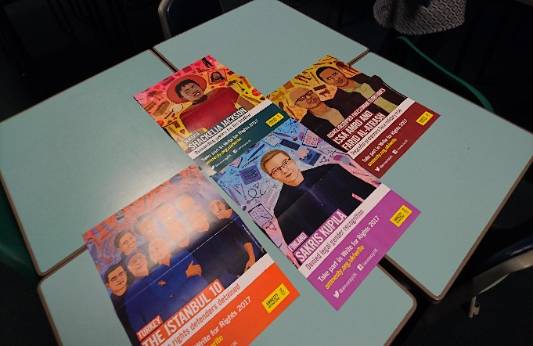**Amnesty Write for Rights Campaign**

The Rights Groups had two weeks dedicated to looking at Amnesty International human rights violation cases and discussed how we will explore Amnesty more in the future.

**Department notice boards**

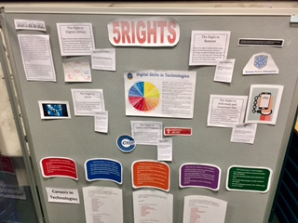

Each faculty area within Firrhill are beginning to design noticeboards showing how specific children’s rights are explored in each subject area and linking this to skills being developed across the curriculum as well. Here is a sneak peek at the Technologies display!

