National 5 February Break Homework Guidelines
Due Monday 19th February
Part 1
Complete at least 2 past papers.
Either use your past paper booklet or the website - http://firrhillhigh.org/?page_id=3808
I will check that you have completed the past papers and ideally marked them using the mark schemes on the website. We will then put some stickers on the progress chart!
Part 2
7 Revision Questions
1) Xavier builds a sheep-pen using two lengths of fencing and a wall. The two lengths of fencing are 15m and 18m. The angle between the fences is 70 degrees. Calculate the area of the sheep-pen. Round your answer to 2 decimal places.
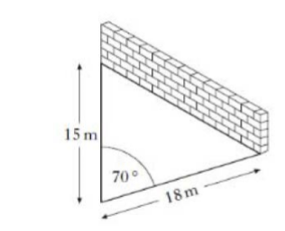
2) For the sheep pen shown above, calculate the length of the brick wall. Give your answers in metres rounded to two decimal places.
3) The diagrams below show 2 vectors u and v. Calculate the vector 4u – 2v.
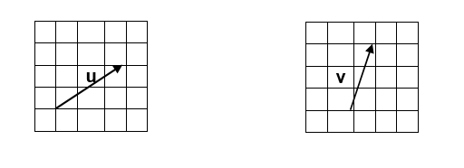

4) The diagram below shows a square based model of a glass pyramid of height 10cm. Square OABC has a side length of 8cm. The coordinates of A are (8, 0, 0). C lies on the y axis. Write down the coordinates of B, C and D.
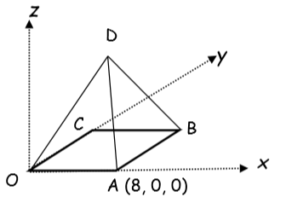

5) $a= \left(\begin{matrix}3 \\ 4\end{matrix}\right) and b= \left(\begin{matrix}0 \\ -8\end{matrix}\right)$calculate the value of $\left|2a+3b\right|$
6) The radio masts, Kangaroo (K), Wallaby (W) and Possum (P) are situated in the Australian outback.
Kangaroo (K) is 350km from Possum.
Wallaby (W) is 600km from Possum.
Possum (P) is on a bearing of 120 degrees from Kangaroo.
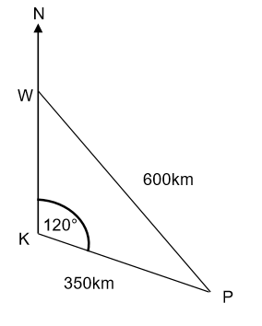

Calculate the bearing of Possum from Wallaby.

7) Dave is varnishing a rectangular room. He measures the length and breadth as shown in the diagram below. Lengths shown are in metres.
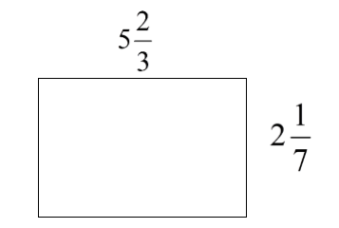

Calculate the exact amount of varnish he will need to varnish the room in square metres.

This sheet can be downloaded from the website if you lose it.

