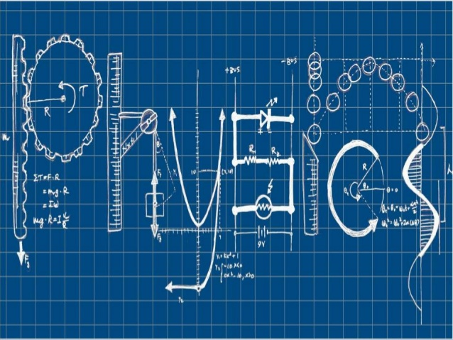National 5 Physics at Leith Academy

**Waves and Radiation**

**Name: _________________________**

**June 2018**

**What you should know from S3…**

We’ll be reviewing all the key material, but there are things you did in the S3 Physics course that you’ll need in this unit.

If you didn’t do the S3 Physics course, you’ll have to work that bit harder.

Grade your own knowledge – where do you think you are at the moment?

|  |  |  |  |
| --- | --- | --- | --- |
| **Key content** | ☹ | 😐 | ☺ |
| I can name the parts of a wave – crest, trough, amplitude, wavelength – and mark them on a diagram |  |  |  |
| I can calculate the frequency of a wave from the number of waves and the time taken to produce them |  |  |  |
| I can calculate the wavelength of a wave from a diagram |  |  |  |
| I can calculate the amplitude of a wave from a diagram |  |  |  |
| I can use the wave equation to find wave speed or frequency or wavelength |  |  |  |
| I can name the different parts of the electromagnetic spectrum |  |  |  |
| I can describe a use for each part of the electromagnetic spectrum |  |  |  |
| I know the speed of light |  |  |  |

My target grade for the end of this unit is: D / C / B / A

To achieve this grade I need to:

_____________________________________________________________________

_____________________________________________________________________

_____________________________________________________________________

**An introduction to waves**We are constantly transmitting information in the form of waves; everything from our mobile phones to the kitchen microwave depends upon waves.

**In physics we say that waves transfer** _________________.

The diagram below shows a representation of a wave.

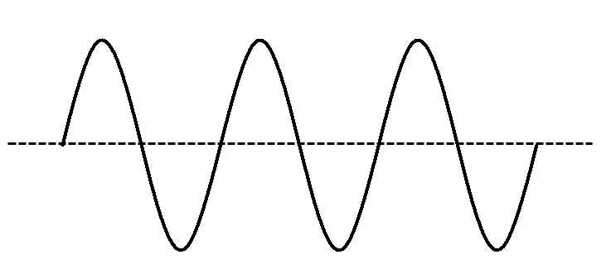

**Label** all the key parts of the wave – crest, trough, amplitude, wavelength

**There are two types of wave** ______________________ and __________________________

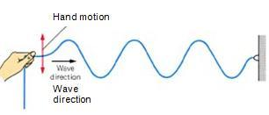

A ______________ wave is one in which……

A ______________ wave is one in which……

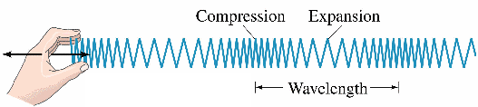

**Sound waves** are an example of ______________________ waves.

**Water waves, radio waves, light waves, microwaves and X-rays** are all examples of _________ waves.

**Wavelength**

The wavelength of a wave is the ______________________________________________________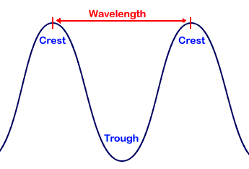

Remember we measure wavelength in metres and give it the symbol 

Example

What is the wavelength of the waves in the diagram below?

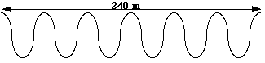

Solution

PROBLEM PRACTICE

Now try the questions on pages 8,9 and 10 of the N4/N5 W&R Problems booklet.

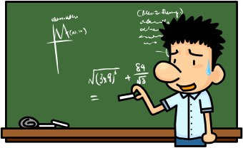

**Frequency**  
When we talk about frequency of things we are talking about how often an event will occur. If your heart beats 60 times a minute then we say it has a frequency of one beat per second.

The frequency of a wave is _______________________________________________________________________________

To calculate frequency, you can use the formula

$$f= \frac{N}{t}$$

f =

N =

t =

Write the meaning of the symbols and their units in the box.

Example  
A man stands on a beach and counts 40 waves hitting the shore in 10 seconds. What is the frequency of these waves?

Solution

When talking about frequency of waves we also talk about the **period** of a wave. The period of something is how long it takes something to happen.

The period of a wave is ______________________________________________________________________________

Period and frequency are linked by the equation:

$$f= \frac{1}{T}$$

f =

T =

Write the meaning of the symbols and their units in the box.

**The Wave Equation**Waves transfer energy from one place to another. This happens at a certain **speed**.

PROBLEM PRACTICE – pages 11 and 12 of the N4/N5 W&R Problems booklet

Waves can often be treated like a normal moving object – we can work out their speed if we know the distance travelled and the time taken.

However, waves have frequency and wavelength – so we will often use the **wave equation**.

v =

f =

● =

v =

d =

t =

Write down the meaning of the symbols and their units in the boxes.

**Example**Joe is on a boat. He sees a water wave travel 60 metres between two buoys. It takes 4 seconds to do this.

Janine Is also on the boat. She notices that waves have a wavelength of 3 m, and that 5 complete waves pass one of the buoys every second.

How does Joe calculate the speed of the waves?

How does Janine calculate the speed of the waves?

Solution

PROBLEM PRACTICE

Now do the problems from pages 17 to 22 in the N4/N5 W&R Problems booklet.

Remember to include units and check your answers as you go.



**Physics skills - working with formulas**

Working with formulas is a key skill in physics. It can seem difficult – but if you go about it in an organised way, it’s actually quite easy.

Remember **TFNAU** from S3? – Table, Formula, Numbers, Answer, Unit.

1. **Table** – read the question and make a table showing what you know and what you need to find out.

2. **Formula** – copy the formula from the formula sheet

3. **Numbers** – put the numbers from the table into the right places in the formula.

4. **Answer** – work out the answer – you may have to re-arrange the numbers but not always

5. **Unit** – don’t forget this, or you lose a mark in exams.

**Examples**  
1. A water wave travels 500 m in a time of 40 s. Calculate its speed.

d = 500 m v = d/t v = 500/40 v = 12.5 m s-1  
t = 40 s  
v = ?

2. A sound wave has a speed of 340 m s-1 and a frequency of 200 Hz. Calculate its wavelength.

v = 340 m s-1 v = f 340 = 200 x   = 340/200  = 1.7 m  
f = 200 Hz  
● = ?

See how you have to re-arrange the numbers here.

**Try these**  
1. A water wave has a frequency of 6 Hz and a wavelength of 3 m. Calculate the wave speed.

2. A wave in a string has a speed on 4.5 ms-1. How much time does it take to travel 22.5 m?

**Diffraction**

All waves can bounce off objects – this is **reflection**.

All waves change speed when they enter a new material – this is **refraction.** (See page XX.)

There is one more thing that all waves do – **diffraction**.

**When a wave passes through a gap** about the same size as its wavelength it will spread out.

The same can happen if a **wave passes around an object**.

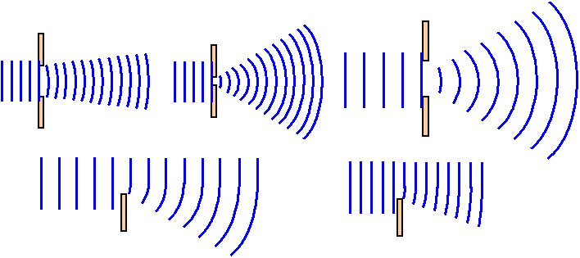

Study the diagrams and complete these sentences.

**When a wave passes through a gap** it bends or d_____________.

Longer wavelengths diffract m_______ than shorter wavelengths.

Smaller gaps cause m_______ diffraction than larger gaps.

Complete the diagram to show how the house can receive radio waves.

Houses in hilly regions receive better radio signals than TV because………

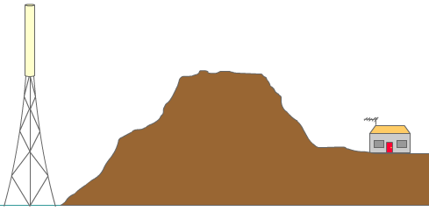

PROBLEM PRACTICE - Now attempt the problems on p14 of the N4 N5 W&R Problems booklet.

**Refraction of light**When light moves from one material (**medium**) to another, its speed changes.

When light travels from air to glass it **slows dow**n and its **wavelength decreases**. If it moves from glass to air, its **speeds up** and its **wavelength increases**.

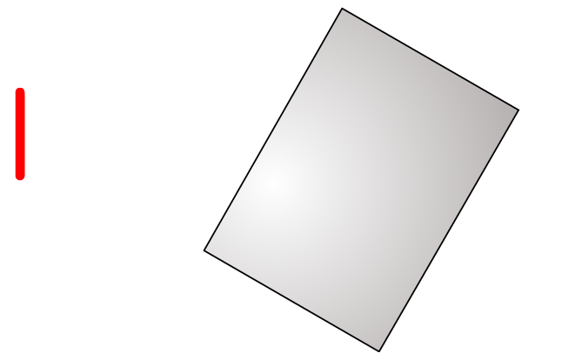This change in speed is called **refraction**. It usually (though not always) causes **a change in direction** of the wave as well.

Complete the diagram to show how the ray of light changes direction as it travels through the block.

**Labelling diagrams**  
We often draw **a ray diagram** to show what a ray of light is doing as it passes through a material. When we draw these diagrams, the ray of light is represented by a straight line and we include three very important features –the normal, the angle of incidence and the angle of refraction.

The normal is………

The angle of incidence is………

The angle of refraction is………



Carry out the experiment to shine the light through the glass block – then label the diagram below and complete the sentences. Draw on the angles of refraction and incidence.

When light goes from air to glass it…….

When light goes from glass to air it…….

**Practical – measuring refraction**

Your teacher will show you how to carry out the experiment. Use this page to record your results. Draw a graph of the results and stick it in.

**Equipment and results**

|  |  |
| --- | --- |
| Angle of incidence (o) | Angle of refraction (o) |
| 10 |  |
| 20 |  |
| 30 |  |
| 40 |  |
| 50 |  |

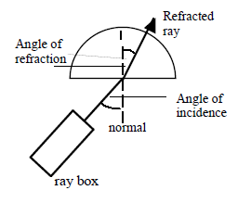

**Refraction – key points**  
When light moves from one medium to another, its speed ___________. This is called _________.

Refraction also causes a change in the _______________ of the light.

When light moves from air to glass its speed _____________ and its wavelength _____________.

When light moves from glass to air, its speed ____________ and its wavelength _____________.

**Practical – total internal reflection**

**Aim:** To investigate total internal reflection and measure the critical angle for perspex.

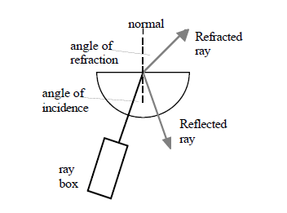**Apparatus:** Ray box, labpack, semi-circular perspex block and a protractor

**Instructions:**

* Setup the apparatus as shown above.
* Align the ray box so that the angle of incidence is 30°.
* Slowly increase the angle of incidence.
* Describe what happens. (1)
* Measure the angle of incidence (the critical angle) when this happens. (2)
* Increase the angle of incidence beyond the critical angle.
* What happens to the ray at the boundary between the perspex and the air? (3)

(1) _________________________________________________________________

_________________________________________________________________

(2) _________________________________________________________________

(3) _________________________________________________________________

**Refraction in action**

Refraction has many applications in everyday life. One of the main uses is **lenses**.

There are two main types of lens: _____________________ and _______________________.

They are used in glasses to correct sight problems.

____________ lens to correct ___________ sight

____________ lens to correct ________ sight

Draw a picture of the two lenses in the boxes. Show how they affect parallel rays of light.

Refraction doesn’t just happen with glass. When light rays move from air into water – or water into air – they will refract. Complete this diagram to show how a ray of light travels **from** the fish **to** the student’s eye.

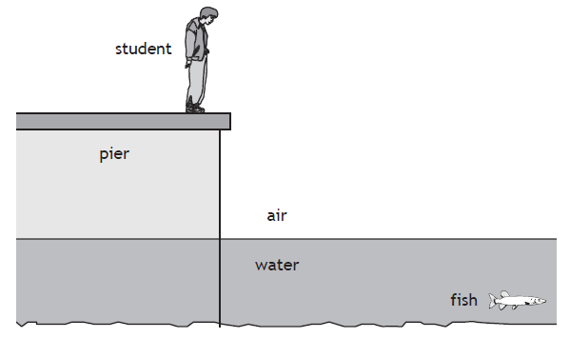

PROBLEM PRACTICE- now attempt questions   
1, 4, 5, 6, 7, 9 from the N4/N5 Problems booklet on page 28

Remember to include units and check your answers as you go.

Use a ruler and a sharp pencil! Draw and label the normal. Remember that light will bend away from the normal when it speeds up. (For example, when it goes from water into air.)

**The electromagnetic spectrum**

All light, radio and TV waves are members of the electromagnetic spectrum**. All waves in the electromagnetic spectrum travel at the same speed** – which is ___________________ ms-1.

Beyond the visible part of the spectrum there are other waves with higher or lower wavelengths that we cannot see. Complete the table below putting the waves in order.

|  |  |  |  |  |  |  |
| --- | --- | --- | --- | --- | --- | --- |
| Radio Waves |  |  | Visible Light |  | X-rays |  |

Increasing frequency

Increasing wavelength

Like all waves, waves in the EM spectrum transfer ___________.

All waves in the EM spectrum travel at the speed of _________.

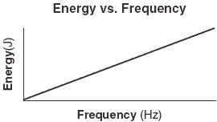 The ________ of the waves depends on their f____________.

The _________ the frequency, the __________ the energy.

Therefore, the waves in the EM spectrum with the most energy are: ________________

The waves in the EM spectrum with the least energy are: __________________

This is why gamma rays and X-rays are dangerous to human health and can kill. Radio waves are not dangerous at all.

**Using the EM spectrum – research activity**  
Beyond the visible part of the spectrum there is many other waves we cannot see but are extremely important for our everyday lives.

|  |  |  |  |  |  |
| --- | --- | --- | --- | --- | --- |
| **Name** | **Wavelength Range** | **Frequency Range** | **Source** | **Detector** | **Uses** |
| Gamma radiation |  |  |  |  |  |
| X-rays |  |  |  |  |  |
| Ultraviolet radiation |  |  |  |  |  |
| Visible light |  |  |  |  |  |
| Infrared radiation |  |  |  |  |  |
| Microwaves |  |  |  |  |  |
| Radio waves |  |  |  |  |  |

PROBLEM PRACTICE  
Now attempt questions from the N4/N5 Problems booklet on pages 23-27.

**Physics skills – prefixes and scientific notation**

**Prefixes**  
In physics we often use some very large or very small numbers. To help, we can use **prefixes** – words put in front of a unit to tell us ‘how many’.

|  |  |  |  |
| --- | --- | --- | --- |
| **name** | **symbol** | **how many** | **example** |
| giga- | G | billion (x 1,000,000,000) | 2.5 GJ = 2,500,000,000 joules |
| mega- | M | million (x 1,000,000) | 3.6 MW = 3,600,000 watts |
| kilo- | k | thousand (x 1,000) | 5.2 km = 5,200 metres |
| milli- | m | thousandth (÷ 1,000) | 14 mm = 0.014 metres |
| micro- | ❍ | millionth (÷ 1,000,000) | 5 J = 0.000005 joules |
| nano- | n | billionth (÷ 1,000,000,000) | 450 nm = 0.00000045 metres |

For calculations, we usually work in ‘base units’ – metres, seconds, joules, watts, etc. If a question uses prefixes, then convert before you do the question.

Example  
A wave has a frequency of 5 kHz and a wavelength of 100 mm. Find its speed.

5 kHz = 5 x 1000 = 5,000 Hz v = f = 5000 x 0.1 = 500 m s-1

100 mm = 100/1000 = 0.1 m

**Scientific notation** helps us to write out large or small numbers in an efficient way.

100 = 10x10 = 102 So 400 = 4 x 100 = **4 x 102**

1000 = 10 x 10 x 10 = 103 So 3600 = 3.6 x 1000 = **3.6 x103**

0.001 = 1÷(10x10x10) = 10-3 So 0.006 = 6 x 0.001 = **6 x 10-3**

0.0001 = 1÷(10x10x10x10) = 10-4 So 0.00075 = 7.5 x 0.0001 = **7.5 x 10-4**

**Scientific notation and prefixes**

|  |  |  |  |
| --- | --- | --- | --- |
| **prefix** | **notation** | **prefix** | **notation** |
| G (giga-) | x 109 | m (milli-) | x 10-3 |
| M (mega-) | x 106 |  (micro-) | x 10-6 |
| k (kilo-) | x 103 | n (nano-) | x 10-9 |

Convert these values to base units:

4.6 km = ____________ 4 mA = _____________ 25.2 MW = ________________

Write these numbers using scientific notation:

9000 = ______________ 2,600,000 = ___________ 0.0015 = _____________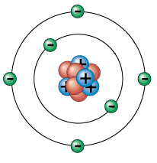**Types of radiation**  
All matter is made up of tiny particles called a___________.   
The a_________ is made up of protons, neutrons and electrons. The p___________ and n______________ are tightly packed together to make up the nucleus. The e______________ orbits around the nucleus.

Label the particles in the diagram.

|  |  |  |  |
| --- | --- | --- | --- |
| **Name of Particle** | **Mass** | **Charge** | **Location** |
| Proton |  |  |  |
| Neutron |  |  |  |
| Electron |  |  |  |

In some atoms, the nucleus is **unstable**. It can ‘spit out’ particles. This is **radioactivity**.

Radioactivity can **ionise** an atom. This means it removes e________________ from the atom. If a neutral atom is ionised, it becomes p____________ charged.

Ionisation can cause cells in living things to c__________ or d___.

There are 3 types of radiation that can be emitted from an atom: a____________, b______________ and g___________________

|  |  |  |  |
| --- | --- | --- | --- |
| **Type of radiation** | **Symbol** | **What is it?** | **Ionisation power** |
|  |  |  |  |
|  |  |  |  |
|  |  |  |  |

**Absorbing radioactivity**  
Radiation can only travel a limited distance before their energy is absorbed. Different radiations can be absorbed by different materials.

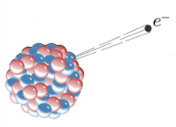Alpha can travel ____________________ in air.

Beta can travel ______________________ in air.

Gamma can travel _____________________________ in air.



Watch the teacher demonstration of the 3 different radiations and what absorbs them. During the experiment complete the table below.

|  |  |  |  |  |
| --- | --- | --- | --- | --- |
| **Source** | **Effect of absorber** | | | |
| **Air** | **Paper** | **Few mm of aluminium** | **Few cm of lead** |
| Alpha |  |  |  |  |
| Beta |  |  |  |  |
| Gamma |  |  |  |  |

1. Which absorber(s) can absorb alpha radiation?

2. Which types of radiation would be absorbed by 5 mm of aluminium?

3. During the experiment, was there any risk to you from the **alpha** radiation? Explain your answer.

4. Spacecraft are exposed to a lot of gamma radiation. How could we protect the astronauts in the spacecraft? What problems might this cause?

**Activity**  
Some materials are naturally radioactive because their nuclei are unstable and will emit radiation to become more stable. We cannot tell when the nuclei will emit radiation as it is a random process. What we can do is measure how often it happens.

**Activity** is defined as………

To work out the activity of a substance we can use the formula:

Write the formula in symbol form and write down all the units that the terms are measured in.

$$Activity= \frac{Number of decays}{time in seconds}$$

A =

N =

t =

**Example problem**A radioactive source has 2400 decays in 30 seconds. Calculate its activity.

Solution

PROBLEM PRACTICE

Now attempt questions from the N4/N5 W&R Problem booklet on p33 (questions 1-5 only).

Remember to include units and check your answers as you go.

**Measuring the activity of the school’s radioactive sources**  
We will carry out an experiment to measure the activity of the school’s three radioactive sources.

Use the space below to draw a table to record your results – we’ll make three measurements for each type of radioactivity, and then calculate an average.

Use this space for a simple diagram of the equipment we used.

**Background radiation**  
Radiation is a naturally occurring effect and is all around us. Our bodies have adapted through evolution to deal with this.

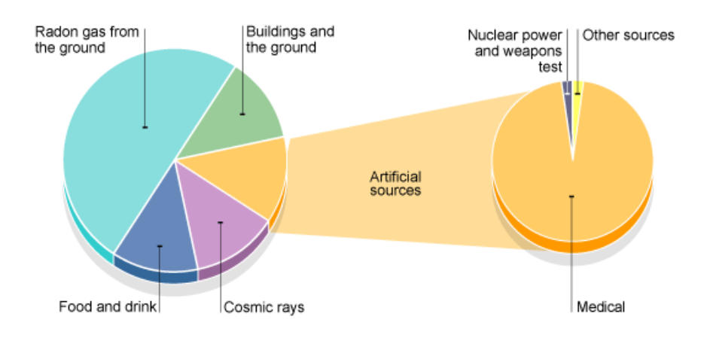

There are radioactive substances all around us. This means that we are exposed to a low level of ______________all the time. This is called ____________ radiation. Background radiation can come from various sources

***Cosmic radiation***  
This comes from far out in_____________**.** The atmosphere absorbs most of it so it is not really a problem for us. However, pilots will absorb more of this due to the height they fly at.

***Food***  
Some of the ____________we eat contains small amounts of______________ substances such as   
carbon 14 and radioactive potassium. Plants absorb carbon 14 from the air as they grow.

***The air and rocks***  
The air around us contains ___________which is a radioactive _____. Radon is also given off by some ___________such as___________**.** This can cause a problem to people living in parts of the country where there is a lot of granite rock – like Aberdeen.

***Nuclear weapons and nuclear power***  
There is still background radiation left over from nuclear weapons testing in the 1950s. Accidents at nuclear power stations like _________________ have also added to background radiation.

***Medical uses***  
Some medical procedures use radioactive sources. These can contribute to background radiation. Although not technically a form of radioactivity, X-rays can cause i_____________ of atoms and also contribute to background radiation.

**Natural and artificial sources of background radiation**  
Some types of background radiation occur naturally – they would be here whether or not humans were on the planet.

There are some artificial sources of background radiation – due to human activity.

Complete the table to show at least three example of each type.

|  |  |
| --- | --- |
| **Natural sources** | **Artificial sources** |
|  |  |
|  |  |
|  |  |
|  |  |
|  |  |

**Measuring background radiation**



Today’s background radiation reading 1 = counts per minute (cpm)

Today’s background radiation reading 2 = cpm

Today’s background radiation reading 3 = cpm

Average = cpm

**Dosimetry**  
Ionising radiation can be very harmful to living cells. The energy absorbed by the bodily tissue can cause damage to the cell’s DNA and affect how the cells operate. It can even kill the cells. It is important to measure exposure to radiation so we can make sure that people’s health is not affected by radiation.

The amount of damage depends upon the **energy** of the radiation absorbed and the **mass** of the tissue that absorbs. We measure this using the idea of **absorbed dose**.

$$D= \frac{E}{m}$$

D =

E =

m =

Write down the meanings of the symbols and the units.

**Example**A 3.5 kg sample of tissue absorbs 7.0 mJ of energy. Calculate the absorbed dose.

Solution

Different types of radiation cause different amounts of damage, so they are given a **radiation weighting factor**. We apply this factor to the absorbed dose to give the **equivalent dose**.

$$H=Dw_{r}$$

H =

D =

wr =

Write down the meanings of the Symbols and the units.

**Example**A sample of tissue which received 40mGy was exposed to alpha radiation. Alpha radiation has a weighting factor of 20. Calculate the equivalent dose.

Solution

The danger to health doesn’t just depend on how much radiation you absorb – but also on how quickly you absorb it. 2 Sv is a very high equivalent dose that would kill you if you absorbed it over a few minutes. If you absorb it over a lifetime, it’s unlikely to do you much damage.

To measure this, we use the idea of **equivalent dose rate**.

Write down the meanings of the symbols and the units.

Note that we can measure the time in seconds, minutes, hours or even years.

$$\dot{H}=\frac{H}{t}$$

$$\dot{H}=$$

H =

t =

|  |  |  |
| --- | --- | --- |
| **Type of Radiation** | **Radiation weighting factor** | **Absorbed Dose (Gy)** |
| gamma rays | 1 | 100 |
| fast neutrons | 10 | 400 |
| alpha particles | 20 | 50 |

**Example**A team of medical researchers were investigating the effect of different types of radiation on body tissue.

The table shows the absorbed doses over a 5 hour period from each type of radiation.

a) Use the data to show which radiation is likely to be most harmful to this particular tissue.

b) The maximum permitted equivalent dose for this tissue is 5 mSv. For how long could the tissue be exposed to fast neutrons before it exceeds this limit?

c) A sample of this tissue has a mass of 25 g. How much energy will it absorb from fast neutrons in 2 hours?

(Hint: work out the equivalent doses first, then the equivalent dose rates)

PROBLEM PRACTICE

Now attempt Questions from the problem book on page 22 – 25 and 33-36 of the challenge books, Remember to include units and check your answers as you go.



**Equivalent dose and sources of radiation**  
People absorb energy from radiation. This could be from background radiation, or because some people work in the nuclear industry. Medical uses of radiation might increase the radiation we absorb.

**Research task**Try to find out what the typical equivalent dose is for the different types of background radiation. Record your results in this table.

You must **learn** the three values in bold at the bottom of the table.

|  |  |
| --- | --- |
| **Source of background radiation** | **Average equivalent dose** |
|  |  |
|  |  |
|  |  |
|  |  |
|  |  |
|  |  |
| **Average annual background radiation in the UK** | **2.2 mSv** |
| **Annual effective dose limit for a member of the public** | **1.0 mSv** |
| **Legal yearly limit for workers in nuclear industry** | **20 mSv** |

PROBLEM PRACTICE - pages 34-36 from the N4/N5 W&R Problems booklet.

**Half-life**  
Once an atom decays there are fewer atoms left to decay - so over time the activity will reduce.

The definition of half-life is…….



Radioactive decay is a random process so we can model it using dice. Your teacher will show you how to carry out the experiment. Plot the results on the graph below. Remember to label the axes.

From the experiment the half-life of my source = _________________________

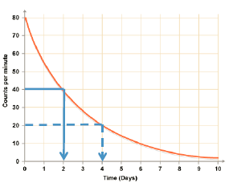

To work out half-life from a graph you…….

**Half Life Example Problems**

1. A Geiger Muller tube and rate-meter were used to measure the half-life of radioactive caesium-140. The activity of the source was noted every 60s. The results are shown in the table. By plotting a suitable graph, find the half-life of the caesium-140.

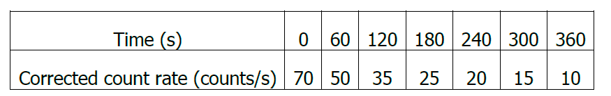

2. The activity of a source drops from 80MBq to 5MBq in 8 days. Calculate its half-life.

Solution

3. A source has an activity of 600 kBq. It has a half-life of 6 hours. What is its activity after 24 hours?

Solution

**Corrected count half-life**Background radiation has to be taken into account when dealing with half-life experiments. It does not come from the source but from other sources such as rocks, cosmic rays etc. Background count should be measured and subtracted from any recorded count (or activity) during an experiment in order to obtain accurate readings from the source being investigated.

**Example question**On a day when the background count was measured as 30 counts per minute, the following readings were obtained from a radioactive source. The readings have not been corrected for background.

|  |  |  |  |  |  |  |  |  |  |
| --- | --- | --- | --- | --- | --- | --- | --- | --- | --- |
| Time (minutes) | 0 | 20 | 40 | 60 | 80 | 100 | 120 | 140 | 160 |
| Activity (counts per minute) | 230 | 190 | 160 | 130 | 110 | 95 | 80 | 70 | 63 |

1. Plot a **corrected** graph of activity against time **for the source only**.
2. Calculate the half life of the source.

PROBLEM PRACTICE  
Now attempt questions from the N4 N5 W&R Problem booklet, pages 37 - 40. Remember to include units and check your answers as you go.

**An experiment to measure half-life**

**You could be asked to describe this experiment in an exam. Learn the details.**

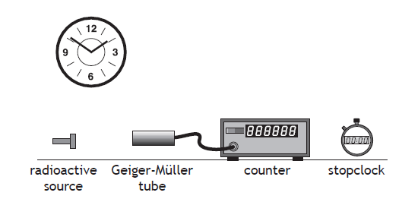

We could use the equipment here to measure the half-life of a radioactive source.

For example:

1. Note down the time from the clock on the wall.
2. Use the stopclock and the counter to measure the number of counts in one minute.
3. Wait for 10 minutes (using clock on the wall) then measure the counts in one minute again.
4. Repeat this every 10 minutes for two hours.
5. Measure the background count and subtract it from all readings.
6. Plot a graph of corrected count per minute against time.
7. Use the graph to find the half-life.

**Research task**

What is a Geiger-Muller (GM) tube? How does it work? Who were Geiger and Muller?

**Applications of radiation**

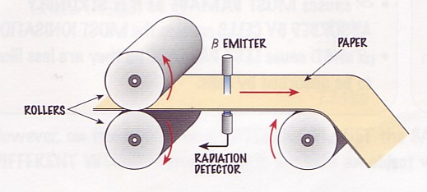**1.** **Controlling the thickness of sheet materials**

Radiation can be used to monitor the thickness of paper as it is being made in a paper mill.

Radiation is emitted by the emitter. It is detected by the detector on the other side of the sheet.

a) If the sheet becomes thicker, what will happen to the level of radiation at the detector?

b) Which of the three types of radiation could be used for this?

c) Why would the other two types not work?

**2. Smoke detectors**

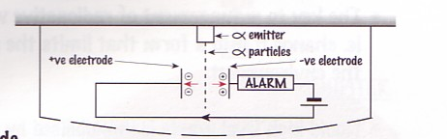Most smoke alarms contain a radioactive source. The radiation causes ionisation of the air particles and the ions formed are attracted to the oppositely charged electrodes. So a current flows in the circuit.

When smoke enters the space between the two electrodes, less ionisation takes place because the radiation is absorbed by the smoke particles. A smaller current than normal flows, and the alarm goes off.

radiation

a) Which of the three types of radiation would be best for this? Why this one?

**3. Cancer treatment**

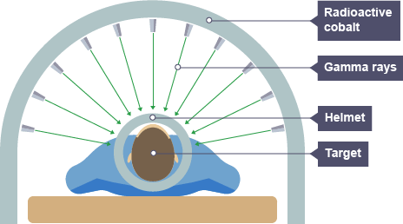Ionising radiation can damage or kill living cells. We can make use of this in cancer treatment. By directing beams of radiation into the body, the cancerous cells can be destroyed. Great care is needed to minimise the effects on healthy tissue.

a) Why is gamma radiation used for this kind of treatment?

**Fission, fusion and nuclear power**  
Some large atoms like uranium are unstable. The nucleus of the atom can ‘split’ into two pieces, releasing energy as it does so. This is called **fission**.

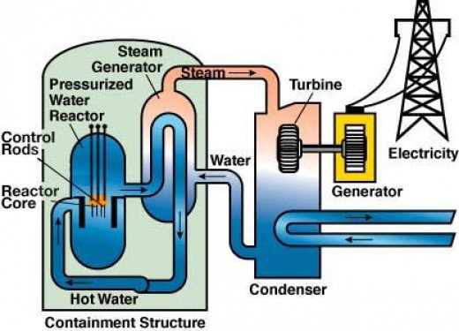If small atoms (like helium) hit into each other at very high speed, they can join together. This also releases energy, and is called **fusion**.

**Fission in more detail**  
Fission is used in nuclear power stations. The energy released is used to heat water. To turn it into steam. The steam spins turbines. The turbine spins the generator to generate electricity.

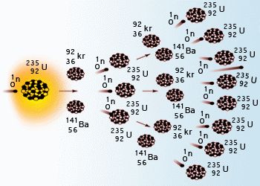But how is so much energy released?

If a uranium nucleus is hit by a neutron, the nucleus can split – releasing energy. It breaks into two large parts, and also another two or three neutrons. These neutrons can cause other nuclei to split – releasing more energy and also more neutrons which can go on to split other nuclei and so on. This is called a **chain reaction**. Millions or billions of nuclei can split in a very short time, releasing a lot of energy.

a) What are some of the advantages of nuclear power?

b) What are some of the disadvantages of nuclear power?

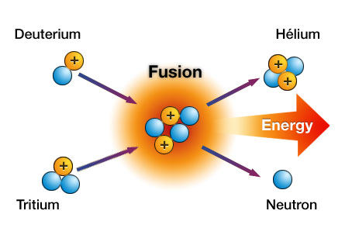**Fusion in more detail**Fusion happens in all stars – it’s how stars produce energy. Without fusion, there would be no stars, no planets, no us.

In fusion, two small nuclei crash together at high speed. They join together to make a new nucleus, but also release energy.

To get the nuclei to crash together hard enough, they have to be travelling very fast. This means they have to be very, very hot – millions of degrees. When they are this hot, they are called **plasma**. These sorts of temperatures are only usually found in the centres of stars.

We can get fusion to happen on Earth – but it’s difficult and very expensive. It is difficult to contain the hot plasma – this has to be done using magnetic fields as the plasma would instantly melt any kind of solid container.

We can end up putting more energy in to heat up the gases than we get out from the fusion reactions. But if we could get fusion to work – we could generate all the energy the world needs without any danger of running out of fuel, and without creating any radioactive waste.

**Fission or fusion – where do we spend the money?**  
Fission reactors work. They are producing power right now. But there are real drawbacks. Fusion power could solve a lot of problems – but we’ve been working on it for 50 years and it’s still not producing much energy.

So should Scotland invest in new fission power stations – or in research into fusion? Or neither?

What do you think?

________________________________________________________________________________

________________________________________________________________________________

________________________________________________________________________________

________________________________________________________________________________

________________________________________________________________________________

________________________________________________________________________________

________________________________________________________________________________

________________________________________________________________________________

PROBLEM PRACTICE  
Now attempt questions from the N4/N5 W&R Problem booklet, p32. Remember to include units and check your answers as you go.

**Formula sheet for National 5**

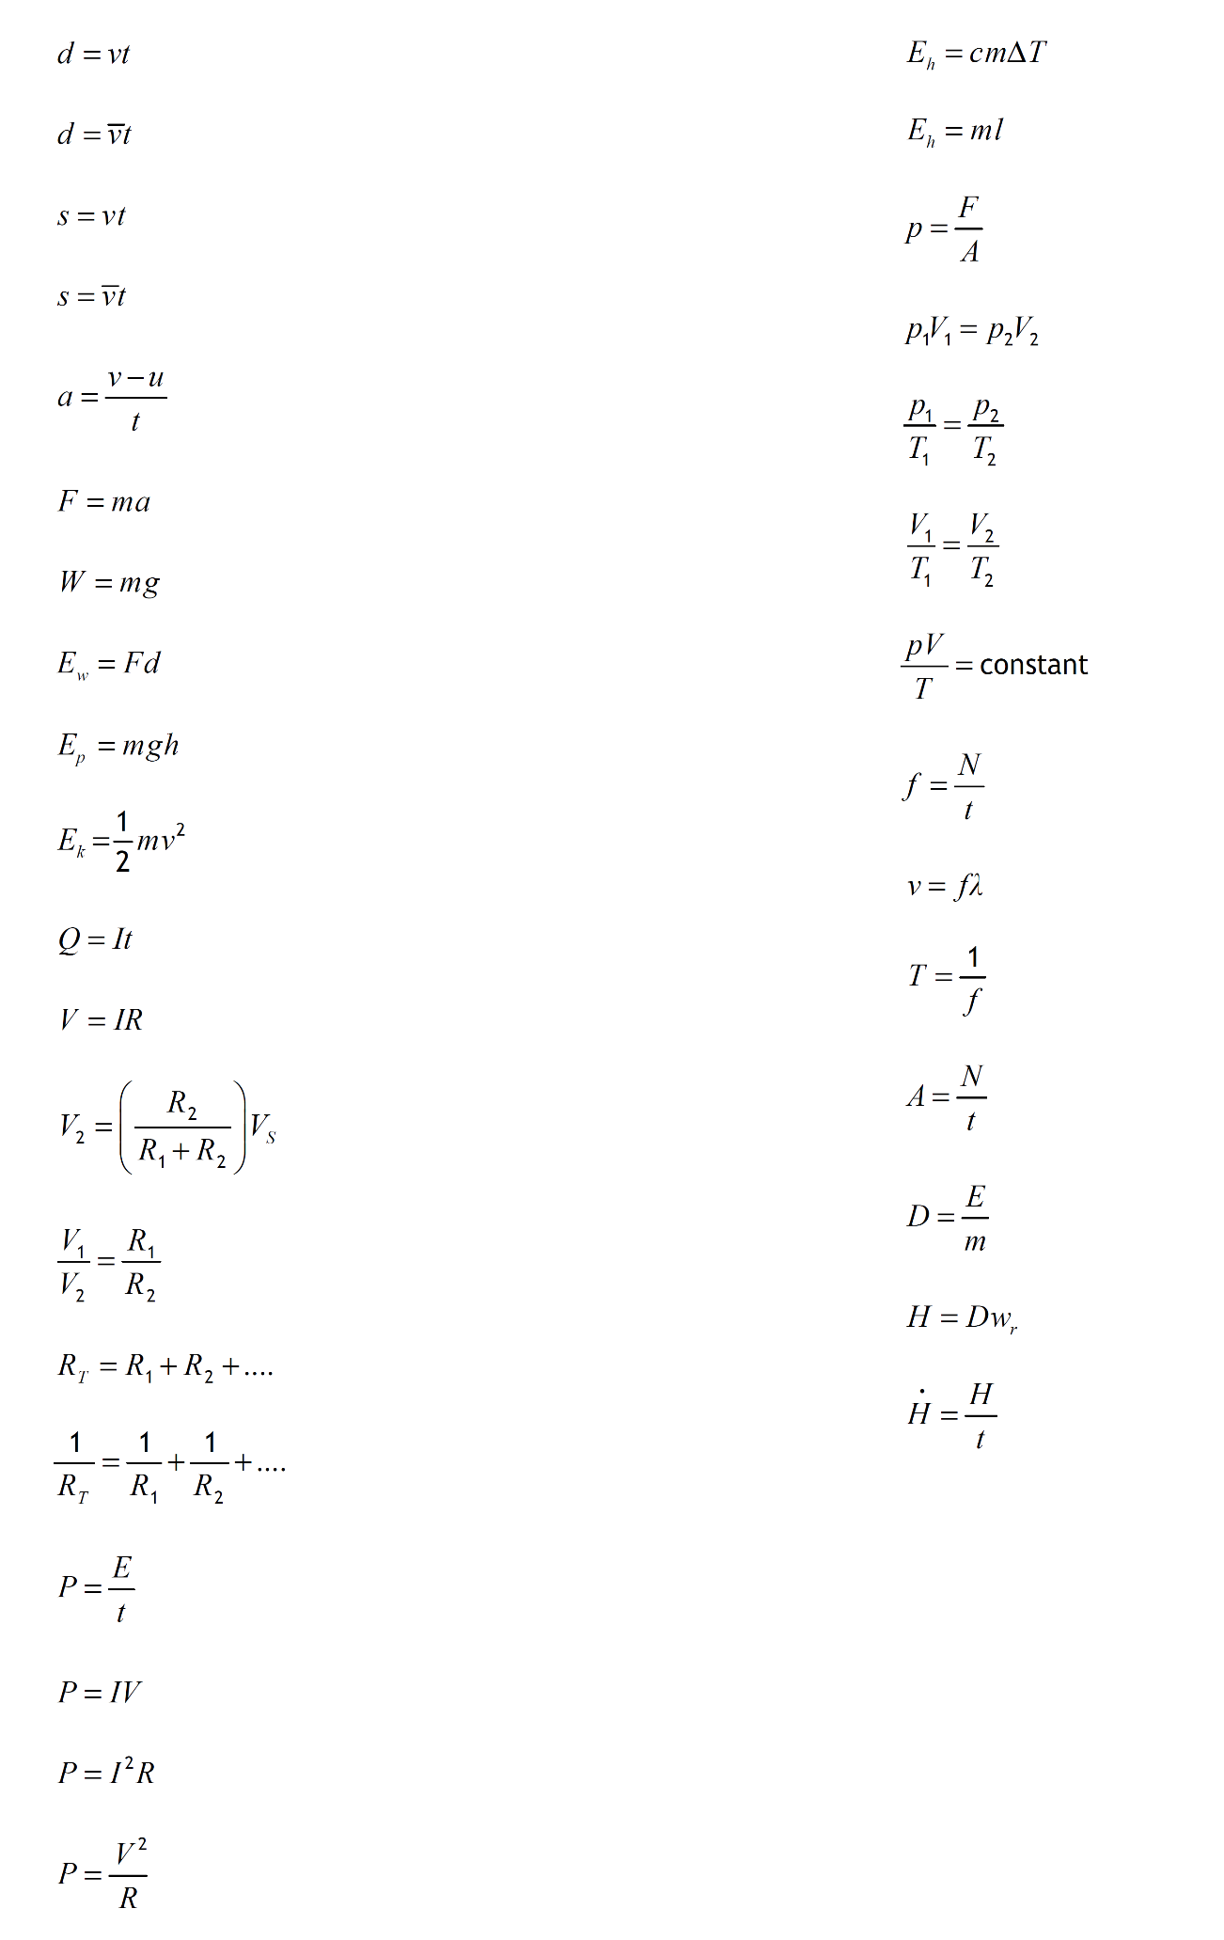By the end of the course, you must know what each letter stands for and what its unit is.

Formulas for this unit