National 5 Physics at Leith Academy

Thermodynamics

March 2018

Specific heat capacity
If you put a 1 kg block of metal under a hot sun, it will heat up very quickly. If you put a 1 kg block of stone in the sun, it will take longer to warm up.

This is because different materials need different quantities of heat to raise their temperature.

The specific heat capacity of a substance is the amount of heat energy needed to change the temperature of 1 kg of the substance by 1°C. Each substance has a different value of specific heat capacity.

$$E_{h}= cm∆T$$

E_{h} =
c =
m =
ΔT =
What does each letter stand for?
What is the correct unit?

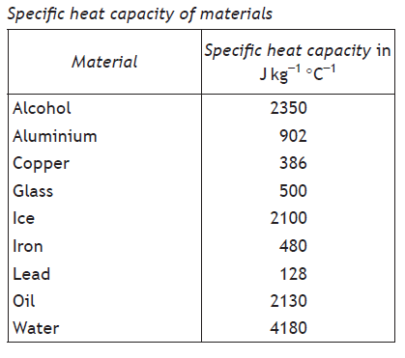

Example 1
How much heat energy is needed to heat 0.5 kg of water from 20 °C to 60 °C?
Solution: the change in temperature needs to be calculated first.
$$∆T=60-20=40 ℃$$
Now find the specific heat capacity of water from the table above: 4180

Now use the formula:
$$E_{H}=cm∆T \\ =4180×0.5×40 \\ =\underline{8.4×{10}^{4} J}$$

Example 2
24 000 J of energy is supplied to a 2 kg block of steel. Calculate the change in temperature.

Example 3
If 30 000 J of energy is supplied to a 4.5 kg block of copper, what will the final temperature be if its initial temperature was 25 ºC?

PROBLEM PRACTICE
N5 D&S page 60 questions 2-15

An experiment to find the specific heat capacity of aluminium

1. Draw a labelled diagram of the equipment here

2. Complete these measurements as you do the experiment

Initial temperature of block = _____ Final temperature of block = ________

Current supplied to heater = ______ Voltage across heater = ________

Time heater is on = ______ mass of block = 1.0 kg

3. Use your measurements to make these calculations

Power of heater P = I x V = ______________

Energy supplied to block E = P x t = ______________

Temperature rise of block ΔT = ______________

The amount of energy needed to raise 1 kg of a material by 1 ºC is called the specific heat capacity of the material.

c = E__
m x ΔT

So the specific heat capacity of aluminium is _________ J kg⁻¹ ºC⁻¹

Temperature and heat

What's wrong with these sentences? Are they all wrong?

The water in the kettle is at a high heat. A kettle produces a lot of temperature.

The heat of the coffee is 85 ºC. An insulated mug stops the coffee losing temperature.

The words heat and temperature are often confused.

Heat is a form of energy. It is caused by the movement of particles in a substance. The faster they move, the more kinetic energy they have. This increases the heat energy in the substance.

Temperature tells us how hot a substance is. It is a measure of the average kinetic energy of the particles in the substance.

Heat energy is measured in joules (J). Temperature is measured in degrees Celsius (ºC)
Conservation of energy and heat transfer
You’ve already learnt an important principle in physics:
Energy cannot be created or destroyed. It is always conserved.
This applies to all types of energy, including heat energy. In fact, we used this idea in the experiment to find the specific heat capacity of aluminium.
We used P = I x V and E = P x t to work out the total amount of _______________ energy.
We assumed that all of this energy was then converted into _____ energy to warm up the block.

Example 1
A 2000 W kettle contains 1.5 kg of water at 20 ºC. It is switched on for 2 minutes.
a) Calculate the electrical energy used by the kettle.
b) If all the electrical energy is converted to heat energy, calculate the final temperature of the water.

Example 2
A 12.0 V heater draws a current of 3.0 A. It is placed in a beaker containing 0.8 kg of oil and switched on for 900 seconds.
a) Calculate the power of the heater.
b) Calculate the electrical energy supplied by the heater.
c) Calculate the temperature rise of the oil.

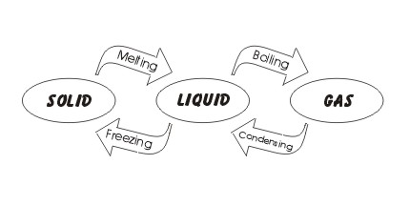
Latent heat
There are three states of matter: solid, liquid and gas.

Substances can change state – for example, solid ice can melt to become liquid water.

Changes of state involve latent heat energy. (Latent means ‘hidden’.)

Whenever a substance changes state, latent heat energy is required.

When solids melt or liquids boil – energy needs to put in.

When gases condense or liquids freeze – energy is given out.

Latent heat is the term used to describe energy that causes a change of state without change of temperature.
Specific latent heat
Specific latent heat is the quantity of energy needed to change the state of 1 kg of a substance.

There is no change in temperature during a change in state.

We can calculate the energy using the formula:

$$E_{h}= ml$$

E_{h} =
m =
l =
What does each letter stand for?
What is the correct unit?

The amount of heat energy required to change 1 kg of ice into water (or water into ice) is NOT the same as the energy required to change 1 kg of water into steam (or steam into water).

It takes 334,00 J of heat energy to turn 1 kg of ice at 0 ºC into liquid water at 0 ºC.

This is called the specific latent of fusion. This applies to solidliquid and liquidsolid changes.

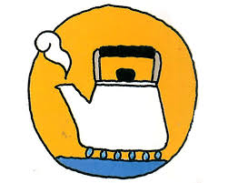

It takes 2,260,000 J of heat energy to turn 1 kg of water at 100 ºC into steam at 100 ºC.

This is the specific latent of vaporisation. This applies to liquidgas and gasliquid changes.

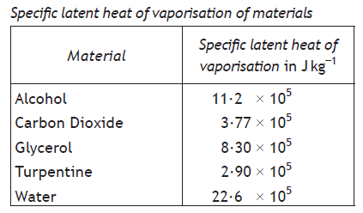
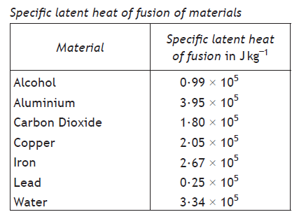

Example 1
800 g of water at 0 ºC is placed in a freezer. Calculate the heat energy that must be removed from the water to change it all into ice at 0 ºC.
Solution: Find the specific latent heat of fusion of water from the table. Remember to convert the mass to kg.

$$E_{H}=ml \\ =0.8×3.34×{10}^{5} \\ =\underline{2.7×{10}^{3} J}$$

Example 2
Water in a kettle is brought to the boil at 100 °C and then heated for a further 2 minutes. The kettle is 240,000 J.
- Calculate the mass of water converted to steam during this time.
- Why would it take a longer time, in practice, to convert this mass of water to steam?

Solution:

PROBLEM PRACTICE
N5 D&S page 62 questions 2-14

Heating and cooling curves
Imagine removing a block of ice from a freezer at -15 ºC and heating it.

To begin with, the solid ice will warm up: $E_{h}=mc∆T$

When it reaches 0 ºC, it will melt into water at 0 ºC: $E_{h}=ml (fusion)$

The liquid water will then heat up until it reaches 100 ºC: $E_{h}=mc∆T$

The water will then turn into steam at 100 ºC: $E_{h}=ml (vaporisation)$

The graph of the change in temperature against time is made up of slopes and horizontal lines.

The slopes show where the temperature is changing: $E_{h}=mc∆T$

The horizontal lines show where the state is changing: $E_{h}=ml$
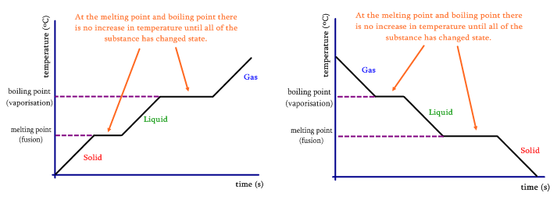
Example
Calculate the total energy required to change 0.5 kg of ice at -15 °C into steam at 100 °C.
Hint: you need to do five calculations: energy to heat up the ice ($E_{H}=cm∆T$)
energy to melt the ice ($E_{h}=ml$)
energy to heat the water ($E_{H}=cm∆T$)
energy to turn the water into steam ($E_{h}=ml$)
then add them together

Pressure
If someone stands on your foot wearing wellingtons, it’s not too bad.
If they are wearing a stiletto heel, they might make a hole in your foot.

Although the force applied is the same, the area is different. We measure this effect using the idea of pressure.

Pressure is defined as the force per unit area:
$$p= \frac{F}{A}$$

p =

F =

A =

What does each letter stand for?
What is the correct unit?

Note: 1 Pa = 1 N m⁻²

Example
Calculate the pressure exerted by a 40 kg mass sitting on a bench. The base of the mass measures 4 m × 2 m.
Solution: the area of the block is
$$A=l×b \\ =2×4 \\ =8 m^{2}$$

The force acting is the weight of the 40 kg mass
$$W=mg \\ =40×9.8 \\ =392 N$$

The pressure is:
$$p=\frac{F}{A} \\ =\frac{392}{8} \\ =\underline{49 Pa}$$

PROBLEM PRACTICE
N5 E&E page 66 questions 1-15
Gases and the Gas Laws
Gases are made up of tiny particles – atoms or molecules – that are widely separated and moving at speed.

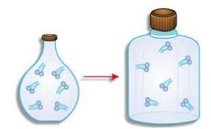
The Gas Laws look at the relationships between three aspects of gases – pressure, volume and temperature.

The volume of a gas is the volume of the container it is in – usually measured in cm³ or m³.

These two bottles contain the same mass of gas – count the particles – but have different volumes.

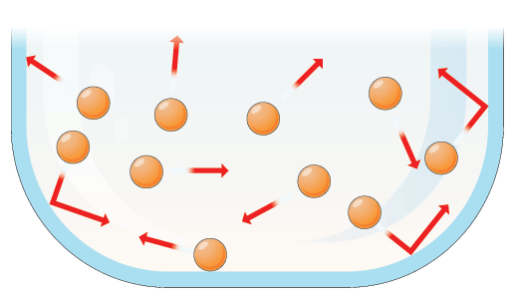
The pressure of a gas is caused by the moving particles hitting against the sides of the container. This applies a force over the area of the container – so we have a pressure. Pressure is measured in pascals (Pa).

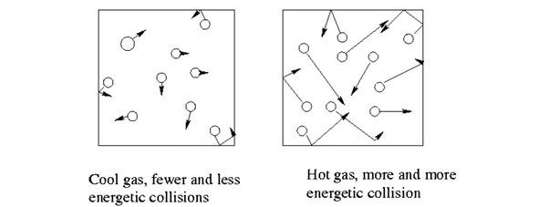
The temperature of a gas is a measure of the average speed of the particles. The faster the particles are moving, the higher the temperature of the gas.

Boyle’s Law
You may be asked about this experiment in an exam – learn the details.

Aim: To find a relationship between pressure and volume for a fixed mass of gas at constant temperature.

Procedure: The pump is used to increase the pressure (measured on the Bourdon gauge). The oil moves up the tube, compressing the gas into a smaller volume (measured on the scale).

The pressure is then gradually reduced in steps, taking measurements of the volume each time.

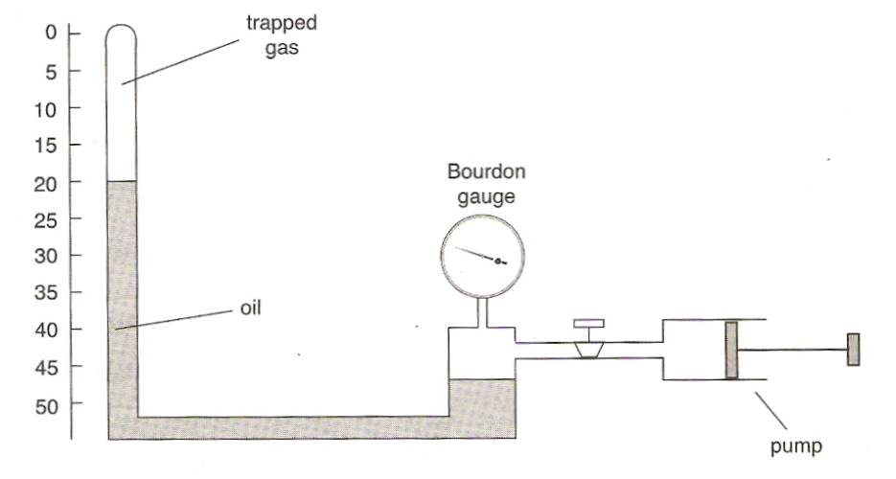
Results
pressure (kPa) | volume (cm³) | p x V | 1/V

Analysis
What do you notice about the values of p x V?

If we draw a graph of p against V, we get something like (a):

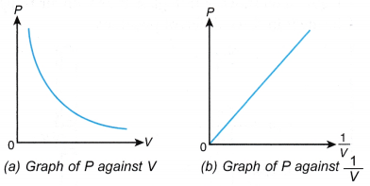

But a graph of p against 1/V looks like (b).

Conclusion: From graph (b) and from the final column of the table above:
k is a constant
$∝$means ‘proportional to’
$$p∝\frac{1}{V} \\ p=k\frac{1}{V}$$

$$pV=k$$

Using Boyle’s Law
For a sample of gas, the value of $p×V$ is always the same. This means we can write:

$$p_{1}V_{1}=p_{2}V_{2}$$

The ‘1’ values are before you change the gas. The ‘2’ values are afterwards.

Example 1
A container holds 0.2 m³ of hydrogen gas at a pressure of 200 × 10⁵ Pa. The volume of the container box is reduced to 0.08 m³. Calculate the new pressure.
Solution:
$$p_{1}V_{1}=p_{2}V_{2} \\ 200×{10}^{5}×0.2=p_{2 }×0.8 \\ p_{2}=\frac{200×{10}^{5}×0.2}{0.08} \\ p_{2}=500×{10}^{5} Pa$$

Example 2
200 cm³ of gas is expanded to 600 cm³ at a constant temperature. If the initial pressure was
1.2 x 10⁵ Pa, calculate the final pressure.

Example 3
58 cm³ of gas at a pressure of 2.5 x 10⁵ Pa is allowed to expand until the pressure reaches
2.0 x 10⁵ Pa. Calculate the new volume.

PROBLEM PRACTICE
N5 E&E page 72 questions 4-9

The Pressure-Temperature Law (or the Gay-Lussac Law)

You may be asked about this experiment in an exam – learn the details.
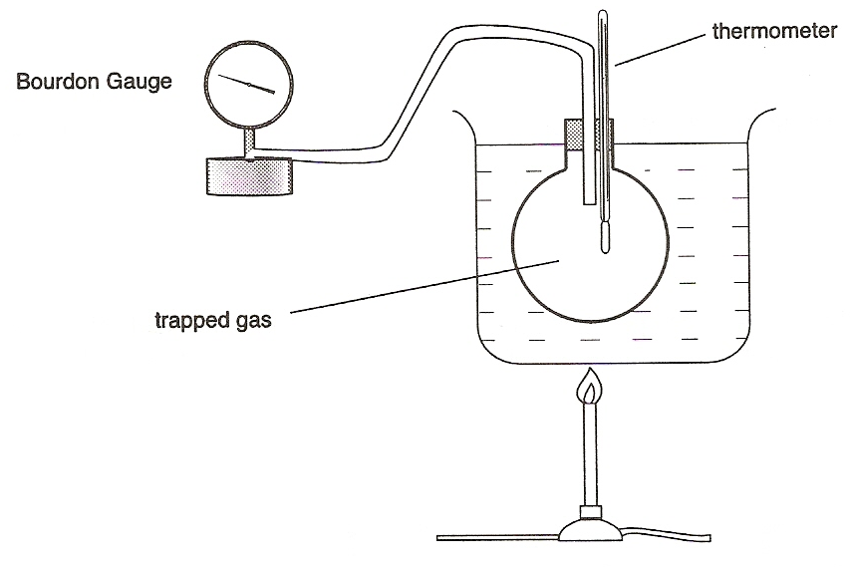

Object: To find a relationship between pressure and temperature for a fixed mass of gas at constant volume.

Procedure: In the apparatus opposite, the water is heated. This heats the gas in the flask. Pressure readings (on the Bourdon gauge) are recorded at different temperatures, as measured by the thermometer.

Typical results:

T ($℃$) | P ($×10^{5}Pa$)
20 | 1.01
30 | 1.04
40 | 1.08
50 | 1.11
60 | 1.15
70 | 1.18

Conclusion
The graph of p against T (°C) is a straight line but it does not go through the origin. If we draw the line ‘backwards’ until it meets the temperature axis, it cuts it at -273 ºC.

If we start our temperature scale at -273 ºC – and call it zero Kelvin – we have a straight line through the origin. So long as we measure temperature in Kelvin, we can write:
$∝$means ‘proportional to’
$$p= ∝T_{}$$

$$p=kT_{K}$$
k is a constant
provided V is constant and a fixed mass of gas
$$\frac{p}{T_{}}=k$$

We usually write this as:
$$\frac{p_{1}}{T_{1}}=\frac{p_{2}}{T_{2}}$$

provided T is measured in Kelvin

Example 1
An empty aerosol can contains 250 cm³ of gas at a temperature of 20 °C and a pressure of 1.5 × 10⁵ Pa. For safety reasons, the can is designed to burst when the pressure inside the can reaches 3.0 × 10⁵ Pa. Find the maximum temperature it can be safely exposed to.

Solution
The temperature needs to be converted to Kelvin:
$$T_{1}=20+273=293 K$$
Now use the Pressure Law:
$$\frac{p_{1}}{T_{1}}=\frac{p_{2}}{T_{2}}$$
$$\frac{1.5×{10}^{5}}{293}=\frac{3×{10}^{5}}{T_{2}} \\ T_{2}=\frac{3×{10}^{5}×293}{1.5×{10}^{5}}$$
$$T_{2}=\underline{586 K}=586-273=\underline{313 ℃}$$

Example 2
A sealed container is heated from 20 °C to 80 °C. If the initial pressure of the gas inside was
160 kPa, calculate the final pressure.

PROBLEM PRACTICE
N5 E&E page 73 questions 10-14

More on absolute zero and the Kelvin scale
What does ‘absolute zero’ actually mean?

At 0 degrees Kelvin, the pressure of a gas is zero. Pressure is caused by particles moving and hitting into the sides of the container. If the pressure is zero, this means the particles must have stopped moving.
Because the particles can’t move any less than ‘not moving’, zero Kelvin (or -273 ºC) is the lowest possible temperature.
This doesn’t mean it’s just the lowest temperature we can get down to – it is the lowest temperature that there can be.
Converting between ºC and K
To convert ºC to K, ADD 273. So 20 ºC = 293 K
To convert K to ºC, SUBTRACT 273. So 400 K = 137 ºC.
Convert these degrees Celsius temperatures to Kelvin:
0 ºC 30 ºC -196 ºC 850 ºC -6 ºC 4156 ºC

Convert these Kelvin temperatures to degrees Celsius:
0 K 250 K 300 K 99 K 274 K 4156 K

Charles’ Law – the link between volume and temperature

You may be asked about this experiment in an exam – learn the details.
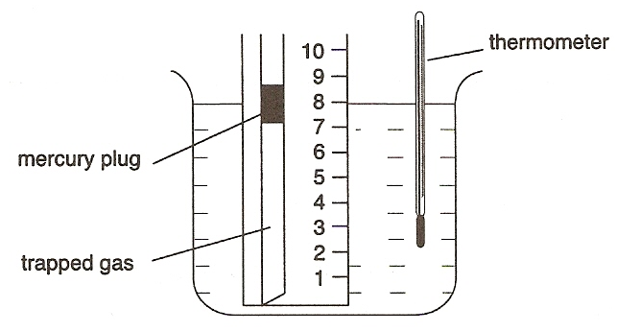
Object: To find a relationship between volume and temperature for a fixed mass of gas at constant pressure.

Procedure: In the apparatus opposite, the temperature of the water is increased, as measured on the thermometer. When heated, the gas expands and pushes the mercury plug up the tube. The linear scale gives a measure of the volume of the trapped gas.

Typical results:
T ($℃$) | V (${cm}^{3}$)
20 | 1.01
30 | 1.04
40 | 1.08
50 | 1.11
60 | 1.15

Conclusion
The graph of V against T (°C) is a straight line but it does not go through the origin. If we draw the line ‘backwards’ until it meets the temperature axis, it cuts it at -273 ºC.

If we start our temperature scale at -273 ºC – and call it zero Kelvin – we have a straight line through the origin. So long as we measure temperature in Kelvin, we can write:
$∝$means ‘proportional to’
$$V= ∝T_{}$$

$$V=kT_{}$$
k is a constant
provided p is constant and a fixed mass of gas
$$\frac{V}{T_{}}=k$$

We usually write this as:
$$\frac{V_{1}}{T_{1}}=\frac{V_{2}}{T_{2}}$$

provided T is measured in degrees Kelvin

Example 1
A syringe contains 50 cm³ of air trapped air at a temperature of 20 °C. The syringe is placed in boiling water at 100 ºC. Calculate the new volume of the trapped air if the pressure remains constant

Solution: the temperatures need to be converted to Kelvin first.
$T_{1}=20+273=293 K$ $T_{2}=100+273=373 K$

Now use Charles’ Law
$$\frac{V_{1}}{T_{1}}=\frac{V_{2}}{T_{2}} \\ \frac{50}{293}=\frac{V_{2}}{373} \\ V_{2}=\frac{50×373}{293} \\ V_{2}=\underline{63.7 cm^{3}}$$

Example 2
A fixed mass of air in a balloon, held at a constant pressure, is cooled from 100 °C. If the volume decreases from 2.0 litres to 1.5 litres calculate the final temperature of trapped air.

PROBLEM PRACTICE
N5 E&E page 74 questions 15-17

The General Gas Equation
The three gas laws can be combined into a single equation. We can use this if pressure, volume and temperature are all changing.
k is a constant
$$\frac{pV}{T}=k$$

Or:
$$\frac{p_{1}V_{1}}{T_{1}}=\frac{p_{2}V_{2}}{T_{2}}$$

Example
Helium in a sealed container was heated from 350 K to 400 K. If the gas was allowed to expand during heating from 50 cm³ to 120 cm³ and the initial pressure 4.2 x 10⁵ Pa, what was the pressure after the container was heated?

Solution: the temperature is already in Kelvin so does not need to be converted.
Use the General Gas Equation.
$$\frac{{p_{1}V}_{1}}{T_{1}}=\frac{p_{2}V_{2}}{T_{2}} \\ \frac{4.2×{10}^{5}×50}{350}=\frac{p_{2}×120}{400} \\ p_{2}=\frac{4.2×{10}^{5}×50×400}{350×120} \\ p_{2}=\underline{2.0×{10}^{5} Pa}$$

PROBLEM PRACTICE
N5 E&E page 74 qn 18

Kinetic theory
We can explain the gas laws by thinking about how the particles move.
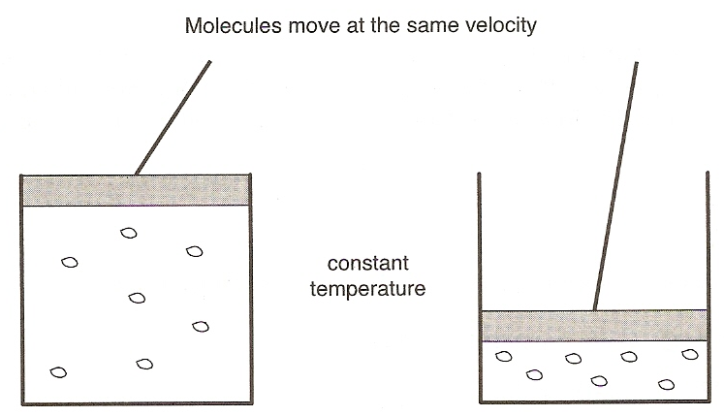
Boyle’s Law (P and V with T constant)

When a fixed mass of gas is compressed in a sealed container:

- the volume decreases
- the molecules are moving with the same velocity so they make more collisions per second with the container walls
- the force applied to walls increases and so the pressure increases.

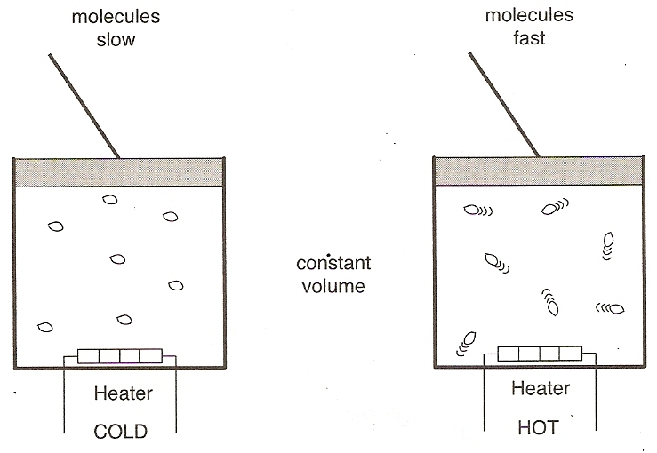
Pressure Law (P and T with V constant)

When a fixed mass of is heated in a sealed container:

- the temperature increases
- the average E_{k} of the molecules increases so the molecules move faster
- they hit the walls harder and more often
- the force applied to walls increases, so the pressure increases

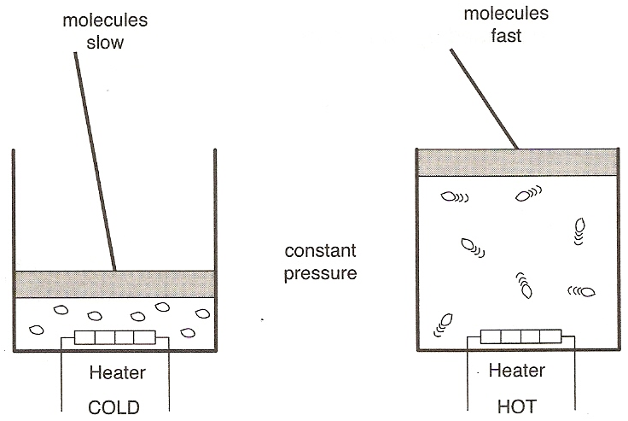
Charles’ Law (V and T with P constant)

When a fixed mass of gas is heated in a sealed container,

- the temperature increases
- the average E_{k} of the molecules increases the molecules move faster
- the gas must expand to keep the pressure the same
- the volume increases.
Use kinetic theory to explain why the pressure of a gas falls if its volume increases.

Formula sheet for National 5
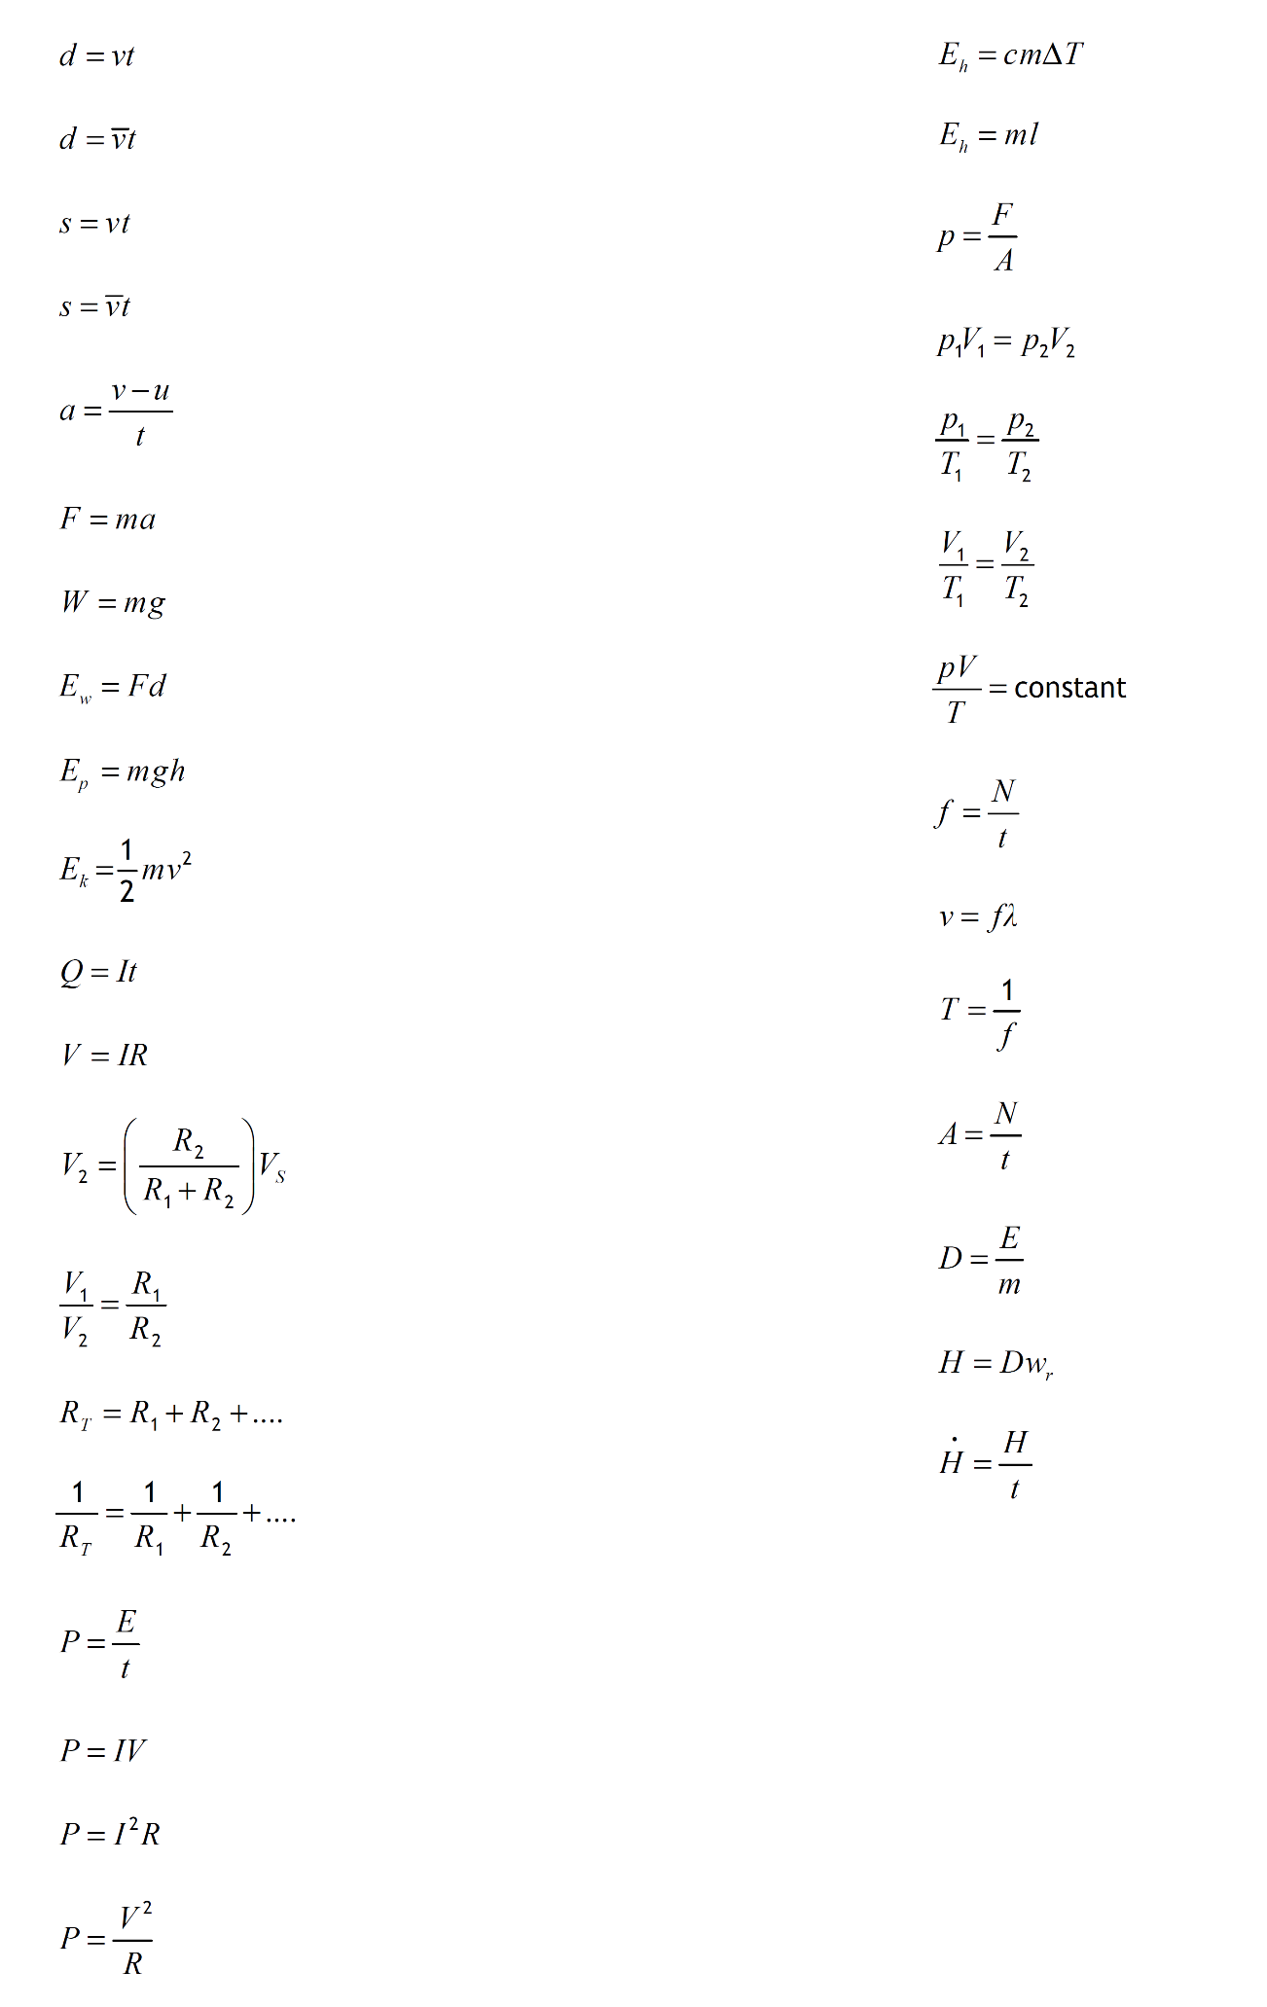
By the end of the course, you must know what each letter stands for and what its unit is.

Formulas for this unit

