Coca-Cola and Pepsi have changed the manufacturing process for their drinks to bring their products in line with new legislation regarding cancer-causing chemicals. The new process gives caramel colouring in the drinks that has less 4-methylimidazole (4-MEI), a chemical which California has added to its list of carcinogens. The structure of 4-MEI is

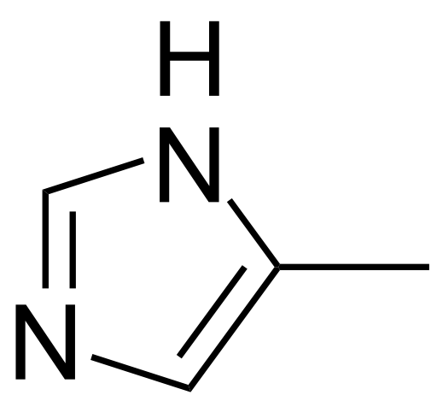

*Using your knowledge of chemistry*, write down what you can about 4-MEI.

The equation for ammonia being made from nitrogen and hydrogen is:

N2(g) + 3H2(g) 2NH3(g) ΔH° = -92.22 kJ mol-1

‘Increasing the temperature and pressure and using a catalyst will increase the value of the equilibrium constant, *K*, and so a larger yield of ammonia will be produced.’ *Using your knowledge of chemistry*, comment on this statement.

A learner doing Advanced Higher Chemistry wrote ‘There are only two types of arrows used in chemistry. The usual arrow, which represents reactants turning into products, and a double arrow, which indicates that a reaction is reversible or has reached equilibrium.’

*Using your knowledge of chemistry*, comment on the learner’s statement.

Electric sparks or arcs display blue hues of light in air. *Using your knowledge of chemistry,* comment on the reasons why this occurs.

*Using your knowledge of chemistry,* suggest a method of producing alcohols and how you could determine that you had produced this alcohol.

A mass spectroscopy experiment produced a parent ion with a mass of 156. Assume that the compound contains C, H and possibly O. *Using your knowledge of chemistry,* suggest possible molecular formulae for the ion fragment and how the actual structure could be determined by spectroscopy and/or other chemical techniques.

Titanium(IV) chloride is a colourless liquid at room temperature. It is used in the production of titanium metal and titanium dioxide.

*Using your knowledge of chemistry,* discuss the chemistry of titanium(IV) chloride and how you would determine the type of bonding present.

Chemicals in tea contribute to the colour when brewed. The colour in tea is mainly from thearubigins and tannins. However, adding lemon juice can lighten the colour and adding sodium bicarbonate can darken the colour.



2H+

Thearubigin (colourless) Thearubigin anion (coloured)

*Using your knowledge of chemistry,* suggest reasons why tea is coloured and why the colour may depend on the source of the water used.

*Using your knowledge of chemistry*, describe how to prepare a carboxylic acid and discuss the chemistry of the chosen carboxylic acid.

A compound has the formula K3[Fe(CN)6]. It has a melting point of 300°C and dissolves in water, forming a yellow solution. *Using your knowledge of chemistry,* deduce from the compound as much chemical information as you can.

Transition metals and their compounds display a variety of colours, for example when a sample of copper is held in a flame it produces a green flame test. Aqueous solutions of copper compounds are blue. Adding ammonia to these solutions gives a deeper blue colour.

*Using your knowledge of chemistry,* discuss why transition metals and their compounds behave in this way.

*Using your knowledge of chemistry,* discuss the following molecule. You may wish to discuss features such as functional groups, probable chemistry, physical properties, isomers or spectroscopic features.

