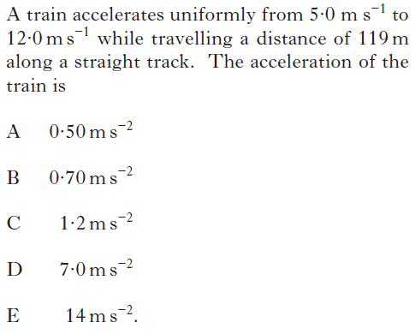
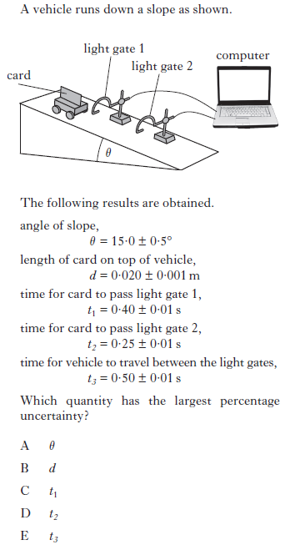
Past Paper Multiple Choice Questions by Topic - Our Dynamic Universe
1. 3.

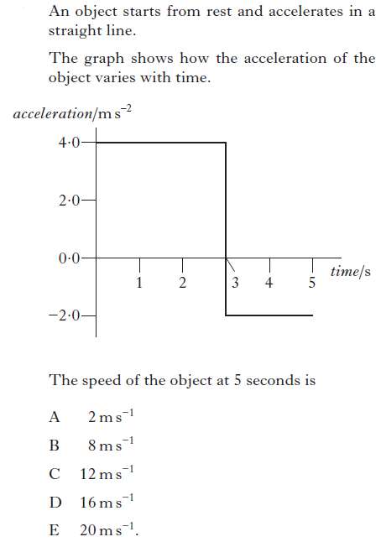
2.

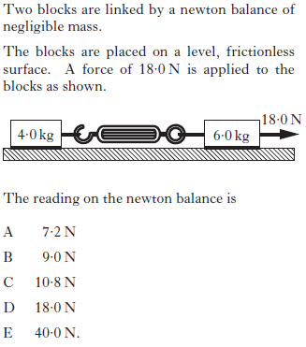
4.

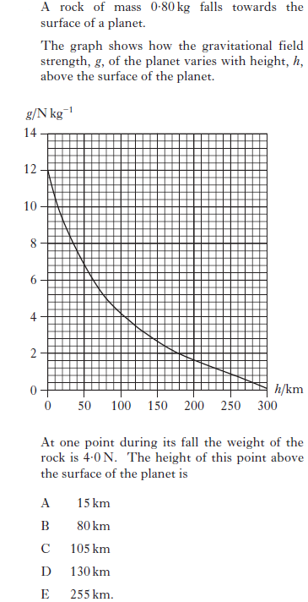
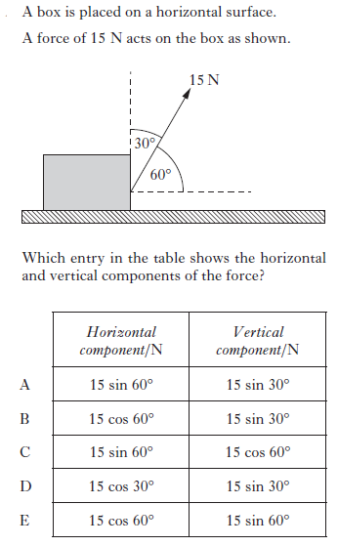
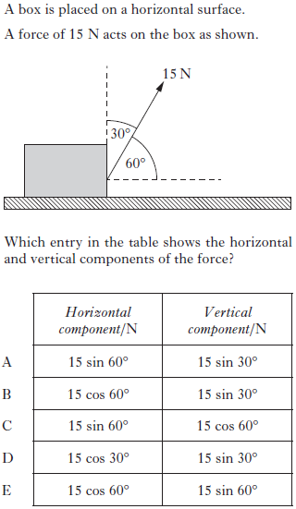
5. 7.

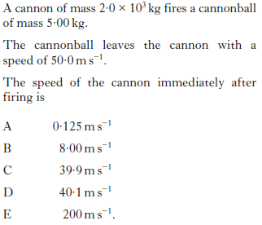
6.

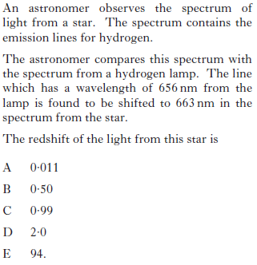
8.
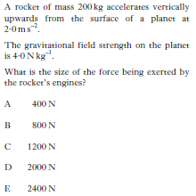
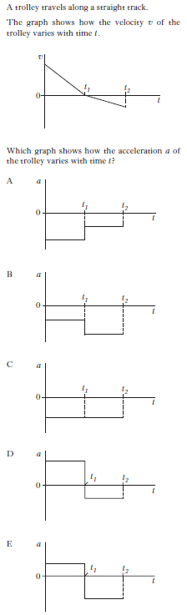
9. 10.

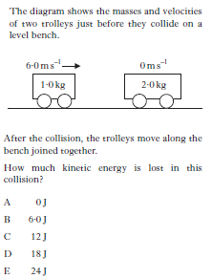
11.
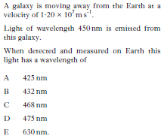
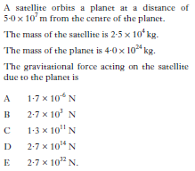
12. 15.

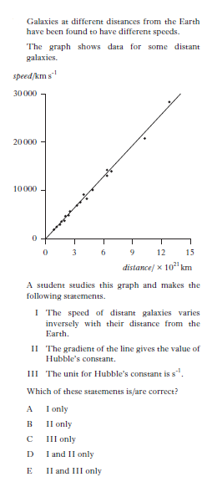
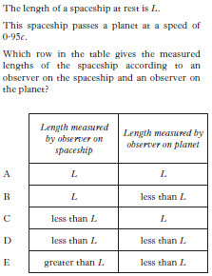
13. 16.

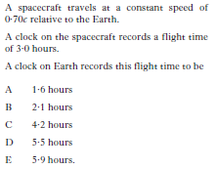
14.

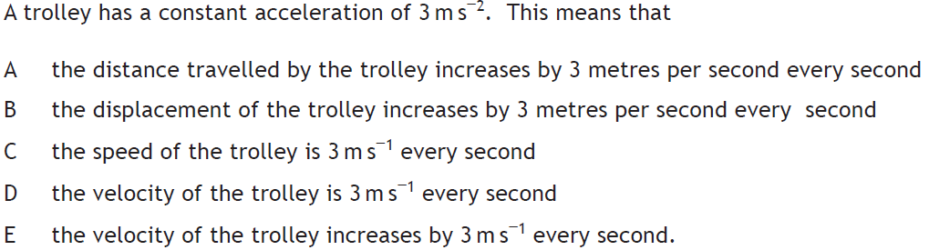
17.

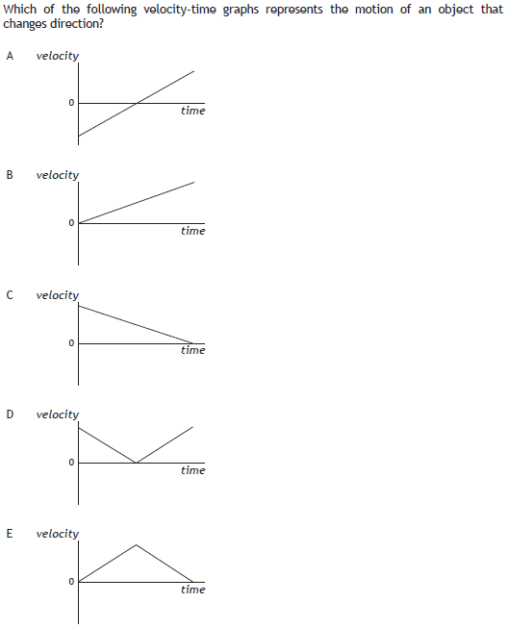
18.
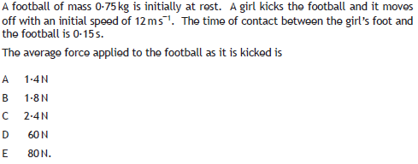
19.

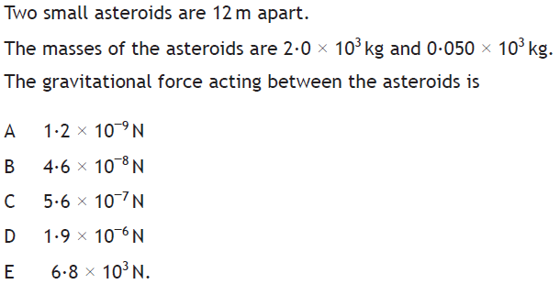
20.

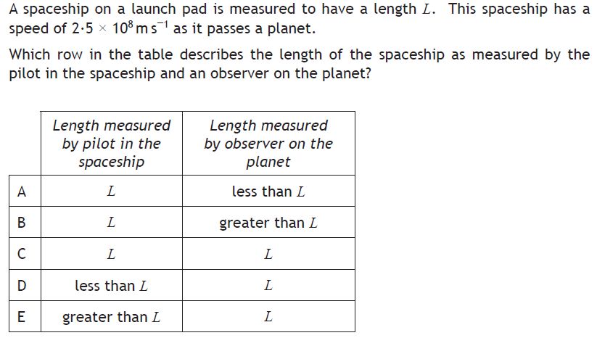
21.
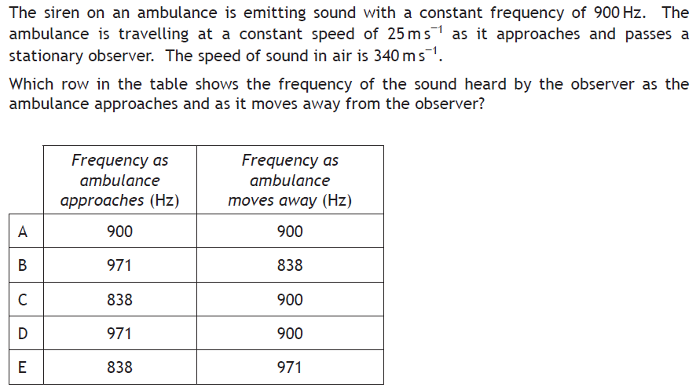
22.
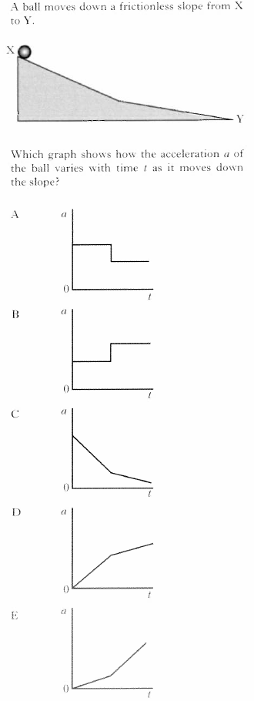
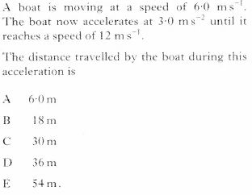
23. 22.

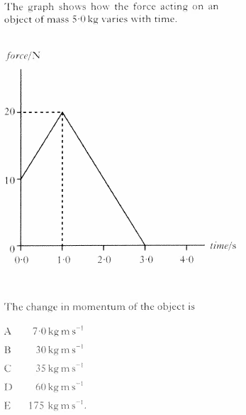
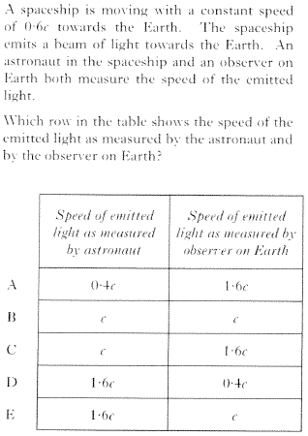
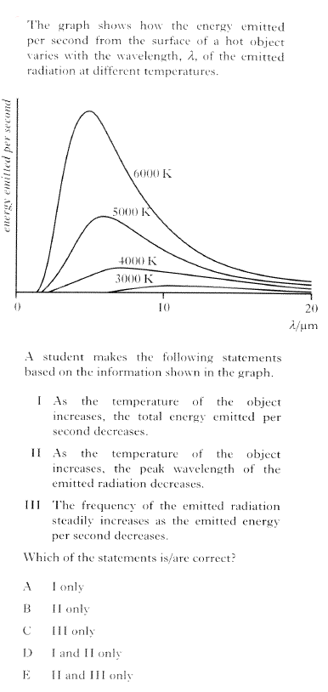
25.
26. 28.

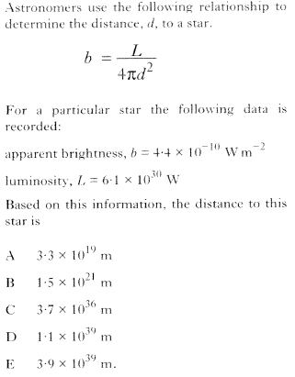
27.

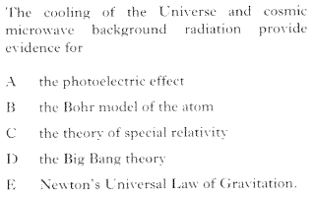
29.
Answers and Original Source of Question
Question Number | Answer | Source
1 | A | Revised Higher 2013 Q1
2 | B | Revised Higher 2013 Q2
3 | B | Revised Higher 2013 Q3
4 | A | Revised Higher 2013 Q4
5 | E | Revised Higher 2013 Q5
6 | A | Revised Higher 2013 Q6
7 | B | Revised Higher 2013 Q7
8 | A | Revised Higher 2013 Q8
9 | A | Revised Higher 2012 Q1
10 | C | Revised Higher 2012 Q2
11 | C | Revised Higher 2012 Q3
12 | B | Revised Higher 2012 Q4
13 | B | Revised Higher 2012 Q5
14 | C | Revised Higher 2012 Q6
15 | C | Revised Higher 2012 Q7
16 | E | Revised Higher 2012 Q8
17 | E | CfE Higher Specimen Q1
18 | A | CfE Higher Specimen Q2
19 | D | CfE Higher Specimen Q3
20 | B | CfE Higher Specimen Q4
21 | A | CfE Higher Specimen Q5
22 | B | CfE Higher Specimen Q6
23 |  | Revised Higher 2014 Q1
24 |  | Revised Higher 2014 Q2
25 |  | Revised Higher 2014 Q3
26 |  | Revised Higher 2014 Q4
27 |  | Revised Higher 2014 Q7
28 |  | Revised Higher 2014 Q5
29 |  | Revised Higher 2014 Q6

