**CfE Advanced Higher**

**Unit 1 – Inorganic & Physical Chemistry**

**Part 1 – Inorganic Chemistry**

**HOMEWORK BOOKLET**

**Homework – Electromagnetic Spectrum**

1. Which of the following is NOT a form of electromagnetic radiation?

A Beta radiation

B Gamma radiation

C Ultra-violet radiation

D Infra-red radiation (1)

1. Compared to visible radiation, ultra-violet radiation has

A longer wavelength and higher velocity

B higher frequency and longer wavelength

C lower frequency and shorter wavelength

D shorter wavelength and higher frequency. (1)

**3.** Which of the following lists electromagnetic radiation bands in order of increasing frequency?

A Ultraviolet, visible, infra-red, radio

B Radio, infra-red, visible, ultraviolet

C Radio, microwave, ultraviolet, visible

D Visible, ultraviolet, X-ray, microwave (1) **4.** Which area of the electromagnetic spectrum has the longest wavelength?

A Red light

B Radio waves

C X-rays

D Blue light (1)

**5.** Light from a sodium street lamp is found to have a frequency of 5.09 x 1014 Hz. Calculate the wavelength of this light in nanometres. (2)

**6.** Potassium compounds produce a lilac colour when heated in a bunsen flame. Use the data booklet to find the wavelength of the light associated with potassium and calculate the frequency of this radiation. (2)

**7.** When hydrogen is subjected to a high voltage in a gas discharge tube and the emitted light is passed through a prism the atomic emission spectrum produced is as shown below.



a. Explain how the lines on the spectrum are produced (2)

b. Which line in the spectrum is red? (1)

c. Calculate the energy, in kJ mol-1, of the line at frequency 4.6 x 1014 Hz. (2)

**8.** To cause caesium atoms on the metal surface to lose electrons energy equivalent to 200 kJ mol-1 must be supplied.

a. Calculate the wavelength of light, in nanometres, that will cause caesium to lose electrons. (2)

b. In which region of the electromagnetic spectrum will this light be found? (1)

**9.** The following technique is used to detect trace elements in steels and other alloys. The metal sample is sparked as shown in the diagram.



The output of one sample is shown below.



a. In which region of the electromagnetic spectrum do these lines lie? (1)

b. Calculate the energy, in kJ mol–1, of the line due to tin. (2)

c. Explain how this sparking procedure relates to the formation of the lines in the spectrum. (1)

Total Marks (20)

**Homework – Orbitals**

1. Which of the following values of the angular momentum quantum number represents a p orbital?

A 0

B 1

C 2

D 3

2. How many atomic orbitals make up the 4d subshell?

A 1

B 3

C 5

D 7

3. The diagram represents

A a specific p orbital

 B any p orbital

C a specific d orbital

D any d orbital.

4. Which of the following statements is correct?

A The 2s and 3s subshells are degenerate

B The 2s orbital has more energy than the 3s orbital

C There are 5 p orbitals in the second energy level

D The value of *l* for a 2s orbital is zero

5. The diagram shows how the energies of s, p, d and f orbitals are related.

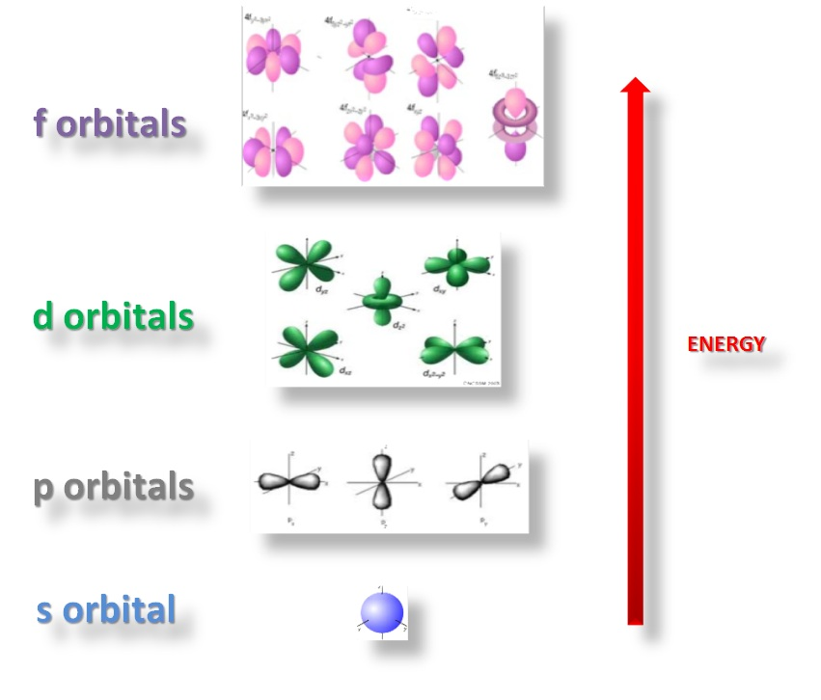 a. All 7 f orbitals are degenerate. What is meant by degenerate? (1)

b. State the maximum number of electrons the f subshell can hold. (1)

c. What are the values of the magnetic quantum number for the 3 p orbitals? (1)

d. What is the smallest value of the prinicipal quantum number in which a d subshell exists? (1)

e. In a sodium vapour lamp electrons are promoted from the 3s orbital to the 3p orbital. This requires electromagnetic radiation with a wavelength of 454 nm. Calculate the energy, in kJ mol-1, associated with light of this wavelength. (2)

6. The number of orbitals and the number of electrons in an energy level or subshell is limited**.**

(a) State the number of orbitals which make up: (i) the s subshell (1)

(ii) the d subshell. (1)

(b) State the number of electrons that are needed to completely fill:

(i) the p subshell (1)

(ii) the first energy level (1)

(iii) the third energy level. (1)

(c) State the number of subshells in the fourth energy level. (1)

7. The table shows four sets of quantum numbers.

***n l m s***

A 2 1 0 - ½

B 3 3 +2 + ½

C 1 0 0 - ½

D 4 2 -2 + ½

a. Explain which set of numbers is not allowed according to quantum theory. (2)

b. Which set of numbers represents an s subshell? (1)

c. Which set of numbers could belong to a hydrogen atom in its ground state? (1)

Total marks (20)



**Homework – Transition Metals**

**1.** Copy the diagram of the Periodic Table and mark on it ‘s’, ‘p’ and ‘d’ to show which type of orbital is being filled in each part of the table.



(1)

2. Write the electron configuration in terms of s, p and d electrons for the following atoms and ions

a. V b. V3+ c. S2- d. Mn4+ e. Cr

f. Ca g. Br- h. Zn2+ i. Cr6+ j. Fe2+ (10)

3. The statement that “an orbital can accommodate, at most, two electrons, and if so, they must be of opposite spin” is based on

A Hund’s rule

B the Pauli exclusion principle

C the aufbau principle

D the Heisenberg uncertainty principle (1)

4. An atom has the electronic configuration

1s2 2s2 2p6 3s2 3p1

What is the charge of the most likely ion formed from this atom?

A -1 B +1 C +2 D +3 (1)

5. The number of unpaired electrons in a gaseous Ni2+ ion is

A 0 B 2 C 4 D 6 (1)

6. An atom of iron contains 26 electrons.

Which of the following diagrams below correctly represents the distribution of electrons in the 3d and 4s orbitals in an atom of iron in its ground state?



(1)

7. According to the aufbau principle, electrons fill orbitals in the order

A 1s 2s 2p 3s 3p 4s 4p 3d

B 1s 2s 2p 3s 3d 3p 4s 4p

C 1s 2s 2p 3s 3p 3d 4s 4p

D 1s 2s 2p 3s 3p 4s 3d 4p. (1)

8. A detector in a Geiger counter contains argon which ionises when nuclear radiation passes through it.

a. Write the electronic configuration for argon in terms of s and p orbitals. (1)

b. The first ionisation energy of argon is 1530 kJ mol−1.

(i) Calculate the wavelength of the radiation, in nm, corresponding to this energy. (2)

(ii) Write the equation for the first ionisation of argon. (1)

Total marks (20)

**Homework – Quantum Numbers**

1. Using your knowledge of chemistry discuss the following electronic configuration.

1s2 2s2 2p6 3s2 3p6 3d6 4s2 (3)

2. How many atomic orbitals make up

a. the 3d subshell

b. the 5p subshell

c. the 3 energy level

d. the second energy level? (4)

3. Suggest a set of values for the four quantum numbers n,l,m and s for an electron in the 2p subshell of an oxygen atom in its ground state. (1)

4. a. Explain why the first ionisation energy of potassium is less than the first ionisation energy of lithium. (1)

b. Explain why the first ionisation energy of potassium is less than the first ionisation energy of calcium. (1)

5. Which one of the following processes requires the largest input of energy?

A He(g) He+(g) + e-

B Ne(g) Ne+(g) + e-

C Na(g) Na+(g) + e-

D Ca(g) Ca+(g) + e- (1)

6. The second ionisation energy for calcium is represented by the equation

A Ca(s) Ca2+(g) + 2e-

B Ca(g) Ca 2+(g) + 2e-

C Ca+(s) Ca2+(g) + e-

D Ca+(g) Ca2+(g) + e- (1)

7. Which one the following sets of ionisation energies corresponds to an element in group two of the Periodic Table

  1st 2nd 3rd 4th 5th

A 580 1800 2700 11600 14800

B 1520 2700 3900 5800 7200

C 790 1600 3200 4400 16100

D 740 1500 7700 10500 13600 (1)

8. The electronic configurations, **X** and **Y**, for two uncharged atoms of sodium are as follows.

**X** 1s2 2s2 2p6 3s1

**Y** 1s2 2s2 2p6 4s1

Which of the following statements is true?

A **X** is an excited state.

B Both **X** and **Y** have vacant 2d orbitals.

C Energy is absorbed in changing **Y** to **X**.

D Less energy is required to ionise **Y** compared to **X** (1)

9. The electronic configurations, in spectroscopic notation, of nitrogen and oxygen in their ground states are shown below.

Nitrogen 1s2 2s2 2p3

Oxygen 1s2 2s2 2p4

a. (i) Draw the electronic configurations, using orbital box notation, for both nitrogen and oxygen. (2)

(ii) Use the orbital box notation for nitrogen’s 2p subshell to illustrate Hund’s rule (1)

(iii) Use the orbital box notation for oxygen’s 2p subshell to illustrate the Pauli exclusion principle. (1)

b. (i) Write an equation which represents the first ionisation energy of oxygen. (1)

(ii) Explain why the first ionisation energy of oxygen is less than that of nitrogen. (1)

Total marks (20)

**Homework – Oxidation States and Complexes**

1. What is the oxidation number of manganese in the ion MnO42- ?

A -2

B +4

C +6

D +7

2. In which of the following reactions does the oxidation state of copper remain the same?

A Zn + CuSO4 → ZnSO4 + Cu

B CuSO4  + Na2CO3 → 2NaCl + CuCO3

C FeCl2 + CuCl2 → FeCl3 + CuCl

D Cu + 4HNO3 → Cu(NO3)2 + 2H2O + 2NO2

3. Which of the following could **not** act as a ligand?

A Na+

B Cl-

C H2O

D NH3

4. The correct formula for the tetraamminedichlorocopper(II) complex is

A [Cu(NH3)4Cl2]2−

B [Cu(NH3)4Cl2]

C [Cu(NH3)4Cl2]2+

D [Cu(NH3)4Cl2]4+.

5. The correct name for the complex ion [Fe(CN)6]4- is

A tetracyanoiron(II)

B tetracyanoferrate(IV)

C hexacyanoiron(IV)

D hexacyanoferrate(II).

6. The coordination number of cobalt in the complex [Co(NH3)4 Cl2]Cl is

A 1

B 2

C 4

D 6.

7. The oxidation number of iron in the complex ion [Fe(OH)(H2O)5]2+ is

A +2

B +3

C +5

D +6.

Questions 8,9 and 10 concern the complex ion shown below.

8. What shape is this complex ion?

A Square planar

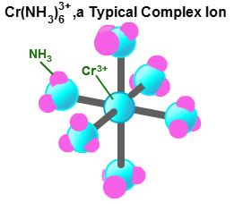 B Tetrahedral

C Octahedral

D Triganol bipyramid

9. The name of this complex ion is

A hexaminechromium(II)

B triamminechromium(VI)

C hexaamminechromium(III)

D triamminechromate(III)

10. The electronic configuration of chromium in this complex ion is

A 1s2 2s2 2p6 3s2 3p6 3d2

B 1s2 2s2 2p6 3s2 3p6 3d3

C 1s2 2s2  2p6 3s2 3p6 3d4

D 1s2 2s2 2p6 3s2 3p6 3d5.

11. Solutions of some complex ions are acidic. For example, an aqueous solution of iron chloride can have a pH of 3.0. One of the processes occurring is:

Fe(H2O)6]3+ + 3Cl–(aq) + H2O(l) [Fe(H2O)5OH]2+ + H+(aq) + 3Cl–(aq)

a. Name the two ligands in the complex structure on the right of the equation above. (1)

b. Draw a diagram showing the shape of the complex ion on the left of the equation and name its shape. (2)

c. Use the oxidation number of iron in the reactant and product to explain whether this reaction is a redox reaction. (2)

12. Name the following transition metal complexes.

a. [Cr(OH)6]3- b. [Co(NH3)6]Cl3 c. [Cu(NH3)4(H2O)2]2+

d. [Pt(NH3)4]2+ e [Fe(Br)6]4- (5)

Total marks (20)

**Homework – Complexes and Colour**

1. The diagram shows the relative energies of the 3d orbitals of a transition metal before and after it complexes with a ligand.

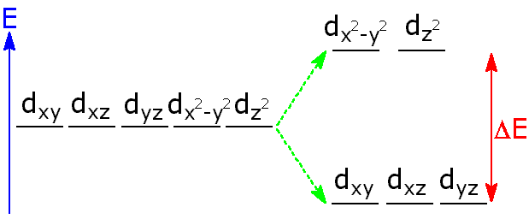

Use your knowledge of chemistry to explain this diagram and why this is important in the observed colours of some transition metal complexes. (3)

2. Brenda was trying to find the concentration of a blue copper(II) sulfate solution using colorimetry.

She made a series of standard solutions and found their absorbance values.

|  |  |  |  |
| --- | --- | --- | --- |
| Test Tube | 0.20 mol l-1 CuSO4/cm3 | H2O/cm3 | Concentration/mol l-1 |
| 1 | 2.0 | 8.0 | w |
| 2 | 4.0 | 6.0 | x |
| 3 | 6.0 | 4.0 | y |
| 4 | 8.0 | 2.0 | z |

The results were used to construct a calibration graph from which the concentration of Brenda’s solution could be found.

a. Suggest how Brenda would have prepared the solution in test tube 1? (1)

b. Calculate the concentrations w, x, y and z (1)

c. What colour filter should be chosen for use in the colorimeter? (1)

d. Brenda’s unknown solution had an absorbance of 0.21.

(i) Suggest why the graph shows a small absorbance when the concentration of the solution is zero. (1)

(ii) Calculate the concentration of the unknown solution. (2)

0.1

0.2

0.3

0.4

0.5

Absorbance

Concentration/mol l-1

Equation of line : Y = 1.65 X + 0.008

e. Brenda noticed that when she added some concentrated ammonia to her solution that it changed colour. Suggest why the colour of the solution changed. (1)

3. The table below gives information about complex ions containing vanadium.

|  |  |
| --- | --- |
| **Ion** | **Colour** |
| [V(H2O)6]2+ | Violet |
| [V(H2O)6]3+ | Green |
| [VO]2+ | Blue |
| [VO2]+ |  |

a. Determine the oxidation number of vanadium in the ions [VO2]+ and [V(H2O)6]2+. (2)

b. Draw the shape of the green complex ion [V(H2O)6]3+. What name is given to this shape? (2)

c. (i) Give the electronic configuration for vanadium in the [VO2]+ ion. (1)

(ii) Suggest why you would predict this ion to be colourless. (1)

d. Light of wavelength varying from 400 to 700 nm is passed through a solution containing [VO]2+ ions. Copy the axes shown below and draw the absorption spectrum that you would expect to obtain. (Page 14 of your Data Booklet may be helpful.)



% Absorbance

(1)

4. The graph shows the visible spectrum obtained from a solution containing the hexachlorochromate(III) complex ion.

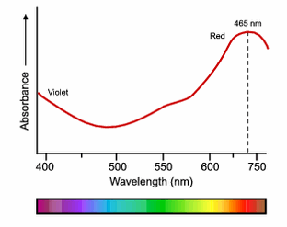a. Write the formula for this complex ion. (1)

b. Predict the colour of this complex ion. (1)

c. Copy the axes and the line shown opposite.

Draw a dotted line to show the absorption of a more concentrated solution of this complex ion. (1)

Total marks (20)

**Homework – Shapes**

1. What is the change in the three dimensional arrangement of the bonds around the oxygen atom in the following reaction?

H2O + H+ H3O+

A Non-linear to pyramidal

B Linear to pyramidal

C Linear to tetrahedral

D Non-linear to tetrahedral

2. The following diagram represents a square planar structure.

 Which of the following species could have a square planar structure?

A SF4

B NH4+

C XeF4

D AlH4-

3. In which of the following molecules will all the bond angles be 90 degrees?

A H2O

B NH3

C CH4

D SF6

4. Which of the following species have the same number of valence shell electron pairs?

A NH4+ and CH4

B NH4+ and BF3

C BF3 and NH3

D PF5 and BF4-

5. Which shape best describes the arrangement of electron pairs around the central iodine atom in the I3- ion?

A Linear

B Tetrahedral

C Trigonal bipyramid

D Octahedral

6. Which of the following diagram best represents the arrangement of electron pairs in the IF4- ion? Note that represents a lone pair of electrons

.

A B



 C D



7. What is the likely structure of an antimony(V) chloride molecule?

A Linear

B Tetrahedral

C Trigonal bipyramidal

D Octahedral

8.

a. What is the arrangement of **electron pairs** around the iodine atom in IF5? (1)

b. By considering the electron pairs in both molecules, explain why the bond angle in BF3 is greater than the bond angle in NH3. (1)

9. Thetable below gives information about three compounds containing chlorine.

|  |  |  |
| --- | --- | --- |
| **Chlorine compound** | **Shape** | **Bond angle** |
| BCl3(g) |  | 120° |
| CCl4(l) | Tetrahedral | 109.5° |
| NCl3(g) | Pyramidal | 107° |

a. State the shape of the BCl3 molecule? (1)

b. In terms of electron-pair repulsions, account for the difference in bond angle between the C and Cl in CCl4 and between the N and Cl in NCl3. (2)

c. Sketch the **shape** of the NCl3 molecule. (1)

10. Chlorine and fluorine react to produce a compound of formula ClF3. This molecule contains three chlorine–fluorine single bonds. Each fluorine atom contributes **one** electron to the bonding.

a. How many electron pairs (both bonding and non-bonding) surround the central chlorine atom in the molecule?(1)

b. What would be the three-dimensional arrangement of electron pairs (both bonding and non-bonding) around the chlorine atom? (1)

c. The fluorine atoms may occupy different positions in this shape, giving rise to three possible shapes for the molecule. Draw two of these shapes. (2)

11. Simple molecules can have a variety of molecular shapes. Use your knowledge of chemistry to discuss the reasons why molecules have different shapes. (3)

Total marks (20)