Past Paper Multiple Choice Questions by Topic - Electricity
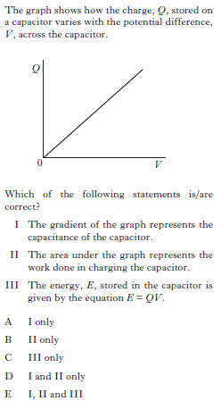
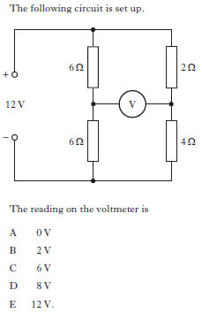
1. 3.

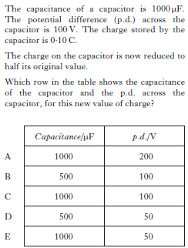
2.

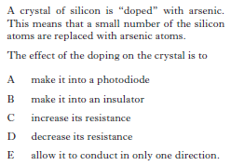
4.

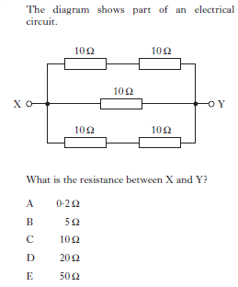
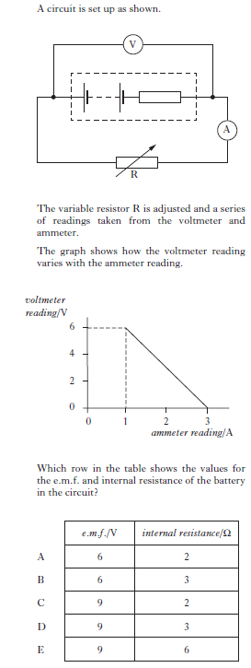
5. 6.

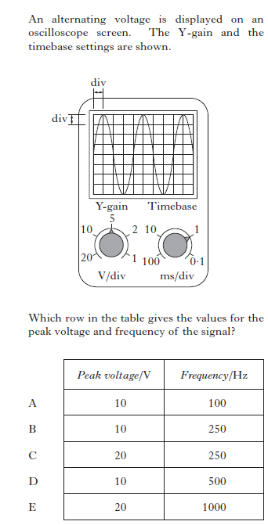
7.

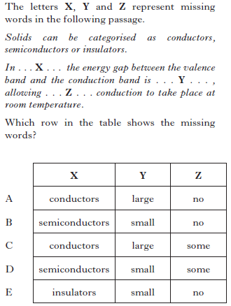
8.

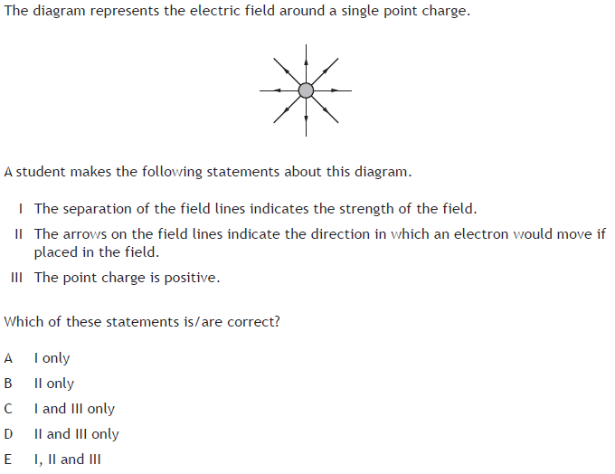
9.

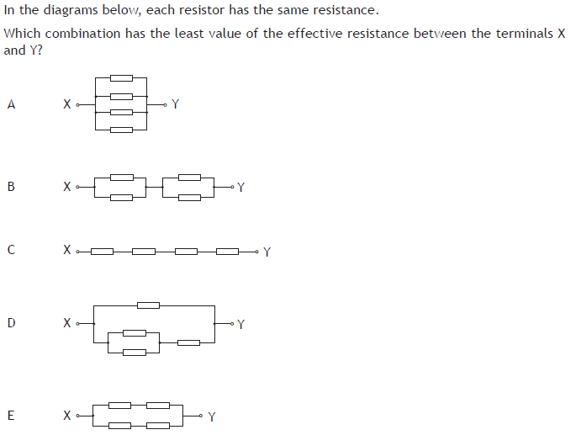
10.

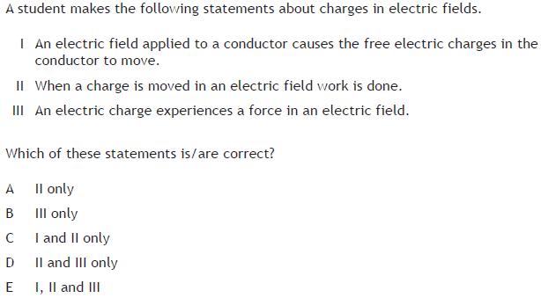
11.
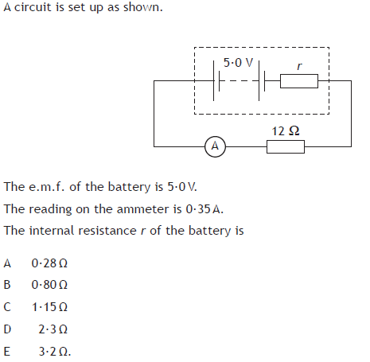
12.

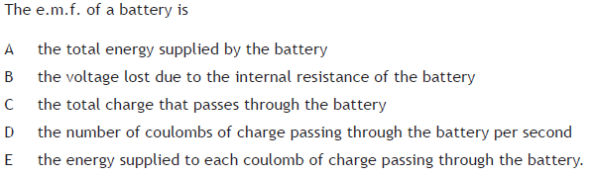
13.

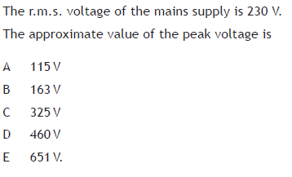
14.
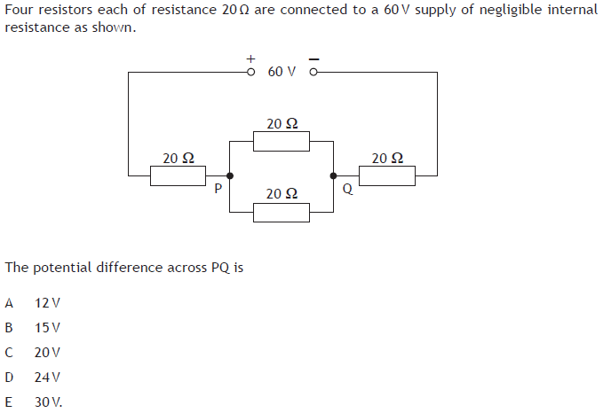
15.

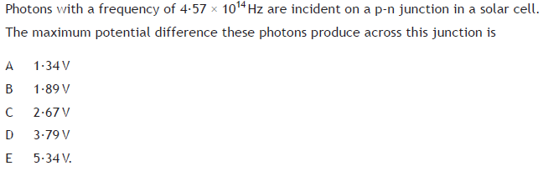
16.

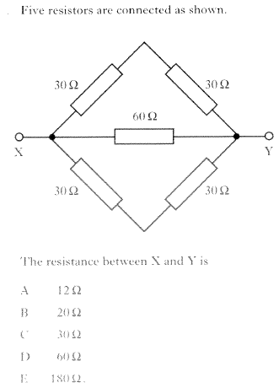
17.

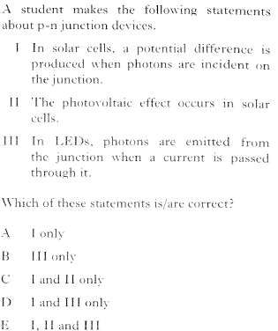
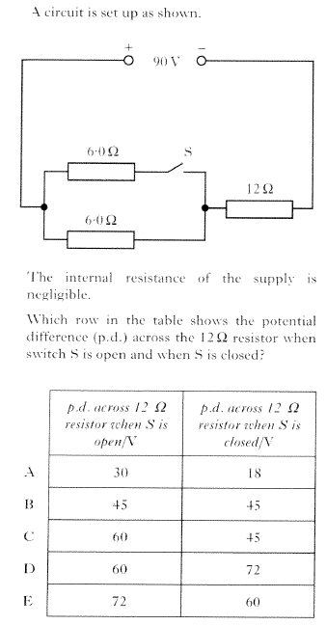
18. 20.

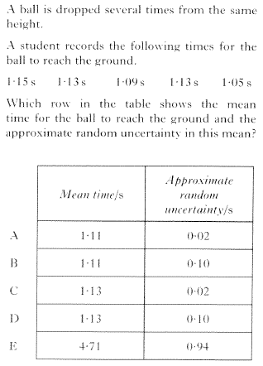
21.

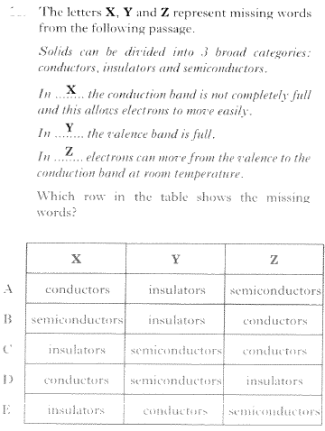
19.
Answers and Original Source of Question
Question Number | Answer | Source
1 | B | Revised Higher 2013 Q17
2 | E | Revised Higher 2013 Q18
3 | D | Revised Higher 2013 Q19
4 | D | Revised Higher 2013 Q20
5 | D | Revised Higher 2012 Q17
6 | B | Revised Higher 2012 Q18
7 | C | Revised Higher 2012 Q19
8 | D | Revised Higher 2012 Q20
9 | C | CfE Higher Specimen Q13
10 | A | CfE Higher Specimen Q14
11 | E | CfE Higher Specimen Q15
12 | D | CfE Higher Specimen Q16
13 | E | CfE Higher Specimen Q17
14 | C | CfE Higher Specimen Q18
15 | A | CfE Higher Specimen Q19
16 | B | CfE Higher Specimen Q20
17 |  | Revised Higher 2014 Q16
18 |  | Revised Higher 2014 Q17
19 |  | Revised Higher 2014 Q18
20 |  | Revised Higher 2014 Q19
21 |  | Revised Higher 2014 Q20
22

