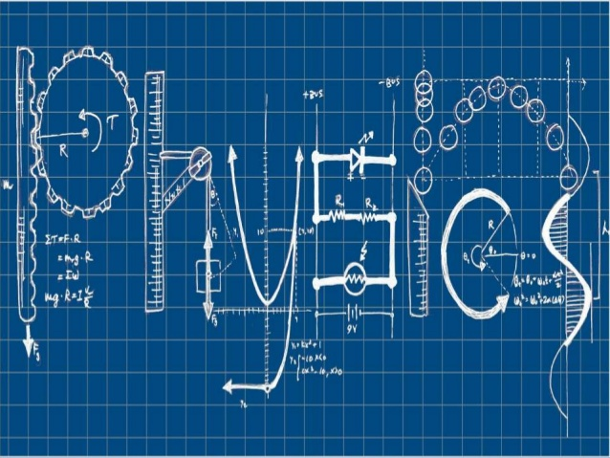National 5 Physics at Leith Academy

**Electricity**

**Name: _________________________**

**What you should know from S3**

We’ll be reviewing all the key material, but there are things you did in the S3 Physics course that you’ll need in this unit.

If you didn’t do the S3 Physics course, you’ll have to work that bit harder.

Grade your own knowledge – where do you think you are at the moment?

|  |  |  |  |
| --- | --- | --- | --- |
| **Key content** | ☹ | 😐 | ☺ |
| I can recognise and draw basic circuit symbols. |  |  |  |
| I know the difference between series and parallel circuits. |  |  |  |
| I know that current is a measure of the flow of charge around a circuit. |  |  |  |
| I know the unit for current and the name of the measuring device. |  |  |  |
| I know that voltage is a measure of the energy given to the charges in a circuit. |  |  |  |
| I know the unit for voltage and the name of the measuring device. |  |  |  |
| I know that resistance is a measure of the opposition to the flow of charge. |  |  |  |
| I know the unit for resistance and the name of the measuring device. |  |  |  |
| I can use Ohm’s Law: $V=IR$ |  |  |  |

My grade in the last unit was: D / C / B / A

My target grade for the end of this unit is: D / C / B / A

To achieve this grade I need to:

_____________________________________________________________________

_____________________________________________________________________

_____________________________________________________________________

**Electric charge and current**

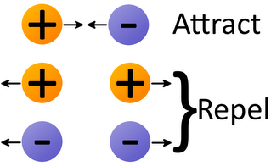**Types of charge**Electric charge comes in two types – positive and negative.

Positive charges repel (push away) other positive charges.

Negative charges repel other negative charges.

Positive charges and negative charges attract each other.

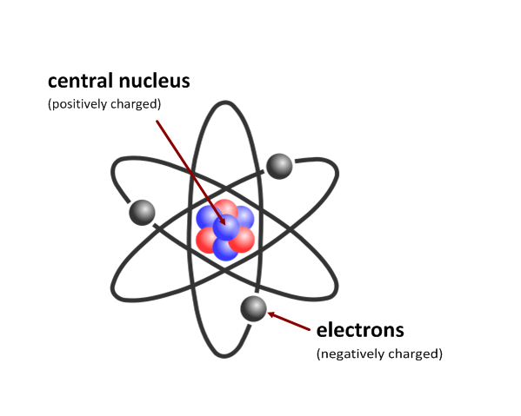**Charges in atoms**  
The atom is made up of a central part called the nucleus, containing protons, which are positively charged, and neutrons. It is surrounded by orbiting electrons which are negatively charged. It is these electrons which move when electricity flows.

Conductors – like silver and copper - have many free electrons, which can move easily. The better the conductor the easier it is for the electrons to move.

Insulators – like wood or plastic - have very few free electrons, which cannot move easily.

**Charge and current**

Electric current is…

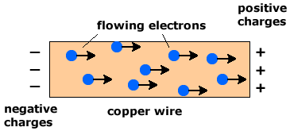

**Current calculations**

Because current is amount of electric charge transferred per unit time, we can write:

What does each letter stand for?

What is the correct unit?

$$Q= It$$

*Q* =

*I* =

*t* =

**Example 1**  
How much charge flows through a lamp in 3.0 seconds if the current in the lamp is 2.5 amperes?

$$Q=It \\ =2.5×3.0 \\ =\underline{ 7.5 C}$$

**Example 2**  
50 coulombs of charge flow through a heater in 10 seconds. What is the current in the heater?

Solution

**Example 3**  
An ammeter at a point in a circuit reads 45 A. How much time does it take for 105 mC of charge to flow through the ammeter?

Solution

PROBLEM PRACTICE

N5 E&E pages XX questions M - N 13

**a.c. and d.c.**

a.c. stands for ____________________________________.

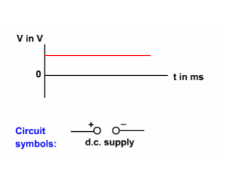d.c. stands for ____________________________________.

In d.c., the electrons flow around the circuit in **one direction** only.

A battery is an example of a d.c. supply where the voltage remains constant.

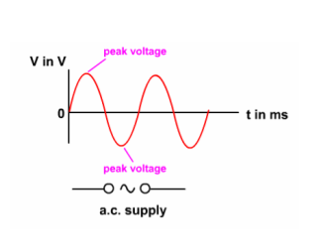

In a.c., the flow of electrons regularly **changes direction**, often many times a second.

In the common form of a.c. the voltage varies from zero to a peak voltage in one direction, back to zero, then to a peak voltage in the opposite direction.

**a.c., d.c. and oscilloscope traces**Use an oscilloscope to look at three sources – d.c, d.c. reversed and a.c.

Sketch the traces in the boxes.

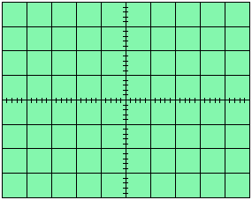 d.c. d.c. reversed a.c.

In the UK, a.c. supplies complete 50 full cycles per second. This is why mains frequency in the UK is 50 Hz.

In some countries, such as the USA, mains frequency is 60 Hz.

**Charges in electric fields**

Just like planets have gravitational fields around them, charged particles have electric fields around them

Gravitational fields apply a force to masses – **electric fields apply a force to charged particles**.

This force can make the particle move. The path it follows depends on the electric field.

**Between two oppositely charged parallel plates**

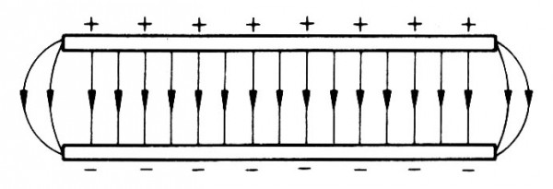

The field lines between the two plates are parallel (though they bend a bit at the ends). This means the field is **uniform** – the same – everywhere between the plates.

An electron (negative charge) in this field would move ________________.

A proton (positive charge) in this field would move _______________.

**Near a single point charge**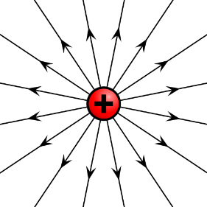The field around a point charge is called **radial** field – the field lines look like bicycle spokes.

The arrows on the field lines show what would happen if a positive test charge was placed in the field.

The greater the distance from the charge, the weaker the electric field.

A positive charge placed in this field would move __________________ the point charge.

A negative charge placed in this field would move _________________ the point charge.

**Between two oppositely charged points**

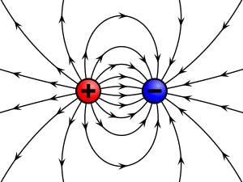What would happen to a positive charge placed at X?

X

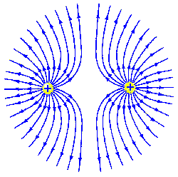**Between two like charged points**

What would happen to a positive charged particle placed at X?

X

**Potential difference**

Electrical supplies – like power packs and batteries – give energy to the charge carriers that move around the circuit.

Potential difference measures how much energy the supply gives to each coulomb of charge.

If we use a 9 V battery in a circuit – then it gives 9 joules of energy to each coulomb of charge. We say that the battery has a **potential difference** of 9 V.

The words potential difference and voltage are often used interchangeably. We might talk about the ‘voltage across a resistor’ or the ‘potential difference across a resistor’.

**Example**6 coulombs of charge pass through a battery. The battery gives the charge a total of 72 J of energy. Calculate the potential difference of the battery.

Solution

**Reviewing current and voltage rules**  
You did this stuff at least once and possibly twice in S1-S3. But unless you know it well, you’ll never be able to analyse circuits – so let’s take a quick look.

**Series circuits**  
A series circuit has only one __________.

Build the following series circuit and measure the current and voltage at the points shown.

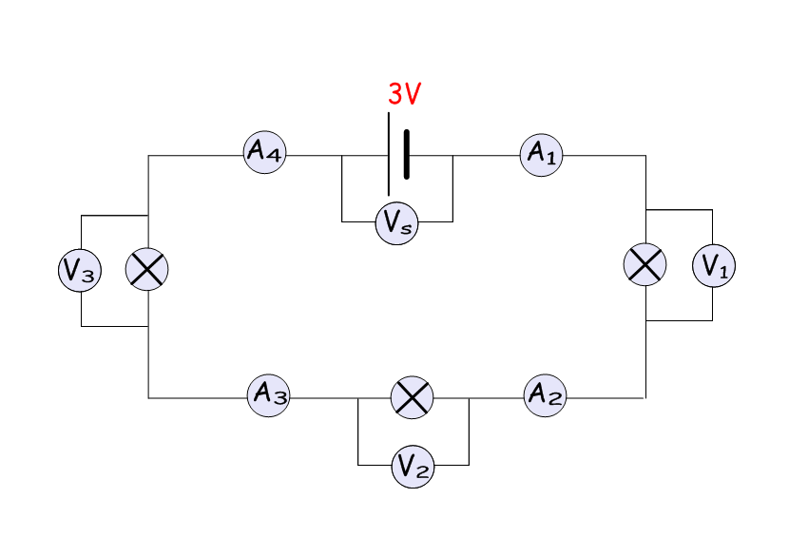

|  |  |
| --- | --- |
| Position | Current (A) |
| A1 |  |
| A2 |  |
| A3 |  |
| A4 |  |

|  |  |
| --- | --- |
| Position | Voltage (V) |
| V1 |  |
| V2 |  |
| V3 |  |
| VS |  |

What do you notice about the currents?

________________________________________________________________________________

What do you notice about the voltages (potential differences)?

________________________________________________________________________________

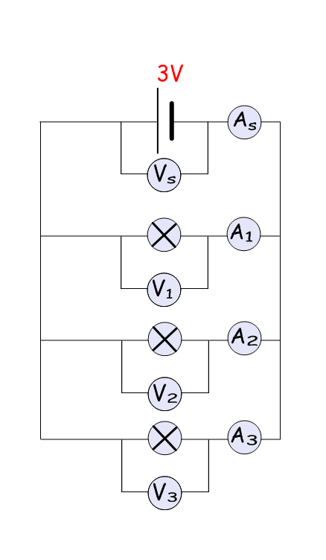**Parallel circuits**

A parallel circuit has more than one __________.

|  |  |
| --- | --- |
| Position | Current (A) |
| A1 |  |
| A2 |  |
| A3 |  |
| As |  |

|  |  |
| --- | --- |
| Position | Voltage (V) |
| V1 |  |
| V2 |  |
| V3 |  |
| VS |  |

What do you notice about the currents?

_____________________________________________________________________________

What do you notice about the voltages (potential differences)?

________________________________________________________________________________

**Summary**

|  |  |
| --- | --- |
| **Series** | |
| In a series circuit, the current is the same at all points. | The sum of voltages across components in series is equal to the voltage of the supply. |
| **Parallel** | |
| The sum of currents in parallel branches is equal to the current drawn from the supply. | The voltage across the branches in a parallel circuits is the same for each component. |

**Resistance**

Charge flowing through a wire doesn’t get it all its own way. Anything in a circuit - like bulbs and wires – will **resist** the current.

The more it resists, the higher its **resistance**.

Resistance is measured in ohms ().

Components called resistors are specially designed to have certain amounts of resistance.

What differences would you notice between Circuit 1 and Circuit 2?

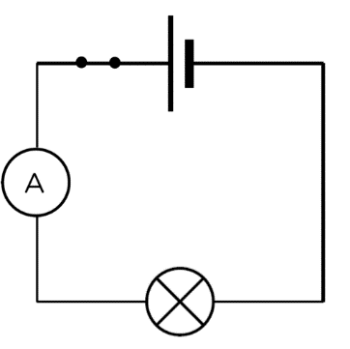 

10  WX

20  WX

Circuit 1 Circuit 2

I would notice that …

**Resistor combinations**  
We can combine resistors in series or in parallel.

Resistors in **series** is so easy we won’t spend much time on it. Quite simply, you **add up** the resistances.

$$R_{TOTAL}=R_{1}+R_{2}+R_{3}$$

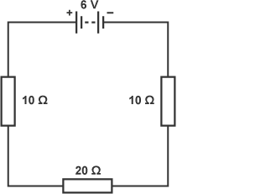

Calculate the total resistance of this circuit.

Solution

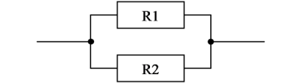**Resistors in parallel**  
This is a bit trickier, so we’ll do an experiment.

Use an ohmmeter to measure different combinations of resistors in parallel. Record your results in the table and measure the resistance of the combination

|  |  |  |  |
| --- | --- | --- | --- |
| **Test** | **R1 ()** | **R2 ()** | **RTOTAL ()** |
| 1 | 15 | 15 |  |
| 2 | 22 | 22 |  |
| 3 | 47 | 47 |  |
| 4 | 15 | 22 |  |
| 5 | 15 | 47 |  |
| 6 | 22 | 47 |  |

Now complete the table below, using a calculator to work out the ‘one overs’. RT = RTOTAL

|  |  |  |  |  |
| --- | --- | --- | --- | --- |
| **Test** | $$\frac{1}{R_{1}}$$ | $$\frac{1}{R_{2}}$$ | $$\frac{1}{R_{1}}+\frac{1}{R_{2}}$$ | $$\frac{1}{R_{T}}$$ |
| 1 |  |  |  |  |
| 2 |  |  |  |  |
| 3 |  |  |  |  |
| 4 |  |  |  |  |
| 5 |  |  |  |  |
| 6 |  |  |  |  |

What do you notice? Can you write it as a formula?

**Resistors in parallel calculations**

To calculate the total resistance of a number of resistors in parallel, we use:

$$\frac{1}{R_{T}}=\frac{1}{R_{1}}+\frac{1}{R_{2}}+…$$

Example: Calculate the total resistance, RT, of the following sets of resistors when:

R1 = 6 Ω; R2 = 4 Ω

R1 = 20 Ω; R2 = 16 Ω

R1 = 400 Ω; R2 = 200 Ω

R1 = 600 Ω; R2 = 400 Ω; R3 = 100 Ω

R1 = 8 Ω; R2 = 4 Ω; R3 = 4 Ω

**Some useful shortcuts**

For two resistors in parallel:

If both resistors are the **same** value, the total is **half** of one of them.

So a 20  and a 20  in parallel have a total resistance of 10 .

You can also use this formula if you find it easier. It’s **not** on the formula sheet and it only works for **two** resistors in parallel.

$$R_{T}=\frac{R_{1}×R_{2}}{R_{1}+R_{2}}$$

Use this formula to find the total resistance of these combinations.



40 

460 

460 

6 k

4 k

700 

230 

12 

**Ohm’s Law**

Ohm’s Law looks at the relationship between the two basic quantities in electricity – voltage (potential difference) and current. This leads to the idea of the third basic quantity – resistance.

You looked at Ohm’s Law in S3, but it’s so important we’ll take another look now. **You could be asked in an exam to describe this experiment.**

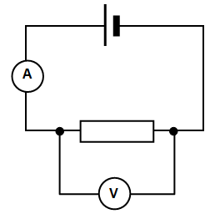**Experiment**: how does the potential difference across a resistor affect the current in the resistor.

Set up the circuit as shown. Use a power supply rather than a battery.

Vary the potential difference across the resistor by turning the control on the power supply. Record the current in the resistor at different potential differences.

|  |  |
| --- | --- |
| **potential difference (V)** | **current (A)** |
| 1.0 |  |
| 2.0 |  |
| 3.0 |  |
| 4.0 |  |
| 5.0 |  |
| 6.0 |  |
| 7.0 |  |
| 8.0 |  |
| 9.0 |  |

Draw a line graph of the potential difference against the current. Make sure you draw a single **line of best fit**.

**Conclusion**:

________________________________________________________________________________

________________________________________________________________________________

**Analysing the graph**

If things went well, your graph should have given a best fit straight line passing through the origin.

This means that current in the resistor is **directly proportional** to the potential difference across the resistor. If you double the potential difference – you get double the current, and so on.

We can write this as:

∝ means “proportional to”

$$V∝I$$

This means that:

$$V=I ×a constant value$$

This constant value is *R*, the resistance of the resistor.

So:

$$V=I×R$$

When a graph of an experiment gives a straight line through the origin, this also means that the gradient of the graph gives the value of the y-axis quantity divided by the x-axis quantity.

So the gradient of your graph gives the value of $V/I$

But this is the resistance, R.

**So, the gradient of a V-I graph gives the value of the resistance**.

Calculate the gradient of the best fit line on your graph to get the value of the resistance.

Use whatever method you have learned in Maths for finding the gradient of a straight line.

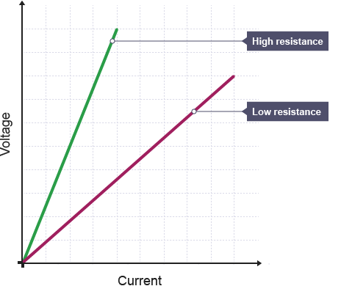**Ohmic and non-ohmic conductors**

An ohmic conductor is a component that obeys Ohm’s Law. A graph of potential difference against current (a voltage-current graph) gives a straight line with a positive gradient. The steeper the gradient, the higher the resistance will be.

**Voltage-current graphs for two ohmic resistors**

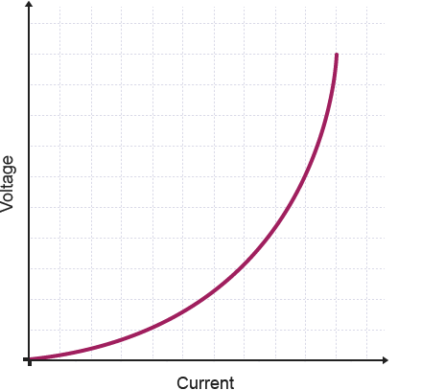**Non-ohmic conductors**A bulb is an example of a **non-ohmic** conductor. Its voltage-current graph does not follow a straight line. Instead, it gives a curve with an increasing gradient. It shows that the resistance increases as the current increases.

**The voltage-current graph for a non-ohmic resistor is curve**

**Why does the resistance increase with temperature?**Imagine walking down a corridor full of people. They get in your way – so they resist your movement. If they stand still, then you can still get past fairly easily. But if they dash about in all direction, it will make it much harder for you to move along the corridor.

This is what happens in the filament wire of the bulb. As the voltage increases and the wire heats up, the atoms in the wire. This makes the atoms vibrate more and more. This makes it more difficult for the electrons to move along the wire – so the resistance increase.

Old-fashioned filament lightbulbs always ‘pop’ when you switch them on. They never stop working once they are on. Can you explain why? Think about the temperature of the wire and what that means for the resistance and the current.

**Circuit symbols**

|  |  |  |
| --- | --- | --- |
| symbol | name | what it does |
|  |  |  |
|  |  |  |
|  |  |  |
|  |  |  |
|  |  |  |
|  |  |  |
|  |  |  |
|  |  |  |
|  |  |  |
|  |  |  |
|  |  |  |
|  |  |  |
|  |  |  |
|  |  |  |
| Image result for diode symbol |  |  |
| Image result for led symbol |  |  |
|  |  |  |
|  |  |  |

You should know the function of several of these components by now. Complete the sentences to check:

A _________________ provides electrical energy.

A _________________ converts electrical energy into light energy.

A _________________ can be used to turn on or off the flow of charge in a circuit.

A _________________ resists the current in a circuit.

A _________________ is used to measure potential difference (voltage).

An _________________ is used to measure current.

A _________________ converts electrical energy into kinetic energy.

A _________________ converts sound energy into electrical energy.

A _________________ converts electrical energy into sound energy.

**The photovoltaic cell**

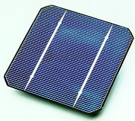A photovoltaic cell is often just called a solar cell.

It converts ___________ energy to _____________ energy.

**The fuse**

When a wire carries an electric current, it heats up. If the wire gets hot enough, it will melt.

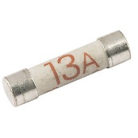

We make use of this in fuses. A fuse is a short length of wire in a cartridge. If the current through the wire gets too high, the wire melts. This cuts off the current.

A fault in an electrical appliance, like a kettle, can cause it to take too high a current. If we didn’t use fuses, the overheating flex could set fire to the plastic coating. So fuses are safety devices that prevent flexes from overheating.

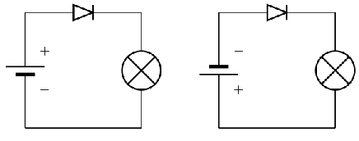

**The diode**

Set up these two circuits.

What happens when you reverse the connections to the diode?

So what does a diode do?

Which way round should the circuit symbol be if a diode is working? Come up with a way to remember this.

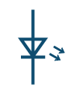**The LED**

LED stands for Light Emitting Diode.

Like a diode, it is a low current device. It is destroyed by high currents. This means we need to fit a series resistor to LEDs to reduce the current to a safe level.

Here is how we work out the value of the resistor.

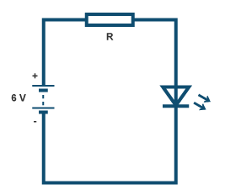**Example 1**: Calculate the size of resistor needed to protect the LED.

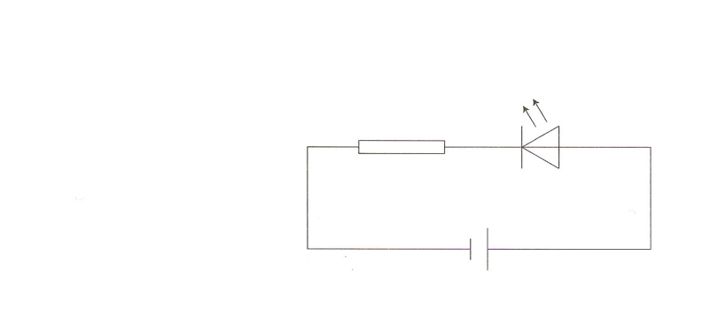

LED properties:

Maximum voltage = 2 V

Maximum current = 20 mA

Supply voltage = 6 V

First work out the voltage across the resistor; remember it is a series circuit.

$$V_{R}=V_{S}-V_{LED (max)} \\ V_{R}=6-2 \\ V_{R}=4 V$$

Therefore the resistor will have to have a maximum of 4 V across it and 20 mA through it. We can now use Ohm’s Law to calculate the value of the resistor.

$$R=\frac{V}{I} \\ =\frac{4}{{20×10}^{-3}}$$

$$=\underline{200 Ω}$$

A resistor with a minimum value of 200 Ω must be chosen to protect the LED.

**Example 2**: Calculate the size of resistor needed to protect an LED rated at 2 V, 100 mA, connected to a 9 V battery.

**The capacitor**

A capacitor consists of two metal plates separated by an insulator. It’s a device which can store electric charge.

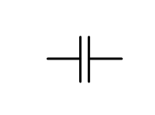

A discharged capacitor has no voltage across its plates. When a capacitor is charging up, the voltage across the plates takes time to rise to the supply voltage. The voltage across a fully charged capacitor is equal to the supply voltage.

The time it takes for a capacitor to charge can be altered in two ways:

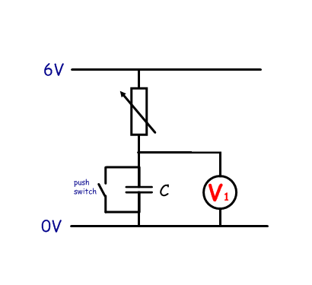

1. Value of the capacitor - the bigger the capacitance the longer it takes to charge.

2. The size of the charging current - the larger the current the shorter the time for the capacitor to charge. The current is usually altered by using a variable resistor.

**The thermistor**

The thermistor is a special type of resistor. Its resistance varies depending on its temperature. The higher the temperature, the lower the resistance.

Remember this as **TURD** – **T**emperature **U**p **R**esistance **D**own.

**The LDR**

LDR stands for Light Dependent Resistor. Its resistance varies depending on the light level. The higher the light level, the lower the resistance.

Remember this as **LURD** – **L**ight **U**p **R**esistance **D**own.

Name some devices that might use thermistors or LDRs

**The relay**  
The relay is a switch that is operated by a magnetic field.

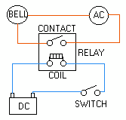When the first circuit is complete, the current in the coil causes it to become magnetised. This pulls shut the switch in the second circuit.

This means we can use a low current circuit to control a high current circuit.

In this example, pressing the switch in the low current DC circuit will turn on the bell in the high current AC circuit.

**Questions**

1. What device could you use to power a calculator?

________________________________________________________________________________

2. What device might be used in the light sensor of a digital camera?

_______________________________________________________________________________

3. Why might you find a capacitor in the circuit for a pedestrian crossing light? (Think about what happens when you press the button.)

________________________________________________________________________________

4. You build a circuit with a diode. The circuit doesn’t come on. What should you check?

________________________________________________________________________________

5. What happens to the resistance of a thermistor if you put it in the fridge?

_______________________________________________________________________________

6. Why do we fit a resistor in series with an LED?

________________________________________________________________________________

**Potential dividers**

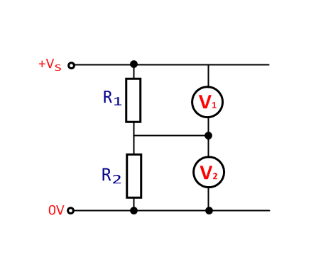A potential divider is a way of dividing up the voltage (potential) from a supply. This means we can get exactly the voltage we need to operate a circuit.

In a potential divider circuit, the voltage across a resistor is related to its resistance. **The higher the resistance of a resistor, the higher the voltage across it.**

Because a potential divider circuit is a series circuit, the current passing through both resistors is the same.

Equations:

$$V_{1}=\frac{R_{1}}{R_{1}+R_{2}}×V_{S}$$

$$\frac{V_{1}}{V_{2}}=\frac{R_{1}}{R_{2}}$$

Example 1: Calculate the voltage across the 90 kΩ resistor in the following circuit.

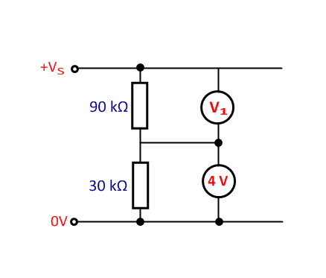

$$\frac{V_{1}}{V_{2}}=\frac{R_{1}}{R_{2}} \\ \frac{V_{1}}{4}=\frac{90×{10}^{3}}{30×{10}^{3}} \\ V_{1}=\frac{4×90×{10}^{3}}{30×{10}^{3}} \\ =\underline{ 12 V}$$

Example 2: Calculate the voltage across the 600 Ω resistor in the following circuit.

$$V_{2}=\frac{R_{2}}{R_{1}+R_{2}}×V_{S} \\ =\frac{600}{(1.8×{10}^{3}+600)}×6 \\ =\underline{ 1.5 V}$$

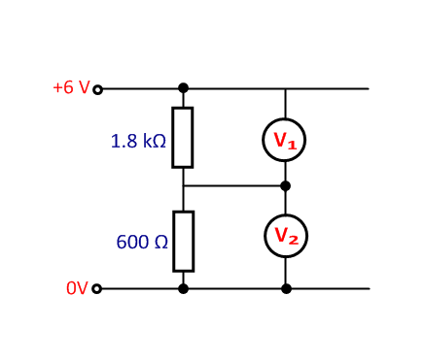

Example 3: Calculate the voltage across the 90 kΩ resistor in the following circuit.

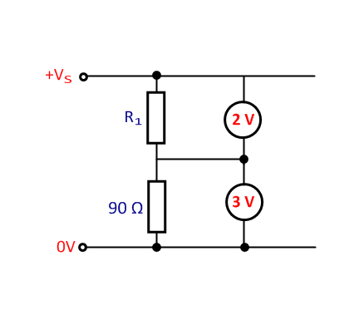

Example 4: Calculate the voltage across the 2 kΩ resistor in the following circuit.

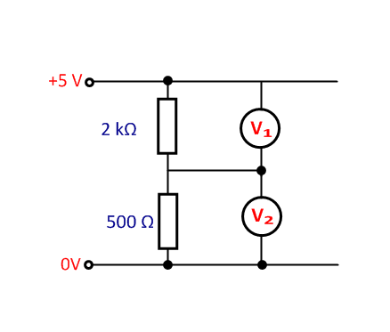

Example 5: Describe the changes to the voltmeter readings (V1 & V2) if

1. the temperature increases
2. the resistance of the variable resistor R1 is increased

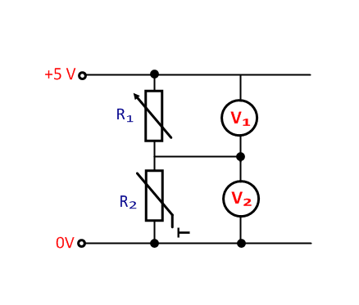

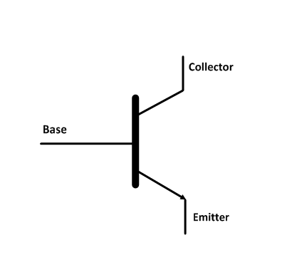**Transistor circuits**

**NPN transistor**

A transistor can be used as a switch.

If a high enough voltage is applied to the base of the transistor, then current flows beteen the collector and emitter.

The ‘switch-on’ voltage for an NPN transistor is about 0.7 V.

**Using transistors in circuits**

Transistors are often used in switching circuits. Here’s one.

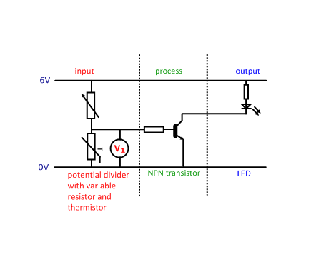

As the temperature goes down, the resistance of the thermistor goes ______.

This means the thermistor takes a ______________ share of the supply voltage. (This is V1.)

If the voltage goes __________ 0.7 V, the transistor switches _____.

This means the LED will __________.

A circuit like this could be used to switch on a heating system when a room gets too cold.

Here’s a similar circuit. Note that the thermistor and variable resistor have been swapped round.

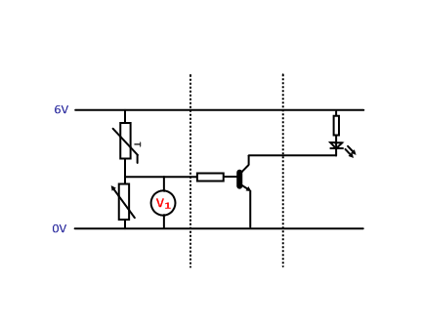

As the temperature goes up, the resistance of the thermistor goes _________.

This means the thermistor takes a ______________ share of the supply voltage.

This means the voltage across the variable resistor (this is V1) gets _____________.

If the voltage goes __________ 0.7 V, the transistor switches _____.

This means the LED will __________.

Can you think of a practical use for this type of circuit?

________________________________________________________________________________

This circuit uses an LDR

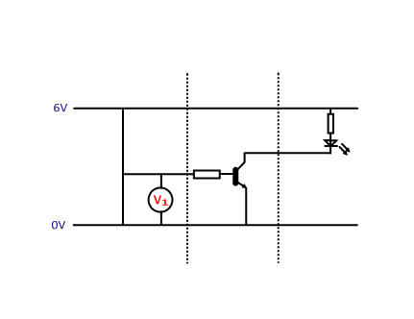

Can you explain how it works?

________________________________________________________________________________

________________________________________________________________________________

A practical use?

________________________________________________________________________________

**What’s the variable resistor for?**

Adjusting the variable resistor allows you adjust when the circuit switches on and off.

For example, in the circuit on page 24, the variable resistor acts as a thermostat. When you increase the resistance of the variable resistor the voltage across it will also increase. In order for the voltage across the thermistor to now reach 0.7 V the temperature will now have to fall further to increase its resistance more. This means the heating now comes on at a lower temperature.

Increasing the resistance of the variable resistor will have the opposite effect and turn the heating on at a higher temperature.

**MOSFETs**

Metal Oxide Semiconductor Field Effect Transistors are a different type of transistor. They ‘switch on’ at a higher voltage – about 2 V. They can handle bigger output current than NPN transistors, so can run bulbs and motors.

base

collector

emitter

s—source

g—gate

d—drain

MOSFET transistor

NPN transistor

Here is a circuit using a MOSFET

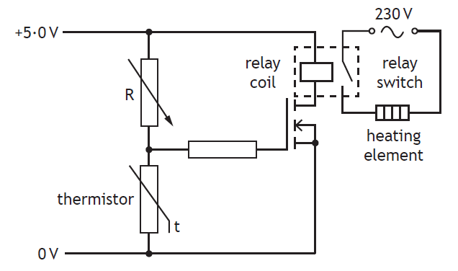

As the temperature falls, the resistance of the thermistor rises.

This means the voltage across the thermistor rises.

When it goes above 2 V, the MOSFET switches on.

This operates the relay, closing the switch in the 230 V circuit, which turns on the heating element.

**Power**Power is a measure of the rate at which energy is transferred.

Electrical devices are labelled with their power ratings. For example an 12 watt (12 W) light bulb uses 12 joules of electrical energy every second, converting it to 12 joules of light and heat energy.

If you run a 12 W bulb 10 seconds, it uses 120 joules of energy.

Because power is the amount of energy transferred per unit time, we can write:

$$P= \frac{E}{t}$$

*P* =

*E* =

*t* =

What does each letter stand for?

What is the correct unit?

**Example 1**  
Calculate the power of a lamp which uses 500 J of energy in 25 seconds.

$$P=\frac{E}{t} \\ =\frac{500}{25} \\ =\underline{ 20 W}$$

**Example 2**  
An electric heater uses 60 kJ of energy in 30 seconds. Calculate its power rating.

Solution

**Example 3**  
A 3.5 W motor is left running for 4 minutes. How much energy does it use?

Solution

**Electrical power**

Electrical power is the rate at which electrical energy is transferred. It depends on both the current and the potential difference (voltage).

The higher the voltage, the brighter a bulb. The higher the current, the brighter a bulb. So:

What does each letter stand for?

What is the correct unit?

$$P= IV$$

*P* =

*I* =

*V* =

**Example 1**  
Calculate the power of a lamp which runs at 12 V and takes a current of 2.5 A.

$$P=IV \\ =2.5×12 \\ =\underline{ 30 W}$$

**Example 2**  
A 230 V kettle draws a current of 8.5 A. Calculate its power rating.

Solution

**Example 3**  
A 0.5 W bulb uses a current of 20 mA. Calculate the potential difference (voltage) across the bulb.

Solution

**Alternative power formulas**

We can derive alternative formulas for power if we combine $P=IV$ with Ohm’s Law, $V=IR$.

Knowing that $I=\frac{V}{R}$ gives:

$$P=IV \\ P=\left(\frac{V}{R}\right)×V \\ P= \frac{V^{2}}{R}$$

Knowing that $V=IR$ gives:

$$P=IV \\ P=I×\left(IR\right) \\ P= I^{2}R$$

To summarise:

$$P=IV$$

$$P=I^{2}R$$

$$P=\frac{V^{2}}{R}$$

Where: *P is power measured in watts (W)*

*I is current measured in amperes (A)*

*V is potential difference measured in volts (V)*

*R is resistance measured in ohms (Ω)*

**Example 1**: Calculate power rating of a 230 V microwave that draws 3.7 A from the mains supply.

$$P=IV \\ =3.7×230 \\ =\underline{ 850 J}$$

**Example 2**: Calculate the power rating of a 230 V toaster if its elements have a resistance of *44 Ω*.

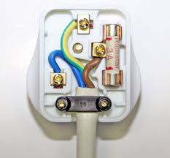**Fuses**Plugs have fuses fitted in them. If an appliance – like a TV – starts to draw too high a current, the thin wire in the fuse will melt and cut off the current. This stops the flex from overheating and possibly causing a fire.

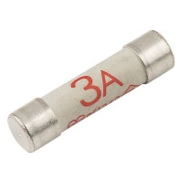Fuses come in different ratings – the size of current needed to melt the wire. The two most common fuses are 3 A and 13 A.

**Using the correct fuse – the fuse rule**If an appliance has a power rating of **less** than 720 W – use a **3 A** fuse.

If an appliance has a power rating **greater** than 720 W – use a **13 A** fuse.

**Using the correct fuse – doing the maths**  
We can use $P=IV$ to work out which fuse to use.

**If the appliance uses a current that is less than 3 A, then use a 3 A fuse.**

**If the current is between 3 A and 13 A, then use a 13 A fuse.**

**Example 1:** What fuse should be fitted to a 800 W hoover that operates from the 230 V mains?

$$P=IV$$ 800 $=I×230$ $$I=\underline{ 3.5 A}$$

*So a* ***13 A*** *fuse is needed.*

**Example 2**: What fuse should be fitted to a 520 W food mixer?

These two approaches don’t quite agree. Try calculating the fuse needed for a 700 W appliance. How does that compare with the ‘fuse rule’?

Notes

**Formula sheet for National 5**

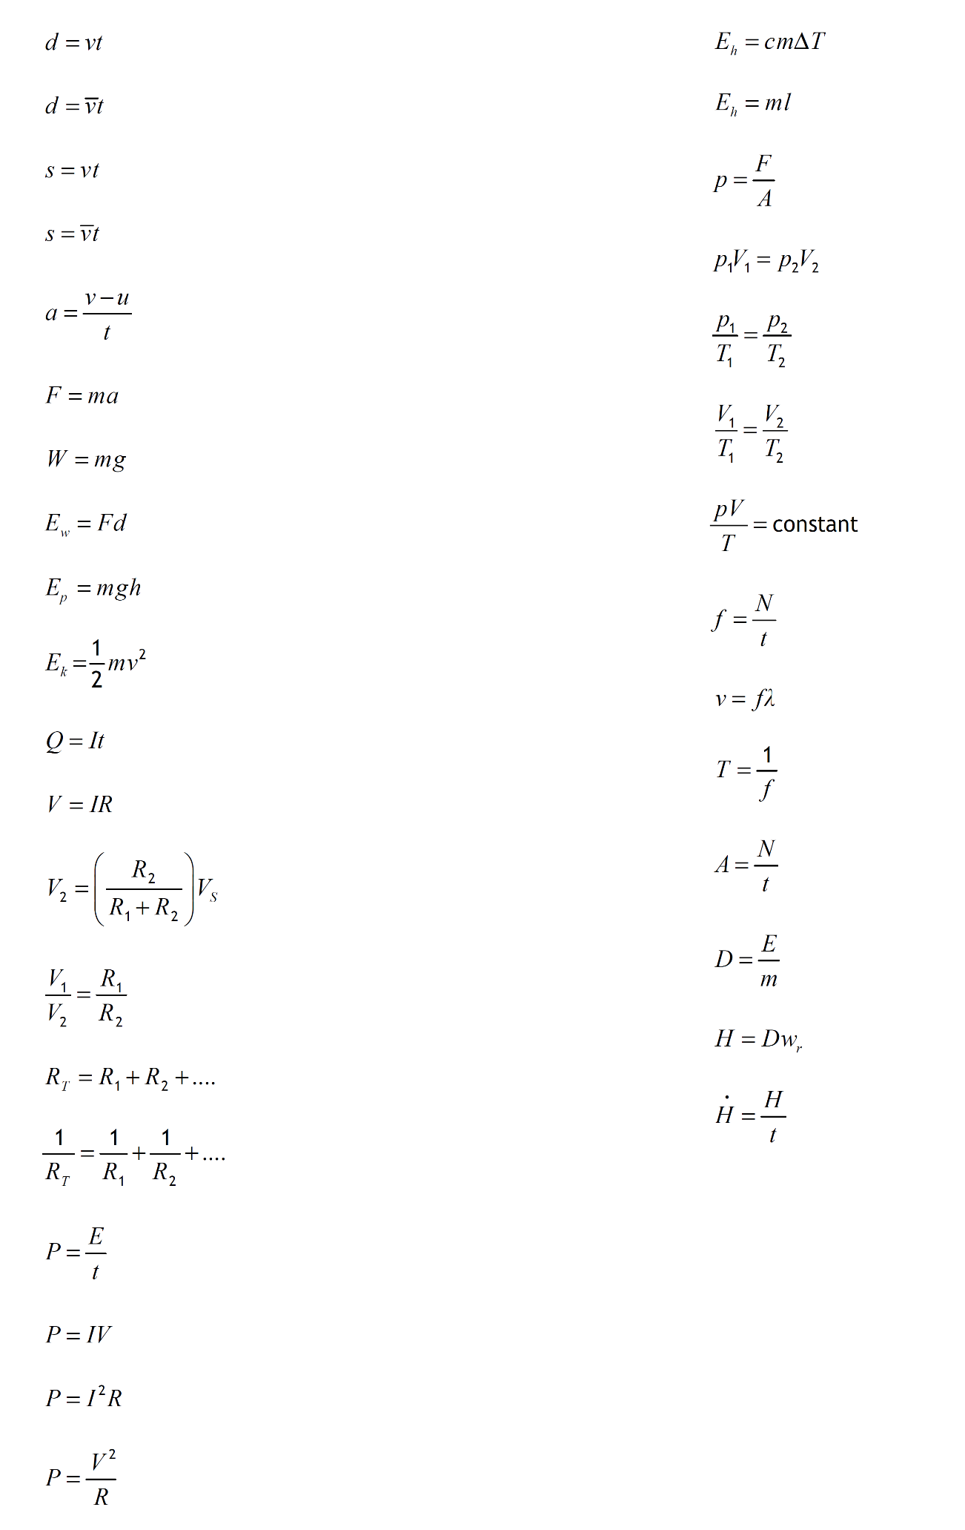By the end of the course, you must know what each letter stands for and what its unit is.

Formulas for this unit