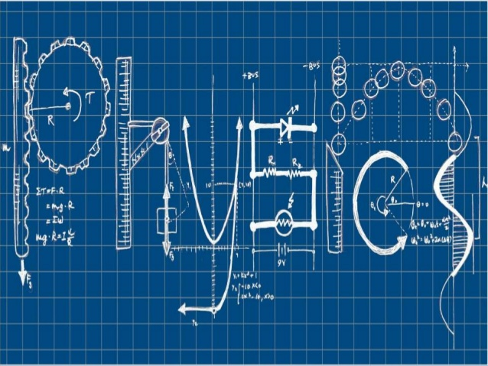National 5 Physics at Leith Academy

**Dynamics**

**Name: _________________________**

**September 2017**

**What you should know from S3…**

We’ll be reviewing all the key material, but there are things you did in the S3 Physics course that you’ll need in this unit.

If you didn’t do the S3 Physics course, you’ll have to work that bit harder.

Grade your own knowledge – where do you think you are at the moment?

|  |  |  |  |
| --- | --- | --- | --- |
| **Key content** | ☹ | 😐 | ☺ |
| I can explain the difference between instantaneous speed and average speed |  |  |  |
| I can describe experiments to measure instantaneous and average speed |  |  |  |
| I can use $v=\frac{d}{t}$ to calculate speeds, distances and times |  |  |  |
| I can explain what is meant by acceleration |  |  |  |
| I can recognise acceleration, constant speed and deceleration on a speed-time graph |  |  |  |
| I can draw a simple speed-time graph from data I am given |  |  |  |
| I can calculate acceleration using $a= \frac{v}{t}$ |  |  |  |
| I can explain what is meant by balanced forces and unbalanced forces |  |  |  |
| I know Newton’s 1st Law and what it tells us about forces and speed |  |  |  |
| I can use Newton’s 2nd Law ( $F=ma)$ to calculate forces, masses and acceleration |  |  |  |

My grade in the last unit was: D / C / B / A

My target grade for the end of this unit is: D / C / B / A

To achieve this grade I need to:

_____________________________________________________________________

_____________________________________________________________________

_____________________________________________________________________

**Speed, distance and time – revision**The speed of an object tells us how far it will travel in a certain amount of time.

We usually measure speed in metres per second.

There’s a good mathematical reason for this odd unit – ask your teacher.

In S3 we wrote this as m/s – but now we write it as **m s-1**.

To calculate speed we use the equation:

Write the equation in the box and label all the symbols. Give the units as well.

There are two different types of speed that we learned about in S3. These were **average** speed and **instantaneous** speed.

Average speed is…….

Instantaneous speed is…….

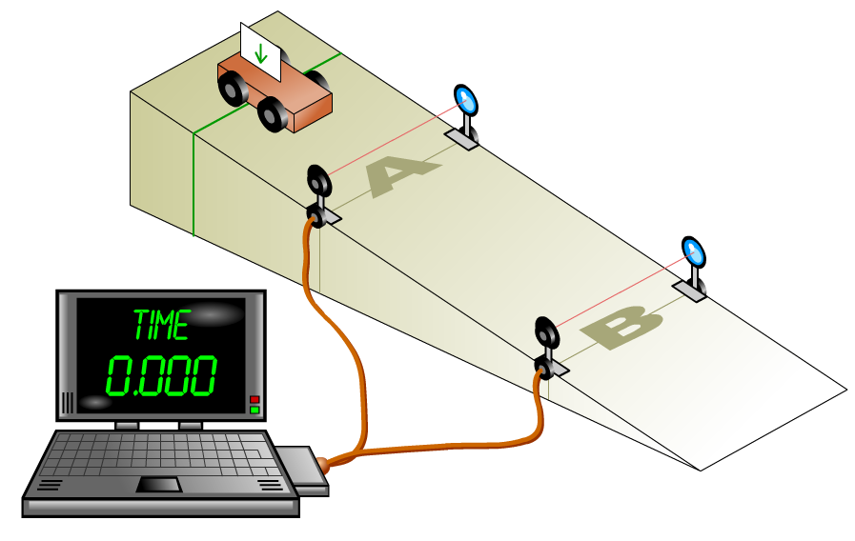**Revision practical - measuring average speed in the lab**

**Instructions**

* + - Measure the distance between the two light gates.
    - Let the trolley roll down the slope – don’t push it.
    - The TSA will record the time taken by the trolley to move between the light gates
    - Enter the distance and time values in the table
    - Calculate the average speed of the trolley as it runs along the track.
    - Repeat this procedure, using a different distance between the light gates.

|  |  |  |  |
| --- | --- | --- | --- |
| **Test** | **distance travelled (m)** | **time taken (s)** | **Average speed  (m s-1)** |
| **1** |  |  |  |
| **2** |  |  |  |
| **3** |  |  |  |

**Results**

Describe in your own words how you measured the average speed of the trolley. Make sure you mention all the equipment you used and what you used it for.

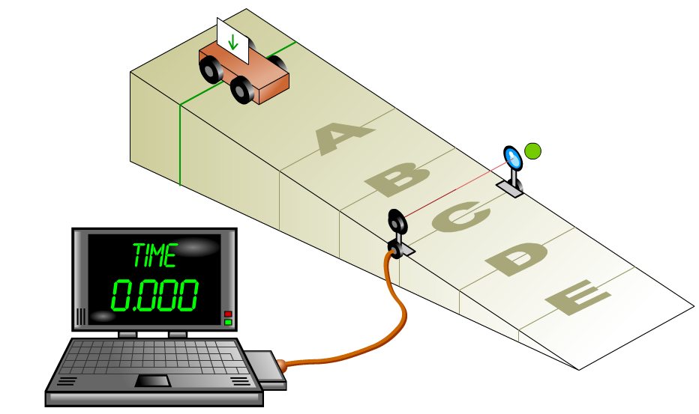**Revision practical - measuring instantaneous speed**

**Instructions:**

* + - Place the light gate near the middle of the ramp.
    - Connect up the light gate to the TSA computer and set the TSA computer to measure short time intervals.
    - Measure the length of the mask in metres.
    - Release the trolley so that it runs down the ramp and the mask cuts the light beam.
    - Record the time interval for the mask to cut the light.
    - Calculate the instantaneous speed.
    - Place the light gate at a different position and try again.

|  |  |  |  |
| --- | --- | --- | --- |
| **Test** | **Length of mask**  **(metres m)** | **Time taken for mask to cut light beam (s)** | **Instantaneous speed of trolley (m/s)** |
| **1** |  |  |  |
| **2** |  |  |  |
| **3** |  |  |  |

Describe in your own words how you measured the instantaneous speed of the trolley. Make sure you mention all the equipment you used and what you used it for.

**Vectors and scalars  
Ev**erything we measure in physics can go into one of two groups.

Some things only have a **size** – like a mass of 3 kg. These are **scalars**.

Some things have a **size** and a **direction** – like a force of 500 N to the left. These are **vectors**.

A scalar quantity is one which…….

A vector quantity is one which…….

Sort these quantities into scalars and vectors.

time mass force acceleration

weight voltage energy temperature

|  |  |
| --- | --- |
| **scalars** | **vectors** |
|  |  |
|  |  |
|  |  |
|  |  |
|  |  |

HINT: To help you decide, think about whether a direction makes sense.

Can we have 5 seconds to the right? No – so time is a scalar.

Can we accelerate downwards? Yes – so acceleration is a vector.

**Distance and displacement**  
There are some quantities that have a scalar version and a vector version.

One of these pairs is **distance** (scalar) and **displacement** (vector).

Distance: how far something has travelled.

Displacement: how far something is from where it started

To understand what displacement means, imagine two twins (Sally and Jane) walking from home to school.

Sally walks 500 m straight to school; Jane walks 300 m to the shop and then 400 m to school.

500 m

300 m

400 m



What distance has Sally walked?

What distance has Jane walked?

How far are they from where they started?

We can see that they have taken different journeys to get to school but have both ended up at the same point. They have travelled different distances, but they both have the same displacement.

Distance is…….

Displacement is…….

Because displacement is a vector, we should give a direction as well. We’ll look at this in the next section.

**Adding scalars and vectors**  
Adding scalars is easy. You just add them up.

3 kg + 4 kg = __________ 15 s + 25 s = __________ 10 J + 23 J = __________

Adding vectors is easy if they are in the same direction or opposite directions.

10 m right + 25 m right = ____________ 50 N right + 20 N left = ____________

If vectors are at an angle to each other, we add them using Pythagoras. Say a car travels 10 km to the east, and then 7 km to the north.

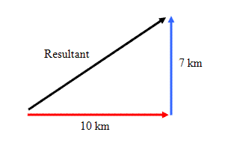R2 = 102 + 72

R2 = 100 + 49

R = √(149) = 12.2 km.

R means the **resultant** – the result of adding the two vectors.

x

To find the direction, we use trigonometry and SOHCAHTOA.

tan x = O/A

tan x = 7/10

x = tan-1 (0.7) = 35o

We usually measure directions clockwise from north, using a three-figure bearing.

So the displacement is **12.2 km on a bearing of 055o**.

Can you see why it’s 055o? If not – ask!

**Example Problem**

1. A boy walks 100 m East then runs for 50 m in the opposite direction.

(a) State the total distance the boy travels.

(b) State the final displacement of the boy from the start point. (Remember to give a direction!)

2. A man walks 500 m due North then 1200 m due East.

(a) State the distance travelled by the man.

(b) Use Pythagoras and trigonometry to find the displacement of the man from his starting point. (You need a size **and** a direction.)

Now try questions 3, 6, 10, 11 and 12 on page 9 of the N5 D&S Problems booklet.

**Speed and velocity**  
**S**peed is a **s**calar. Speed tells us how much distance an object has covered in a certain time.

**V**elocity is a **v**ector. Velocity tells us the displacement of an object in a certain time.

Because velocity is a vector:

* we need to give a direction
* we add velocities using Pythagoras and trigonometry

**Calculating speed and velocity**Both terms are worked out in a similar ways and have the same units. You must remember to include a direction when working out velocity.

$$velocity= \frac{displacement}{time}$$

$$v=\frac{s}{t}$$

Velocity is measured in ms-1. It needs a direction.

$$speed= \frac{distance}{time}$$

$$v=\frac{d}{t}$$

Speed is measured in m s-1

Sometimes, physicists can be a bit stupid.

We use two different symbols for distance (d) and displacement (s), but we use the same symbol for speed and velocity (v).

Most of the time, if you stick to $v=d/t$ you will be OK.

**Example**

1. One lap of a running track is 400 m. An athlete completes this lap in 48 s.

(a) State the distance travelled by the athlete.

(b) State the displacement of the athlete.

(c) Calculate the average speed of the athlete.

(d) Calculate the average velocity of the athlete.

Solution

2. A lorry travels 60 km, North, then 80 km, East, as shown here.

The journey takes 2 hours.

**80 km**

**60 km**

(a) State the distance travelled by the lorry.

(b) Calculate the overall displacement of the lorry.

(c) Calculate the lorry’s average speed in km h-1.

(d) Calculate the lorry’s average velocity in km h-1.

Solution

3. A boy swims south across a river with a velocity of 4 ms-1.

The river’s velocity is 8 m s-1 west.

MC900018515[1]

**8 ms-1**

**4 ms-1**

Calculate the resultant velocity of the boy. (Include a direction.)

Solution

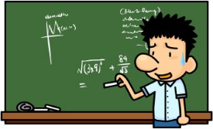

PRACTICE QUESTIONS

Now attempt problems from pages 12 to 16 of the N5 D&S booklet.

YOU ARE NOW ABLE TO COMPLETE HOMEWORK 1



**Speed-time graphs**

By using speed-time graphs, we can see how an object is moving and carry out calculations about its journey.

Draw the speed-time graph for the following examples:

v(ms-1)

t(s)

Object moving with constant speed

v(ms-1)

t(s)

Object moving with constant acceleration

v(ms-1)

t(s)

Object moving with constant deceleration

**Using graphs to describe motion**In real life, the speed of objects changes. They get faster, slow down, stop. You need to be able to use a graph to describe what’s happening.

|  |  |
| --- | --- |
| Position | Description of motion |
| A |  |
| B |  |
| C |  |
| D |  |
| E |  |

v(ms-1)

t(s)

Speed-time graph for a car driving through town.

A

B

C

D

E

**Velocity-time graphs**  
How is velocity different from speed? Velocities have a ______________.

In a velocity-time graph, we can show not just the size of a velocity but also its direction – as long as we are just working with ‘opposite’ directions like up/down or left/right.

Anything we draw on the **+** velocity axis we take as one direction.

Anything we draw on the **–** velocity axis counts as the other direction.

So:

**+** 4 m s-1 might mean 4 m s-1 to the right

**-** 6 m s-1 means 6 m s-1 to the left

The – 6 is **faster** than the + 4. The signs only tell us the direction.

In this graph of a car’s journey, **+** means ‘to the right’ and **–** means ‘to the left’

1. What is the velocity of the car after 2 seconds. (Size **and** direction.)

2. What is the velocity after 10 s.

3. What can you say about the car at 8 seconds?

**Problem 1**  
Draw this journey on the graph below:

Jared walks to the right at a constant velocity of 4 m s-1 for 4 seconds. In the next two seconds, he slows down to a stop. He immediately turns round. Over the next 8 seconds he increases his velocity until he reaches 8 m s-1 to the left.

**Problem 2**  
Polly fires an arrow straight up in the air.

It leaves the bow at 60 m s-1. After 6 seconds, it reaches its highest point. It then falls back to the ground. It takes 6 seconds to hits the ground, when it is travelling at 60 m s-1.

**Finding displacement from velocity-time graphs**If an object’s velocity is changing, we cannot just use d = v x t to find how far it has travelled. This formula only works when an object is travelling at a constant velocity.

To work out displacement from a velocity-time graph you……

We break up the velocity-time graph into rectangles and triangles, then use simple maths to calculate the area.

**Example problems**

Area A = 5 x 12 = 60

Area B = 5 x 18 = 90

Area C = ½ x 12 x 25 = 150

So total displacement is:

60 + 90 + 150 = 300 metres.

velocity

in ms-1

time in s

30

5

12

30

0

C

B

A

If the graph goes below the axis – because the object is travelling in the opposite direction – then we count it as a **negative** displacement. Here’s a graph of a bird flying north, then south.

PRACTICE QUESTIONS

N5 D&S – pages 24 - 26

Area A = ½ x 8 x 10 = 40 (NORTH)

Area B = ½ x 8 x **-**6 = **-**24 (SOUTH)

So total displacement is:

40 m N – 24 m S = 16 m NORTH.

B

A

**Velocity-time graph for a bouncing ball**In this experiment, we’ll monitor the velocity of a basketball as it bounces up and down beneath a motion sensor.

What do you think the velocity-time graph will look like? Sketch it here. (Take UP as positive.)

v (m s-1)

t(s)

After you’ve seen the experiment, sketch the actual graph here:

v (m s-1)

t(s)

Add labels to your graph, explaining what is happening at each point.

**Acceleration**

Acceleration is……………

It is measured in…………………

In S3, you learnt how to calculate acceleration from:

v = change in speed

t = time taken for change

At National 5, we use a different approach – though it’s really the same thing.

$$a= \frac{v-u}{t}$$

a =

u =

v =

t =

**Example problems**

1. A train travelling at 10 m s-1 takes 12 seconds to increase its velocity to 16 m s-1. Calculate the acceleration of the train.

Solution

2. A remote controlled car has an initial velocity of 3.0 m s-1. It accelerates at 0.5 m s-2 for 4 s. Calculate its final velocity.

Solution

**Deceleration and using the formula**If an object is decelerating, its final velocity will be **less** than its initial velocity.

So when you work out $v-u$ you get a **negative** value, and your answer for $a$ will be **negative**.

That’s fine – your answer shows how much the velocity **decreases** by every second.

If a question tells you that an object is decelerating – then use a negative value for $a$.

**Example problems**

1. A driver in a car is travelling at 24 m s-1. She applies the brakes. The car takes 4.0 seconds to slow down to 16 m s-1. Calculate the deceleration.

Solution (HINT: u = 24 m s-1, v = 16 m s-1)

2. As a plane lands, it is travelling at 80 m s-1. It takes 16.0 seconds to come to a halt. Calculate the deceleration of the plane.

Solution (HINT: think what the final velocity will be.)

PRACTICE QUESTIONS - N5 D&S – pages 19-21

**Finding acceleration from a velocity-time graph**

A velocity-time graph can tell us:

* the initial velocity of an object
* the final velocity of an object
* the time taken for the change in velocity

That’s everything we need to know to calculate acceleration.

**Example problem**

This graph shows the journey of a car over a 20s interval.

Calculate the acceleration of the car between:

35

30

25

20

15

10

5

0

velocity

in m s-1

0 10s 20s

(a) 0 and 10 seconds

(b) 10 and 20 seconds.

Solution

Mathematically, finding the acceleration from a velocity-time graph is the same as finding the gradient of the line.

**acceleration = gradient of a line on a velocity-time graph**

Whatever method you use in maths for finding gradients – you can now use in physics.

PRACTICE QUESTIONS - N5 D&S – pages 22-23

**Practical – measuring acceleration**

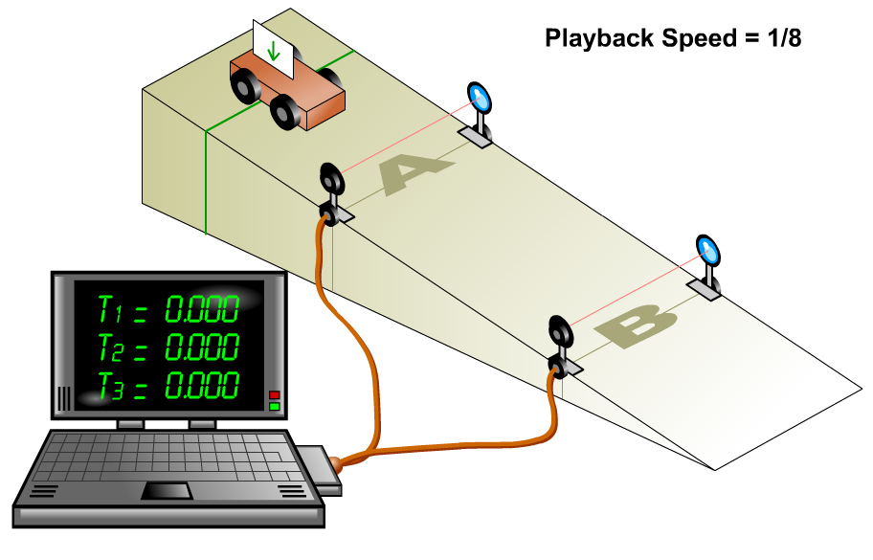

When the trolley passes light gate **A** – we can use the width of the mask and the time to pass the light gate to calculate the **initial** velocity of the trolley at A.

When the trolley passes light gate **B** – we can use the width of the mask and the time to pass the light gate to calculate the **final** velocity of the trolley at B.

We can also measure the time it takes the trolley to travel from A to B.

|  |  |  |  |  |
| --- | --- | --- | --- | --- |
| Test | velocity at **A** (m s-1)  **u (initial velocity)** | velocity at **B** (m s-1)  **v (final velocity)** | time to travel from A to B (s)  **t** | acceleration  (m s-2) |
| 1 |  |  |  |  |
| 2 |  |  |  |  |
| 3 |  |  |  |  |
| 4 |  |  |  |  |
| 5 |  |  |  |  |

**Results**

Now write a description about how to measure acceleration.

Explain how the equipment was used and how the calculations were done.

Include a labelled diagram in the blank space below to help your description.

Look at this method of measuring acceleration. It uses a **double mask** and a single light gate Can you explain how it works?

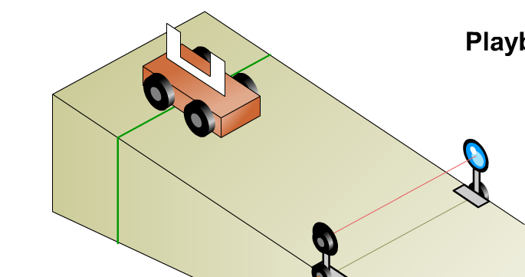

**Newton’s 1st Law**

You first met Newton’s 1st Law in S1 – but we may not have called it that.

Newton’s 1st Law tells us what happens to the velocity of an object when the forces on it are balanced.

“Balanced forces” means…

Add forces to these diagrams to balance out the forces.

15N

5N

Newton’s 1st Law say that if the forces on an object are balanced…

So why do things slow down if we don’t keep pushing them?

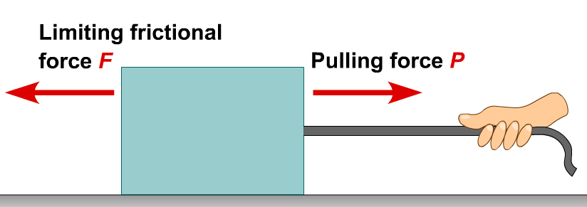Because of **friction**.

To keep something moving at a constant velocity, we have to keep pulling (or pushing) it. Our pulling force balances the friction force.

In space, there are no friction forces. If you give something a push, it keeps on moving at a constant velocity – for ever.

PRACTICE QUESTIONS - N5 D&S – page 32 – questions 1-4

**Newton’s 2nd Law - practical**

If balanced forces mean a constant velocity – what happens if the forces are unbalanced?

When an unbalanced force acts on an object…………

**[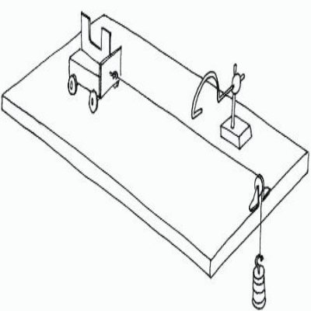](https://uk.pinterest.com/pin/191966002844326730/)The relationship between force and acceleration**In this experiment, we apply an unbalanced force to a trolley and measure its acceleration.

The track is very smooth, so frictional forces can be ignored.

Label the diagram.

**Results**

|  |  |  |  |
| --- | --- | --- | --- |
| **mass on thread** | **unbalanced force (N)** | **mass being accelerated (kg)** | **acceleration**  **(m s-2)** |
| 1 |  | 0.30 |  |
| 2 |  | 0.30 |  |
| 3 |  | 0.30 |  |
| 4 |  | 0.30 |  |
| 5 |  | 0.30 |  |

**Graph**Draw a line graph of acceleration (y-axis) against unbalanced force (x-axis). Stick it in this booklet.

**Conclusion**

**Newton’s 2nd Law as a formula**

Your experiment should have shown that the acceleration of the trolley was **directly proportional** the force – double the force, double the acceleration.

What would happen if to the acceleration of a trolley if you used the same unbalanced force but doubled the mass of the trolley?

We can write Newton’s 2nd Law as:

What does each letter stand for?

What is the correct unit?

$$F= ma$$

F =

m =

a =

**Example**Find the force needed to accelerate a boy and his bike at 1.5 m s-2 if they have a total mass   
of 50 kg.

Solution

Newton’s 2nd Law looks very simple. It **is** very simple. But it lies at the heart of physics. Understand it properly – and you have gone a long way to understanding physics.

PROBLEM PRACTICE

N5 D&S pages 35 questions 1 - 13



**More complex Newton 2 calculations**

Often, there is more than one force acting on an object.

Newton 2 applies to the **unbalanced** force. So you need to work out the unbalanced force first, before using Fun = ma.

If the forces point in the same direction or in the opposite direction, this is quite easy.

Fun = 30 – 10 = 20 N

5 kg

30 N

10 N

Fun = ma

20 = 5 x a so a = 4 ms-2

PROBLEM PRACTICE

N5 D&S pages 36 questions 14 – 25 (miss out Q17 and Q22)

**Forces at right angles**  
This is a bit harder. Remember that forces are vectors, so you need to find the resultant force using trigonometry. You also need to add the vectors ‘tip-to-tail’ – this means that you arrange the vectors so that the tip of one vector joins the tail of the other vector.

Here are two forces acting on a ship:

600 N N

2000 kg

800 N N

Arrange the vectors tip-to-tail:

8000 N N

6000 N N

Add the resultant, and use Pythagoras to find the size.

8000 N N

6000 N N

X2 = 6002 + 8002

X = √(1,000,000)

X = 1,000 N

Now use Fun = ma 1,000 = 2,000 x a so a = **0.5 m s-2**

This ball has a mass of 0.5 kg and is acted on by two forces.

20 N

12 N

a) Draw a diagram showing the two vectors tip-to-tail.

b) Use Pythagoras to find the size of the resultant force.

c) Use Fun = ma to find the acceleration of the ball.

Solution

**Mass and weight**

In everyday language the words mass and weight get interchanged. In physics, they have very definite – and different – meanings. You must learn the difference!

Mass is…..

Weight is…….

The weight of an object is caused the pull of gravity. Gravity pulls more or less in different places. We measure this using **gravitational field strength**, or **g**.

g tells us the force gravity applies to a mass of 1 kg. On Earth, the value of g is about **9.8 N kg-1**.

To calculate the weight of an object, we use:

What does each letter stand for?

What is the correct unit?

$$W= mg$$

W =

m =

g =

Complete the table below to show what happens to your weight on different planets:

|  |  |  |  |
| --- | --- | --- | --- |
| **Name of planet** | **Value of g  (N kg-1)** | **My mass on this planet (kg)** | **My weight on this planet (N)** |
| Mercury | 3.7 |  |  |
| Venus | 8.9 |  |  |
| Earth | 9.8 |  |  |
| (The Moon) | 1.6 |  |  |
| Mars | 3.7 |  |  |
| Jupiter | 24.9 |  |  |

PROBLEM PRACTICE

N5 D&S page 28 questions 6 – 20

**Newton’s 3rd Law and rockets**

Newton’s 1st Law and 2nd Law are all to do with the forces on a single object.

Newton’s 3rd Law tells us what happens when **two objects are in contact**.

Newton’s 3rd Law tells us -

Because Newton 3 deals with two forces, these are often called Newton pairs.

Here’s an example:

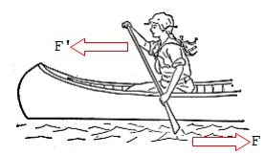The paddle applies a force to the water (F). So the water applies an equal and opposite force to the paddle (F’). It’s the F’ force that makes the canoe accelerate.

PROBLEM PRACTICE

N5 D&S page 43

Use Newton 3 to describe what’s happening in each of these pictures.



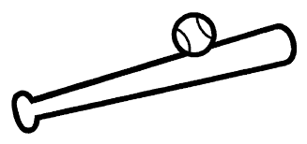

**So what about rockets?**If you’ve ever blown up a balloon and let it go – then you have used the same physics that rockets use.

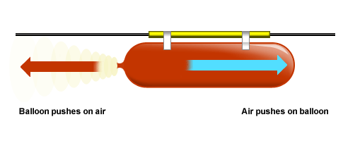

When you blow up a balloon, the stretched rubber applies a force to the air – so the air applies a force to the balloon. This makes the balloon accelerate.

**Practical – water rockets**Depending on the weather, you may be able to carry out an experiment with a water rocket.

1. Describe what you did.

2. Use Newton’s 3rd Law to explain what happened.

**Newton’s Laws, terminal velocity and freefall**

Terminal velocity is…

Imagine a boy falls out of a plane.



1. At the moment he falls, what force is acting on him?

2. Is this an unbalanced force?

3. So what happens to the boys’ velocity? (Newton 2)



4. As the boy’s velocity increases, what other force starts to act?

5. What happens to the size of this force as the boys falls faster?



6. Eventually, what will happen to the two forces on the boy?

7. So what can you say about his velocity now? (Newton 1)

8. What do we call this velocity?

**Velocity-time graph for a falling object**

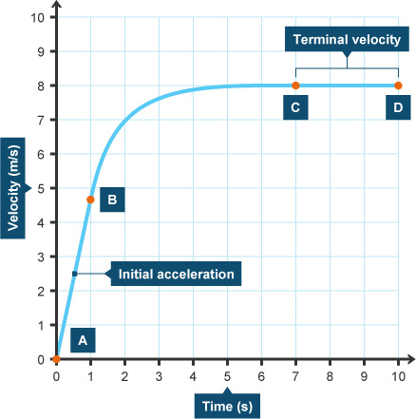

1. Between A and B, the line is very steep. What does this tell you about the acceleration?

2. Between B and C, the gradient of the line gradually decreases. What does this tell you about the acceleration?

3. Between C and D, the line is level – what does this tell you about the velocity.?

4. Add a line to the graph to show what would happen if the boy used a parachute at point D. (HINT: when the parachute opens, the air resistance force will be BIGGER than the boy’s weight. Think about Newton 2 and what this means.)

**Free-fall**  
If there is no air resistance, then the only force acting on a falling object is its weight.



Because this is an unbalanced force, the object will keep accelerating (at 9.8 m s-2 on Earth) until it hits the ground.

Motion like this is called **free-fall**.

(Although it’s difficult to get rid of air resistance, we sometimes assume there is no air resistance. This makes it easier to work out what falling objects do.)

PROBLEM PRACTICE

N5 D&S page 41

**Energy**What is energy? That’s a tough question.

In physics, we can think of energy as ‘the ability to do something’.

You get energy from your food – so you can walk and run

Moving objects have energy – so they can hurt when they hit you.

Energy is measured in **joules** (J).

**Types of energy**  
Complete the table with the different types of energy. You may not know them all – that’s fine.

|  |  |
| --- | --- |
| **Clue** | **Type of energy** |
| hot things have lots of this |  |
| batteries can provide this |  |
| we can see thanks to this |  |
| anything that is moving has this |  |
| anything that can be burnt contains this |  |
| anything raised off the ground has this |  |
| a shout produces more of this than a whisper |  |
| contained within the nucleus of atoms |  |

**Conservation of energy**

This is a really big idea in physics – it really does matter. Physicists studying sub-atomic particles use this idea. So do physicists studying black holes.

Energy cannot be created or destroyed.   
It can only be converted from one type into another.

So when you run:

chemical energy from your food 🡪 kinetic energy.

When you switch on a torch:

electrical energy 🡪 light energy + heat energy

Complete this table to show the energy changes.

|  |  |
| --- | --- |
| **what happens** | **starting energy 🡪 finishing energy(ies)** |
| switch on torch | electrical energy 🡪 light energy + heat energy |
| strike a match |  |
| drop a ball |  |
| drive a car |  |
| put on the brakes |  |

Take a look at this diagram of a power station.

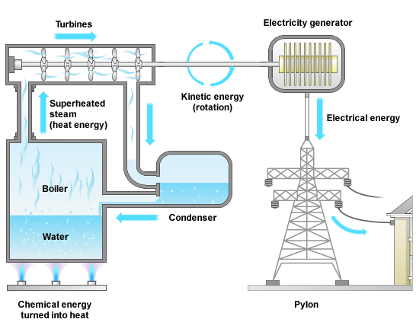1. What is the energy change when the fuel is burnt?

🡪

2. What is the energy change in the turbines?

🡪

3. What is the energy change in the generator?

🡪

**So how do we lose energy?**  
We often say that energy has been lost – or we are wasting energy. How can this happen if energy cannot be destroyed?

In many situations, friction produces heat energy. This escapes to the air around us. It’s not been destroyed – but we can’t get it back again and it’s not useful to us.

Wasted heat energy

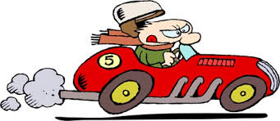

Useful kinetic energy

Chemical energy from petrol

**Work done**If you push a bike along – it gains kinetic energy. That’s because you’ve done work on the bike.

The amount of work you do (in joules) is the same as the amount of energy the bike gains (in joules).

To calculate the work done, we use:

What does each letter stand for?

What is the correct unit?

$$E_{w}= Fd$$

$E_{w}=$

$F=$

$d=$

g =

**Example**When a driver brakes, the brakes apply an average force of 600 N to the wheels of the car. The car takes 25 m to come to a stop. Calculate the work done by the brakes.

Solution

The brakes have used friction to convert ______________ energy 🡪 __________ energy.

PROBLEM PRACTICE

N5 D&S pages 51-53

**Practical – work done**Use a newton balance to drag a block along the bench or floor. By making suitable measurements, calculate the work done.**Gravitational potential energy**

When you lift up a heavy box, you do work – you apply a force through a distance.

The work you do is stored in the box as gravitational potential energy.

The heavier the box, the more potential energy is stored. The higher you lift the box, the more potential energy is stored.

To calculate the potential energy gained, we use:

$$E_{p}= mgh$$

$E_{p}=$

$m=$

$g=$

$$h=$$

g =

What does each letter stand for?

What is the correct unit?

**Example**Sadiq lifts a 18 kg suitcase from the floor onto a shelf 1.5 m high. Calculate the gain in potential energy of the suitcase.

Solution

**Example**Valeria picks up a 3.0 kg from the floor and places it on the table. If the brick gains 24.5 J of potential energy, calculate the height of the desk.

Solution

PROBLEM PRACTICE

N5 D&S pages 57-58

**Kinetic energy**

Moving objects like cars - have kinetic energy.

The heavier the car, the more kinetic energy it has. The faster the car is travelling, the more kinetic energy it has.

To calculate the potential energy gained, we use:

$$E_{k}= \frac{1}{2}mv^{2}$$

$E_{k}=$

$m=$

$v=$

g =

What does each letter stand for?

What is the correct unit?

**Example**A 0.5 kg football is travelling at 12 m s-1. Calculate its kinetic energy.

Solution

**Example**Michal has a mass of 70 kg and has kinetic energy of 315 J. How fast is he travelling?

(This is quite tricky – you need to find $v^{2}$ first and then take the √ ${(v}^{2})$

Solution

PROBLEM PRACTICE

N5 D&S pages 54-56

**Practical – using conservation of energy to find braking force**1. What type of energy does a moving car have?

2. What do the brakes apply to the wheels to stop the car?

The work done by the brakes must be equal to the kinetic energy the car had before the brakes were applied. We can use this idea to find the size of the braking force.



As the trolley passes through the light gate, we measure its **instantaneous speed**. The light gate hits the braking plate and knocks it onto the wheels. We measure the **braking distance** – how far trolley travels before it stops.

|  |  |  |  |  |
| --- | --- | --- | --- | --- |
| **speed (m s-1)** | **braking distance 1 (m)** | **braking distance 2 (m)** | **braking distance 3 (m)** | **average b.d. (m)** |
|  |  |  |  |  |

$m$, mass of trolley = _________ kg $v$, speed of trolley = _________ m s-1

, average braking distance of trolley = _________ m

1. Calculate the kinetic energy of the trolley as it passes the light gate, $E_{k}$

You know that the $E_{k}$ is equal to the work done by the brakes $E_{w}$. You also know that

2. So now calculate the average braking force, $F$

**Kinetic energy, work done and conservation of energy**  
When a moving object is stopped, it loses all of its kinetic energy. The force of friction does work on the object, turning the kinetic energy into heat energy.

Conservation of energy tells us that the work done by friction must be equal to the kinetic energy lost.

So we can write:

$$E_{k}= E_{w}$$

$$\frac{1}{2}mv^{2}=Fd$$

So if we know how far an object travels before stopping – we can work out the average force.

If we know the average force – we can work out how far it travels.

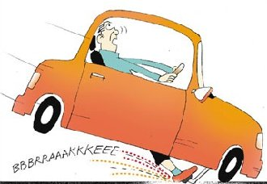**Worked example**  
A car of mass 800 kg is travelling at 10 m s-1 when the driver sees a red light and applies the brakes. The brakes exert a force of 1000 N on the wheels. How far does the car travel before stopping?

$$E_{k}= E_{w}$$

$$\frac{1}{2}mv^{2}=Fd$$

$$\frac{1}{2}.800.{10}^{2}=1000d$$

$$40,000=1000d$$

$$d=40 m$$

**Example**A 60 kg ice-hockey player is skating at 6 m s-1 when he slips and falls. If he travels 30 m along the ice before stopping, what is the average force of friction that acts on him?

Solution

**Kinetic energy and potential energy conversions**  
If a flower-pot is knocked off a window ledge, it loses potential energy as it falls – because it’s losing height. It gains kinetic energy because it’s travelling faster and faster.

When it hits the ground, all of its potential energy has changed into kinetic energy.

When a firework takes off from ground level, it has plenty of kinetic energy. As it rises, it loses kinetic energy because it’s getting slower – but it gains potential energy because it’s getting higher.

So whenever an object rises or falls we can say:

**gain/loss in kinetic energy = loss/gain in potential energy**

This is not on the Formula Sheet, but it is worth learning

$$E_{k}= E_{p}$$

$$\frac{1}{2}mv^{2}=mgh$$

$$v^{2}=2gh$$

So if we know how far something has fallen – we can work out its speed when it hits the ground

If we know how fast something takes off – we can work out how high it gets.

**Worked example**  
A coin is dropped from the top of the Scott Monument, which is 60 m high. Calculate the speed of the coin when it hits the ground.

$$v^{2}=2gh$$

$$v^{2}=2 x 9.8 x 60$$

$$v=\sqrt{1176}=34.3 m s^{-1}$$

(The coin wouldn’t really be going this fast – what have we ignored?)

**Example**A 0.5 kg firework takes off at 40 m s-1. How high does it get?



Solution

PROBLEM PRACTICE

N5 D&S pages 72-75

**Formula sheet for National 5**

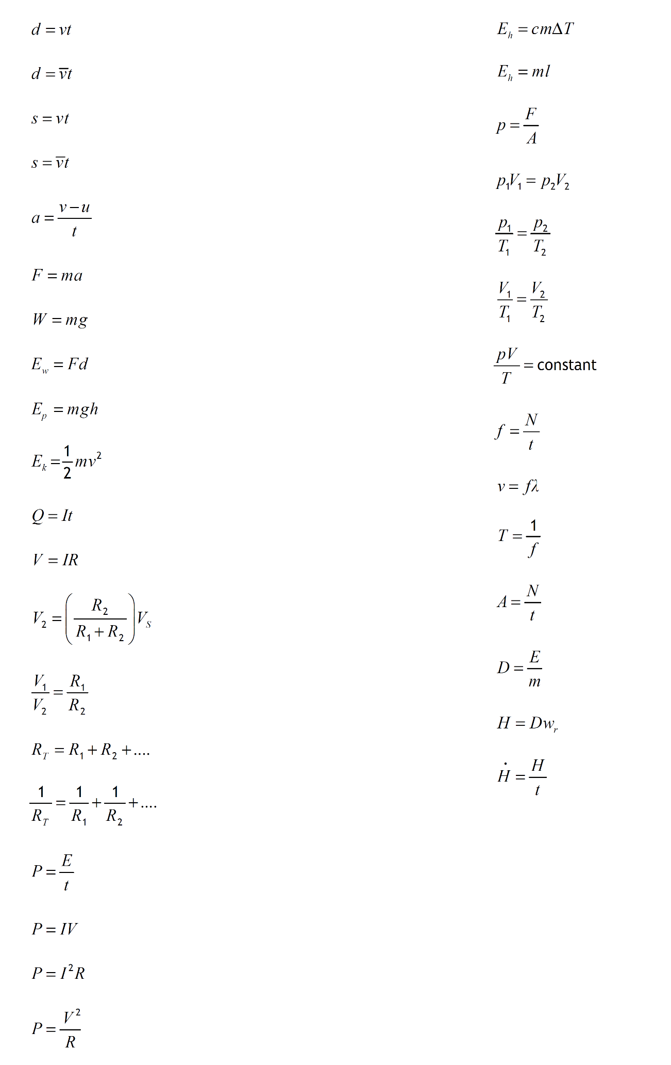By the end of the course, you must know what each letter stands for and what its unit is.

Formulas for this unit