**HIGHER CHEMISTRY**

Unit 1

Chemical Changes and Structure

[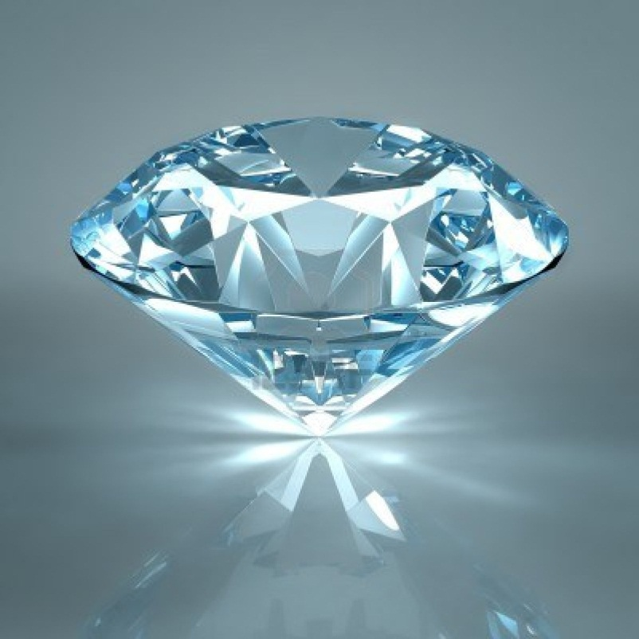](http://www.google.co.uk/url?sa=i&rct=j&q=diamond&source=images&cd=&cad=rja&docid=WU5gjVhyg5PjIM&tbnid=ZvJMDkpx5pmHFM:&ved=0CAUQjRw&url=http://www.123rf.com/photo_8612055_diamond-jewel-isolated-on-light-blue-background-beautiful-sparkling-diamond-on-a-light-reflective-su.html&ei=Bp6lUZ-IGsnC0QXHgIHYDA&bvm=bv.47008514,d.d2k&psig=AFQjCNFlcaRjE7FHmoSkdgz3eKcWV6IxvA&ust=1369894775955324)

**Controlling the Rate of Reaction**

ANSWERS

1. A pupil made the following observations on dripping taps. 45cm3 of water was collected from Tap A in 3 minutes. 340 cm3 of water was collected from Tap B in 20 minutes. By calculating the average rate of loss of water from each tap, find out which tap was dripping faster.

*A= 0.25 cm3s-1 B= 0.28 cm3s-1 B was dripping faster.*

2. A pupil was attempting to measure the rate of a chemical reaction which produced a gas. After six seconds 8cm3 of gas had been collected. After ten seconds the total volume of gas collected was 14cm3. Calculate the average rate of the reaction during this time interval (from six to ten seconds).

*1.5 cm3s-1*

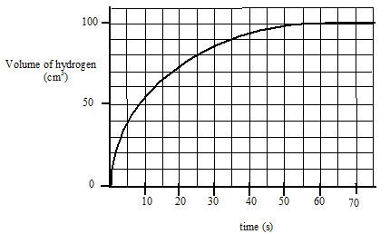3. The graph below shows the volume of hydrogen gas released when a 10cm strip of magnesium (mass = 0.1g) was added to 30cm3 of 1 mol l-1 hydrochloric acid.

(a) Calculate the average rate of reaction

i) over the first 15 seconds ii) between 20 and 30 seconds

*i) 4.33 cm3s-1 ii) 1.2 cm3s-1*

(b) How long did it take for the reaction to stop?

*55 seconds*

(c) The graph shows that the rate of reaction changes as the reaction proceeds. Explain why it changes in this way.

*As more of the reactants are used up the number of collisions decreases and so the rate decreases until all the reactants are used up.*

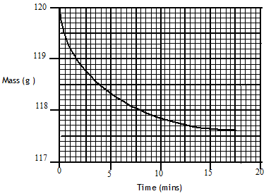4. Marble chips (calcium carbonate), reacted with excess dilute hydrochloric acid.

The rate of reaction was followed by recording the mass of the container and the reaction mixture over a period of time. The results of the experiment are shown in the following graph.

(a) Write a balanced equation for the reaction.

*CaCO3 + 2HCl → CaCl2 + H2O + CO2*

(b) Give a reason for the loss of mass of the container.

*As carbon dioxide gas is released the mass is lost to the surroundings.*

(c) Calculate the average rate of reaction over the first five minutes.

*0.34 gmin-1*

(d) Why does the average rate of reaction decrease as the reaction proceeds?

*As the concentration of reactants (and therefore number of collisions) decreases as they are used up the rate decreases until all reactants are used up.*

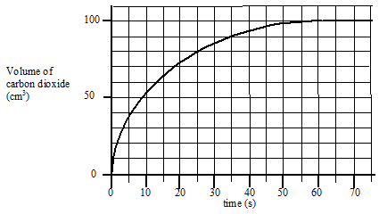

5. The results shown below were obtained when 0.42 g of powdered chalk was added to 20 cm3 hydrochloric acid, concentration 2 mol l-1 (an excess of the acid).

(a) Sketch the graph and add a **solid** line to the graph to show what would happen if 0.42g of chalk lumps was used instead of powdered chalk.

*See red line.*

(b) Add a **dotted** line to the graph to show what would happen if 20 cm3 of 3 mol l-1 hydrochloric acid was used instead of 2 mol l-1 hydrochloric acid.

*See green dotted line.*

6. 1.0 g of zinc was placed in 20 cm3 of 2 mol l-1 hydrochloric acid. After 20 seconds the zinc was removed, washed, dried and re-weighed. The remaining zinc weighed 0.35 g.

(a) Write a balanced chemical equation for the reaction.

*Zn + 2HCl → ZnCl2 + H2*

(b) Calculate the average rate of the reaction.

*0.03 gs-1*

(c) Calculate the number of moles of hydrochloric acid used up in the 20 seconds.

*0.02 moles*

7. A pupil was investigating the effect of temperature on the rate of a chemical reaction and obtained the following data.

|  |  |  |  |  |  |
| --- | --- | --- | --- | --- | --- |
| Temperature (oC) | 15 | 25 | 33 | 37 | 44 |
| Time for reaction to  finish (s) | 154 | 66.7 | 40 | 30.3 | 22.2 |
| Relative rate ( s-1 ) | *6.5 x 10-3* | *15 x 10-3* | *25 x 10-3* | *33 x 10-3* | *45 x 10-3* |

(a) Copy the table and calculate the relative rate of reaction at each temperature and add them to the table, putting the correct units in the brackets.

(b) Plot a graph of relative rate against temperature.

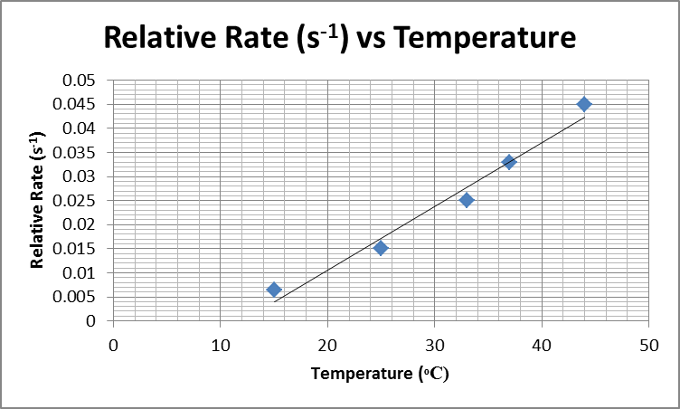

(c) Predict what the **relative rate** of the reaction will be at 50 0C.

*Dependent on graph. For this graph relative rate = 49.1 x 10-3 s-1*

(d) Use the graph to estimate the **time** for the reaction to finish at 40 0C.

*Dependent on graph. For this graph time = 27.7 seconds.*

8. Hydrogen peroxide can be used to clean contact lenses. In this process, the enzyme catalase is added to break down hydrogen peroxide. The equation for the reaction is:

2H2O2  **🡪** 2H2O + O2

The rate of oxygen production was measured in three laboratory experiments

using the same volume of hydrogen peroxide at the same temperature.

|  |  |  |
| --- | --- | --- |
| Experiment | Concentration of H2O2/ mol l-1 | Catalyst used |
| **A** | 0.2 | yes |
| **B** | 0.4 | yes |
| **C** | 0.2 | no |

The curve obtained for experiment **A** is shown.

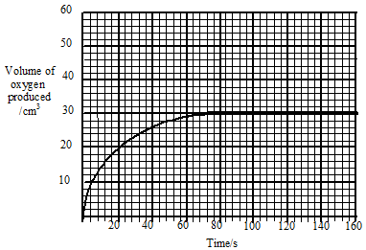

(a) Calculate the average rate of the reaction over the first 40 s.

*0.63 cm3s-1*

(b) Copy the graph and add curves to the graph to show the results of experiments B and C. Label each curve clearly.

*Red line = B, Green line = C.*

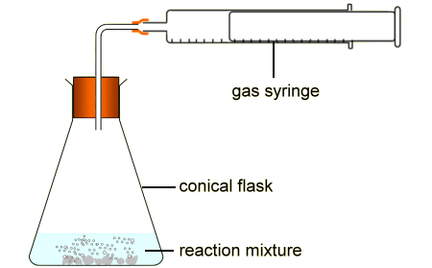(c) Draw a labelled diagram of assembled lab apparatus which could be used to carry out these experiments.

**Section 1 Controlling the Rate**

**Reaction profiles, catalysts and temperature and kinetic energy**

**Homework 2**

1. What is meant by the term “activation energy”?

*The minimum kinetic energy required for a reaction to occur*

2. The potential energy diagram below shows the energy pathway for a chemical reaction.



(a) What is the value for the activation energy for the forward reaction?

*80*

(b) What is the enthalpy change for the forward reaction?

*60*

(c) Is the forward reaction exothermic or endothermic? Explain your answer.

*Endothermic. The products have more potential energy than the reactants*

(d) Draw the reaction profile and add a dotted line to show the effect of the addition of a catalyst.

*Dotted line must lower the activation energy but reactant and product potential energies remain the same.*

(e) What is the value for the activation energy for the backward reaction?

*20*

(f) What is the enthalpy change for the backward reaction?

*60*

(g) On the reaction profile that you have drawn, mark on the graph the position of the activated complex.

*At the apex of the curve (120)*

3.

(a) What is the enthalpy change for the forward reaction?

*30kJmol-1*

(b) Is the reaction exothermic or endothermic?

*Exothermic*

(c) When a catalyst is used, the activation energy of the forward reaction is reduced to 35kJmol-1. What is the activation energy of the catalysed reverse reaction?

*65kJmol-1*



4. The decomposition of an aqueous solution of hydrogen peroxide into oxygen and water can be catalysed by iodide ions, I-(aq), or by solid manganese (IV) oxide, MnO2(s).

For each of these catalysts state, with a reason, whether the catalysis is homogeneous or heterogeneous.

*Iodide ions, I-(aq); homogeneous – same state*

*Solid manganese (IV) oxide, MnO2(s); heterogeneous – different state*

5. An advice leaflet given to motorists when catalytic converters were first used states: “Cars fitted with catalytic converters must be run on unleaded petrol only.” Research this issue and answer the questions below.

(a) Outline the reasons for fitting catalytic converters, naming the substances reacting and what happens to them.

*Reduce toxic gases produced by the internal combustion engine. Carbon monoxide to carbon dioxide. Nitrogen oxides to nitrogen and oxygen, unburnt hydrocarbons to carbon dioxide and water.*

(b) Describe in terms of adsorption how catalysts work, and state the effect this has on the activation energy for the reaction.

*Metal atoms on the surface have ‘spare’ bonds and are capable of forming weak bonds with the reactant molecules – known as ‘adsorption’. This reduces the activation energy for the reaction. When the molecules leave the surface of the catalyst this is known as desorption.*

(c) Describe how a substance poisons a catalyst.

*If a substance bonds to the surfaces of a catalyst and stays there, it is said to ‘poison’ the catalyst. The sites on the catalyst surface become ‘clogged’ and prevent the catalyst from working effectively.*

(d) Explain the reason for the advice given at the start of the question.

To prevent poisoning of the catalyst.

6. Select the correct answer. In area **X**



A. molecules always form an activated complex

B. no molecules have the energy to form an activated complex

C. collisions between molecules are always successful in forming products

D. all molecules have the energy to form an activated complex

*D*

7.



Which of the following is the correct interpretation of the above energy distribution diagram for a reaction as the temperature **decreases** from T2 to T1 ?



D

8. At any particular temperature the collisions between molecules in a substance have a range of kinetic energies.



(a) Why does the graph shown suggest a slow rate of reaction?

*Small number of molecules with kinetic energy higher than the activation energy.*

(b) Copy the graph shown then add to it a second graph using a dotted line to show the effect of increasing the temperature.

*Note, same area under each curve*.

(c) Use your graph to explain why a small change in temperature can produce a large change in reaction rate.

*Small temperature change increases the kinetic energy of the molecules, increasing the numbers with sufficient activation energy.*

9. (a) In the graph, the shaded area represents the number of molecules with the required energy of activation, EA, for reaction to occur.

Copy the graph and draw a line to show how a catalyst affects the energy of activation.

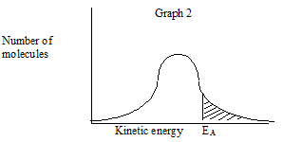

EA with catalyst

(b) A collision involving molecules with the required energy of activation may **not** result in reaction. State a reason for this.

*If the collision geometry is incorrect then the activated complex cannot form and so no reaction occurs.*

**Section 2 Periodicity**

**Bonding in elements 1-20**

**Homework 3**

1. (a) Graph 1 shows the boiling points of the Group 8 elements.

Why do the boiling points increase down Group 8?

*The forces of attraction increase down the group which means more energy is required to break these attractive forces and so boiling points increase. (Larger cloud of electrons so greater induced dipoles).*



(b) Graph 2 shows the melting points of elements from lithium to neon across the second period. Give reasons for the high melting points of boron and carbon.

*Due to the covalent network structures they form, carbon and boron have high melting points. Multi-directional, strong, covalent bonds require a lot of energy to break.*



2. Phosphorus can be described as a molecular element.

(a) What type of bonding holds the atoms together **within** each molecule?

*Covalent*

(b) What type of bonding holds the molecules together in a piece of solid phosphorus?

*London Dispersion Forces*

(c) Why does phosphorus have a low melting point?

*Only need to supply enough energy to break the weak LDF*

3. Graphite is a form of carbon which has a layered structure.

(a) What is the main type of bonding that holds the atoms together **within** each layer?

*Covalent*

(b) What type of bonding exists **between** layers?

*London Dispersion Forces*

(c) How does this explain graphite’s use as a solid lubricant?

*Layers can slide past each other easily*

4. The table gives information about 3 elements X, Y, Z.



(a) Which element is likely to have a covalent network structure?

*Y*

(b) Which element is likely to have a metallic lattice?

*X*

(c) Which element could be a diatomic gas?

*Z*

5. The table below shows the types of bonding considered to exist among the elements.



Which structure best describes the normal state of:

(a) fluorine (b) sodium (c) phosphorus (d) neon (e) boron

*a)molecular gas b)metallic lattice c)molecular solid d)monatomic gas e)covalent network*

6. The Periodic Table below has been divided into four sections - **A, B, C** and **D.**



1. State the type of structure in each of the four sections A, B, C and D.

*A – metallic lattice; B – covalent network; C – covalent molecular; D – monatomic*

1. In which section(s) will London dispersion forces between the particles determine the melting point?

*C+D because vdW are the only type of forces present between the atoms and molecules in these sections.*

1. Using elements in the above table as examples, explain briefly the difference in melting point between a covalent molecular substance and a covalent network substance.

*Covalent molecular – strong intramolecular covalent bonds (shared pair of electrons) and weak intermolecular bonds (London dispersion forces) which don’t require as much energy to break, e.g. Cl2*

*Covalent network – multi-directional, strong intramolecular forces which require a lot of energy to break, e.g. C (diamond), B, Si*

**Section 2 Periodicity**

**Patterns in the Periodic Table**

**Homework 4**

1. As we go across the periodic table the covalent radius decreases. This trend is evident if we examine the data relating to the third period.

(a) Construct a table of atomic number and covalent radii for the elements in period three.



(b) Explain the trend shown in your table.

*Nuclear charge increases L to R, more electrons but in the same energy level, so all equally affected by the nucleus, so radius decreases due to increased attraction.*

2.

(a) Explain the following trend found in the elements in the periodic table:

“the atomic size increases going down a group.”

*Additional energy shell going down the group, increased shielding of nucleus from outer electrons, despite increase in nuclear charge.*

(b) The P3– ion and the Ca 2+ ion have the same electron arrangement but the Ca 2+ ion is smaller than the P 3– ion. Give the reason for this difference.

*Ca 2+ ion has greater nuclear charge, 20 compared to 15 but same number of electrons and energy levels.*

3.

The graph below shows the first ionisation energies of successive elements with increasing atomic

number.



Elements A, B and C belong to the same group of the Periodic Table. Identify the group.

*Group 7, Halogens*

4. The table gives information about the ionisation energies of carbon and silicon.



1. Write an equation for the 1st ionisation energy for carbon.

C(g) → C+(g) + e-

(b) Explain why the 1st ionisation energy for silicon is less than carbon.

*More shielding of the outer electrons from the nucleus, so outer electrons require less energy to remove them.*

5. The table below shows data for some of the elements in period three.



(a) Explain why the ionisation energies tend to increase as we move across a period.

*The nuclear charge increases but the additional electrons are adding to the same energy level, so they are held more strongly by the nucleus.*

(b) Within any period it is the noble gas which has the highest first ionisation energy. Explain why this is so.

*The electron is being removed from a full energy shell, so the nuclear charge has the greatest effect for that period.*

(c) The second ionisation energy for sodium is 4562 kJmol-1. Why is this value nearly 10x higher than the first ionisation energy?

*To remove a second electron we need to remove it from a full, stable, outer electron shell which requires more energy.*

(d) Why is there no value for the covalent radius for argon?

*It doesn’t form covalent bonds.*

6. The third ionisation energy of magnesium is 7750 kJ mol-1 and the third ionisation of aluminium is 2760 kJ mol-1.

(a) Write an equation for the third ionisation energy for magnesium and one for aluminium.

Mg2+(g) → Mg3+(g) + e-

Al2+(g) → Al3+(g) + e-

(b) Why is third ionisation energy for magnesium so much greater than the third ionisation of aluminium?

*To remove a third electron from Mg2+ we need to remove it from a full, stable, outer electron shell which requires lots of energy. However, to remove a third electron from Al2+ we are removing an electron to give the ion a full outer electron shell which is energetically favourable and so requires less energy than required to remove a third electron from Mg2+.*

7. Ionisation energies can be found by applying an increasing voltage across test samples of gases until the gases ionise.

The results below were obtained from experiments using hydrogen atoms and then helium atoms.



(a) Why are there two results for helium but only one for hydrogen?

*Helium contains two electrons that can be removed but hydrogen only contains one.*

(b) (i) Write an equation which would represent the first ionisation energy of helium gas.

*He(g) → He+(g) + e-*

(ii) Why is the first ionisation of helium higher than that of hydrogen?

*You are removing an electron from a full outer electron shell.*

c) The ionisation energy, I.E. , can be found from:

I.E. = voltage x 1.6 x 10-19 J

Calculate a value for the first ionisation energy of helium.

*I.E. = 24.6 x 1.6x10-19 = 3.936x10-18 J per atom*

*3.936x10-18 x 6.02x1023 = 2369.47 kJ mol-1*

8. Calculate the energy required to carry out the following:

B(g) → B3+(g)

*6888kJmol-1*

9.

(a) Copy and complete the following statements.

(i) Electronegativity is a measure of the *attraction* an atom in a covalent bond

has for the *shared* pair of electrons.

(ii) In the Periodic table electronegativity *increases* across a period and *decreases* down a group.

(b) In each of the following pairs identify the element with the greater electronegativity.

( i) phosphorus or ***carbon***  (ii) silicon or ***nitrogen***

(c) Give the name of the most electronegative element

*Fluorine*

**Section 3 Structure and Bonding**

**Bonding in Compounds and intermolecular forces**

**Homework 5**

1. The table below gives information about three compounds.

**

(a) Which would you identify as covalent network?

*P*

(b) Which would you identify as covalent molecular?

*R*

2. Silicon dioxide and carbon dioxide have similar names and formulae. Yet these two compounds are very different in their properties.

(a) Use the data book to find the melting point of each compound.

*1713C -78.5C*

(b) Explain in terms of bonding and structure why silicon dioxide is a very high melting point and solid and carbon dioxide is a gas at room temperature.

*Silicon dioxide is covalent network, so melting will have to break very strong covalent bonds, which requires high energy. Carbon dioxide is covalent molecular so only the weak London Dispersion Forces have to be broken to melt the substance.*

3. Hydrogen chloride is an example of a molecule containing a polar covalent bond.

(a) Explain what a polar covalent bond is.

*Molecule with a permanent dipole due to an uneven distribution of electrons.*

(b) Draw a diagram of the HCl molecule to show the direction of the polarity.

H → Cl

(c) How does the strength of the intermolecular forces between the HCl molecules compare with the strength of the intermolecular forces between the Cl2 molecules?

*Higher strength due to permanent dipole electromagnetic attraction compared with temporary induce attractions.*

4. The hydrogen to oxygen bond in water is polarised as shown in the diagram below.

**

(a) Explain why the bond is polar as shown above.

*Electronegativity of oxygen is higher than hydrogen so the electrons are more attracted to oxygen, setting up a permanent negative dipole round it and a positive dipole round hydrogen.*

(b) For any of the bonds that are polar, draw a similar diagram to show the bond polarity.

(i) *hydrogen to chlorine* (ii) nitrogen to chlorine (iii) *hydrogen to sulfur*

(iv) *sulfur to chlorine* (v) *phosphorus to chlorine*

5. The covalent bond in hydrogen chloride gas, HCl, is polar and the molecule is polar. The covalent bonds in silicon tetrachloride, SiCl4, are also polar. Explain why the silicon tetrachloride molecule is non-polar.

*Symmetrical molecule, so overall it has no polarity.*

6. A chemist tested two liquids, carbon tetrabromide and tribromomethane, by running them out of burettes. She found only one stream of liquid was deflected by a charged rod

* *

(a) Which of the two liquids was deflected?

*Tribromoethane*

(b) Explain in terms of molecular structure why one liquid was deflected and why the other liquid was undeflected?

*Carbon tetrabromide is symmetrical, so non-polar, tribromomethane is polar.*

7. CH4 and CF4 are both molecular compounds in which the molecules have the same

tetrahedral shape.

(a) What type of bonding holds the atoms together within the molecules of these two compounds?

*Covalent*

(b) Which would you expect to have the higher boiling point and why?

*CF4 larger molecule so higher LDF attractions.*

(c) The HCF3 molecule also has a tetrahedral shape and its boiling point is higher than that of CH4 and CF4. Suggest a reason for this.

*Even larger molecule so higher LDF attractions.*

8. Elements and compounds show a variety of structures.

**

Identify the substance(s)

(a) with a tetrahedral arrangement of bonds in a covalent network.

*F*

(b) which can conduct electricity because of delocalised electrons.

*B*

(c) with discrete covalent molecules

*A & E*

9. The boiling points of compounds depend on the intermolecular forces.

|  |  |  |  |
| --- | --- | --- | --- |
| Name | Formula | Molecular mass | Boiling point (0C) |
| butane | CH3CH2CH2CH3 | *58* | - 0.5 |
| propanone | CH3COCH3 | *58* | 56 |

(a) Copy the table and calculate the molecular mass for each compound.

(b) Explain why the boiling points are different.

*Butane only has van der Waals intermolecular forces whereas propanone contains hydrogen bonding due to permanent dipoles.*

10. Methanol and ethane have approximately the same molecular mass yet have different boiling points. Methanol boils at 65oC and ethane boils at -89oC.

(a) Draw a diagram to show the polarity of the O-H bond.

**

(b) Explain why methanol has a much higher boiling point than ethane.

*Methanol has an O-H group, which causes Hydrogen Bonding. This requires higher energy to break, so gives methanol higher boiling and melting points than ethane, which only has LDF joining the molecules.*

11. There are many types of bonding force between atoms and molecules.

|  |  |  |
| --- | --- | --- |
| **A**  permanent dipole to permanent dipole interactions | **B**  non-polar covalent bonds | **C**  hydrogen bonds |
| **D**  ionic bonds | **E**  metallic bonds | **F**  London dispersion forces |

(a) Identify the three forces present in hydrogen fluoride.

*A, C + F*

(b) Identify the force(s) present in

( i) methane (ii) sodium chloride (iii) hydrogen bromide (iv) neon (v) oxygen

*i) B + F ii) D iii) A + F iv) F v) B + F*

(c) Identify the bond(s) and/or force(s) of attraction

(i) responsible for the low boiling point of argon.

*F*

(ii) that can exist **between** molecules.

*A, C & F*

(iii) that allow electrons a lot of free movement.

*E*

12. Which of the compounds below have:

**

Identify the substance(s) where the intermolecular forces are

(a) van der Waals’ forces **only.**

*A*

**(**b) hydrogen bonds

*B & D*

13. In an experiment three liquids were tested for polarity and viscosity. The diagram shows the molecules in each of these liquids.



(a) Which of these liquids contains polar molecules?

*P & Q*

(b) Which of these liquids will contain hydrogen bonding?

*Q*

(c) Which of these liquids will be undeflected by a charged rod as it drains from a

burette?

*R*

(d) Which of these liquids is likely to drain from the burette most slowly?

*Q*

14. Many of the properties of water arise from the presence of polar O - H bonds which make the water molecules polar. Carbon dioxide contains polar C = O bonds but its molecules are non polar.

(a) Explain this difference with the aid of diagrams for each molecule, showing polarities.

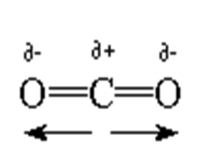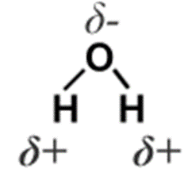

*Water has an unequal sharing of electrons and is unsymmetrical and therefore has permanent dipoles due to the differing electronegativities of the atoms.*

*Carbon dioxide has no polarity overall as the size and directions of the dipoles are exact opposites (molecule is symmetrical) and therefore they cancel each other out.*

(b) Water is unusual in that in the solid form (ice) is less dense than the liquid form. Explain why water behaves in this way.

*This is due to the hydrogen bonding and so an ordered crystal forms that spaces the molecules out more as there are large gaps in the crystals formed.*

15. Both bonded and non-bonded pairs of electrons repel each other and this determines the shape of the molecule.

The following procedure is used to find the total number of pairs of electrons around a central atom.

(i) Note the number of electrons in the outer energy level (shell) of the central atom.

(ii) Note the number of other atoms present --- each atom provides one electron for bonding.

(iii) Add (i) and (ii) to give the total number of electrons.

(iv) Divide this number by two to give the number of electron pairs - both bonded and non- bonded pairs.

**Example:-** with ammonia, NH3, N is the central atom.

(i) 2,5 = 5 electrons

(ii) 3H 3 x 1 = 3 electrons

(iii) Total = 8 electrons

(iv) 8 electrons gives four pairs.

Since NH3 only has 3 bonds there is one non-bonded pair. The 4 pairs of electrons repel each other, giving the pyramid shape of the ammonia molecule as shown in the first row of the table.

Copy and complete the table.

|  |  |  |  |  |  |
| --- | --- | --- | --- | --- | --- |
| Formula | Outer electrons in central atom | Total number of electrons | Bonded pairs | Non-bonded pairs | Molecular shape |
| NH3 | 5 | 8 | 3 | 1 |  |
| CCl4 | 4 | *8* | 4 | 0 | http://images.encyclopedia.com/utility/image.aspx?id=2793629&imagetype=Manual&height=300&width=300 |
| BeCl2 | 2 | 4 | 2 | *0* | *Cl – Be - Cl* |
| PF5 | *5* | 10 | 5 | *0* |  |

16. The Group 5 hydrides are covalent compounds.



Explain why the boiling point of NH3 is higher than the boiling point of PH3 and AsH3.

*NH3 has hydrogen bonds which are stronger than the van der Waals forces involved in PH3 and AsH3 which means that more energy is required to break the hydrogen bonds and therefore the boiling point of NH3 is higher.*

17. The table below shows the boiling point, molecular mass and structure of the simplest alkanol, methanol, the simplest alkanoic acid, methanoic acid and the ester methyl methanoate which forms when the acid and the alkanol react together in a condensation reaction.



(a) Using **molecular mass** as the **only criterion**, use the boiling points of methanol and methanoic acid to predict the boiling point of methyl methanoate and put it in the table.

*135*

(b) The boiling point of the ester is in fact 320C. Explain in terms of the intermolecular forces why this value is so different from your prediction.

*The ester doesn’t form hydrogen bonds but only van der Waals which are weaker and therefore require less energy to break and so the boiling point is lower.*

18. Consider the substances: potassium, bromine and potassium bromide.

(a) Construct a table to show the type of bonding, the structure, the solubility or reaction with water, the state at room temperature and the electrical conductivity of the three substances.

|  |  |  |  |  |  |
| --- | --- | --- | --- | --- | --- |
| **Substance** | **Bonding Type** | **Structure** | **Solubility/reaction with water** | **State at r.t.** | **Electrical conductivity** |
| Potassium | Metallic | Lattice | Very reactive | Solid | Conducts |
| Bromine | Covalent | Molecular | Soluble | Liquid | Non-conductor |
| Potassium bromide | Ionic | Lattice | Very soluble | Solid | Conducts in solution or molten |

(b) Explain the solubility of potassium bromide in water in terms of its bonding.

*It is an ionic compound that dissolves readily in water as the ions dissociate and interact with the hydrogen and hydroxide ions of water.*

19. Lithium iodide is quite soluble in non-polar solvents e.g. white spirit (a mixture of hydrocarbons).

(a) What does this statement suggest about the type of bonding in lithium iodide?

*Non-polar*

(b) State, with an explanation, whether you would expect lithium fluoride to be more or less soluble than lithium iodide in non-polar solvents.

*Less, as fluorine is more electronegative*

20. Ice is unusually strong for the small size of its molecules.

(a) What type of bonding holds the molecules together in ice?

*Hydrogen bonding*

(b) Explain why ice has a lower density than liquid water.

*The H-bonding causes the water molecules to move further apart as they freeze, which lowers the density.*