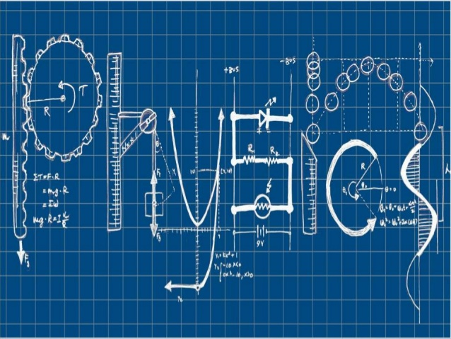
National 5 Physics at Leith Academy

Astrophysics

Name: _________________________

December 2017

What you should know from S3…and the Dynamics topic in S4
We’ll be reviewing all the key material, but there are things you did in the S3 Physics course that you’ll need in this unit – and also from the Dynamics topic in S4.
If you didn’t do the S3 Physics course, you’ll have to work that bit harder.
Grade your own knowledge – where do you think you are at the moment?
Key content
I can find distance travelled and acceleration from speed-time graphs (S4)
I can use $v=\frac{d}{t}$ to calculate speeds, distances and times (S3 and S4)
I can calculate acceleration using $a= \frac{v-u}{t}$ (S4)
I can use Newton’s Laws to explain motion (S3 and S4)
I can give examples of how the electromagnetic spectrum is used by astronomers (S3)
I know the approximate age of the universe (S3)
I have a basic understanding of Big Bang theory (S3)
I can calculate weight using $W=mg$ (S4)
I can use scientific notation to handle large numbers

My grade in the last unit was: D / C / B / A
My target grade for the end of this unit is: D / C / B / A
To achieve this grade I need to:
_____________________________________________________________________
_____________________________________________________________________
_____________________________________________________________________
Projectiles
What is a projectile?
A projectile is something that moves under the influence of gravity.
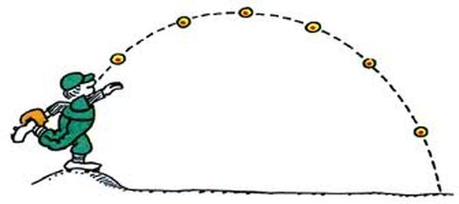
A football kicked through the air is a projectile. So is a golf ball hit through the air. So is a satellite orbiting the earth.
Projectiles follow a curved path, like this:

Why a curved path?
We can look at the movement of the projectile as made up of two parts:
- horizontal motion
- vertical motion
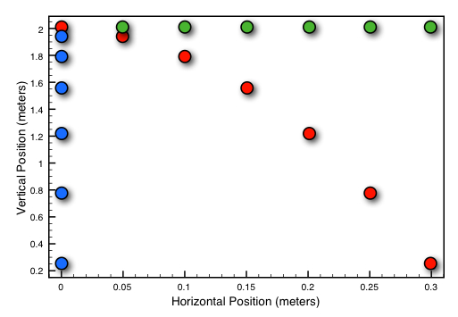
Horizontally, the projectile is not affected by gravity. So it moves at a constant velocity. (See how the horizontal ‘dots’ are the same distance apart.)
Vertically, the projectile has a constant acceleration due to gravity. (See how the vertical ‘dots’ get further apart as the projectile gets faster.)
These two motions combine to give a curve.

Projectile calculations
To work out how projectiles move, we look at the horizontal (H) and vertical (V) motions separately. So for a projectile that is in the air for a time t:
(H) Moves at a constant velocity so: $v_{h}=\frac{s}{t}$
(V) Accelerates due to gravity, so: $v_{v}=u_{v}+at$
s = the displacement (distance) travelled by the projectile.
v_{h} = the horizontal velocity (which stays constant)
u_{v} = the initial vertical velocity (usually zero) and v_{v} = the final vertical velocity
a = acceleration due to gravity, which is 9.8 ms⁻² on Earth.
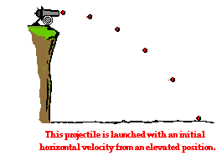
Worked example
A cannonball is fired off a cliff at 50 m s⁻¹. It lands
4 seconds later.
a) How far from the bottom of the cliff does the cannonball land?
Horizontally, the cannonball travels at a constant velocity. So:

$$v_{h}=\frac{s}{t}$$
$$50= \frac{s}{4}$$
$$s=200 m$$
b) What is the vertical velocity of the cannonball when it lands?
Vertically, the ball accelerates at 9.8 m s⁻². Its initial vertical velocity is zero. So:
$$v_{v}=u_{v}+at$$
$$v_{v}=0+(9.8×4)$$
$$v_{v}=39.2 m{ s}^{-1}$$

Example
Superman run horizontally off the top of a building at 180 m s⁻¹. He lands on the ground 5 seconds later.
a) How far from the building does Superman land?
b) What is Superman’s vertical speed as he hits the ground?
Solution

Projectiles and graphs
We can also use velocity-time graphs in projectile calculations.
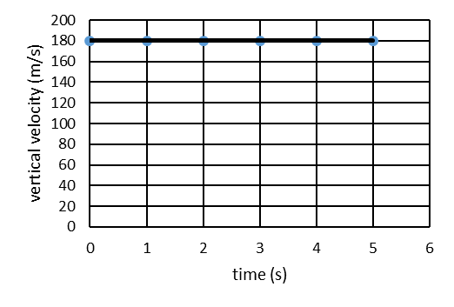
Projectiles and velocity-time graphs
We can use velocity-time graphs to help with projectile calculations.
Superman’s horizontal velocity stays constant at 180 m s⁻¹ for 5 seconds. So here’s a velocity-time graph for Superman’s horizontal velocity.

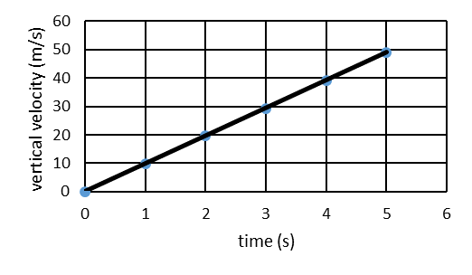
Remember – displacement = area under a velocity-time graph.
$$horizontal displacement=area under v_{h}-t graph$$
$$s_{h}=l×b$$
$$s_{h}=5 s×180 m{ s}^{-1}$$
$$s_{h}=900 m$$
We know that Superman’s initial vertical velocity was zero and his final vertical velocity (after 5 seconds) was 49 m s⁻¹. So here’s a graph of his vertical velocity against time.

Again – displacement = area under a velocity-time graph.
$$vertical displacement=area under v_{v}-t graph \\ s_{v}=\frac{1}{2}×b×h$$
$$s_{v}=\frac{1}{2}×5×49$$
$$s_{v}=122.5 m$$
If Superman has dropped by a distance of 122.5 m, then the building must be 122.5 m high.
(A quick way to work out the vertical displacement is do $\frac{1}{2} × time × final vertical velocity$ )
PROBLEM PRACTICE – pages 44-47 of the N4/N5 W&R Problems booklet

Satellites
What is a satellite?
A satellite is anything that orbits (goes round) another body, such as the Earth.
There are natural satellites – an example is ________________________.
There are artificial satellites - an example is ________________________.
How does a satellite stay in orbit?
Isaac Newton worked this out long before we put satellites in space. He used a ‘thought experiment’ which we now call Newton’s Cannon.
Imagine a powerful cannon on top of a mountain. It fires a shell at high speed.
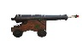
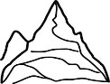
Draw the path of the shell on this diagram.

Now imagine the mountain is much higher and the cannon much more powerful. The missile travels so far that we notice the curve of the Earth. Draw the path again.
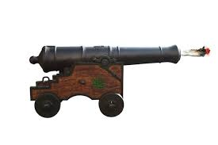

Now what if the mountain is much higher and the shell is fired much faster? The curve of the fall will now match the curve of the Earth. Draw the (circular) orbit on the diagram.
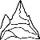
So, a satellite stays in orbit because it is ‘falling around’ the Earth. The curve of the satellite’s fall matches the curve of the Earth.

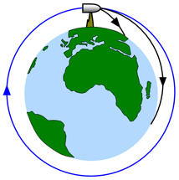
A satellite is a special case of a projectile.
The satellite’s horizontal velocity stays constant as it orbits the earth.
The weight of the satellite provides the force which makes it accelerate towards the centre of the Earth.
If the horizontal velocity is high enough, then the curve of the fall matches the curve of the Earth.
This is also how the Moon orbits the Earth. And how the Earth orbits the Sun.

Satellite orbits
The time it takes a satellite to complete one orbit is called the period.
The period depends on the altitude (height) of the satellite’s orbit.

The greater the altitude of the orbit, the _______________ the period of the satellite.

Geostationary orbits
If a satellite orbits at the right altitude, it will have a period of 24 hours – the same time it takes the Earth to turn once.
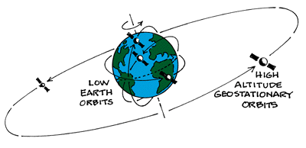

This means that the satellite will stay above the same point of the Earth at all times. This is very useful if we want to communicate with the satellite at all times.

Geostationary satellites have a period of ______hours and orbit at an altitude of ________ km.
Satellite research
Satellites have can be used for many different purposes – such as communication, weather forecasting, GPS and astronomy research.
Find out about each of these satellites. Think about the befits we get from each of them.

benefits
main uses
orbital period
orbit altitude
launch date
image | 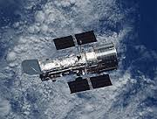 | 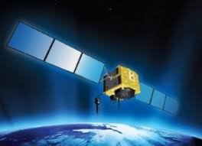 | 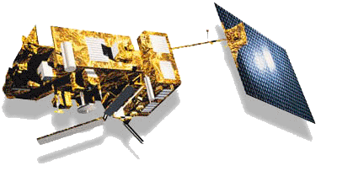 | 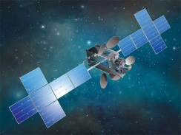
name | Hubble Space Telescope (HST) | USA-266 (NAVSTAR 76) | MetOp | Echostar 23
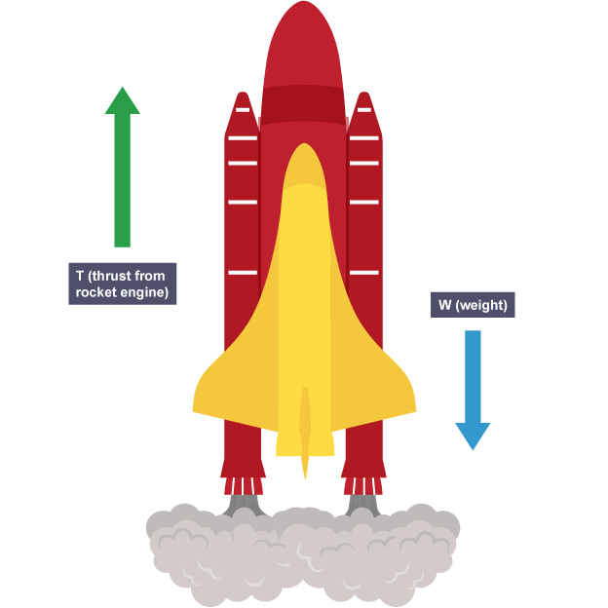
Rocket science
Getting into space is difficult. The Earth has a strong gravitational field that pulls us towards the centre. To overcome this, we need powerful rockets.

How does a rocket take off?
When a rocket takes off from the launch pad, there are two forces acting – its weight downwards and the thrust from the rocket engines upwards.
If the thrust is bigger than the weight, there will be an unbalanced force upwards.

Newton’s 2nd Law tells us that if there is an unbalanced force, the rocket will _____________.

Worked example
The engines of a 5000 kg rocket develop a thrust of 80 kN.
a) Calculate the weight of the rocket.
b) Calculate the unbalanced force acting on the rocket.
c) Calculate the initial acceleration of the rocket.

a) $W=mg=5000 × 9.8=49,000 N$
b) $F_{un}=T-W=80,000-49,000=31,000 N$
c) $F_{un}=m×a$
$31,000=5,000×a$
$a= \frac{31,000}{5,000}=6.2 m s^{-2}$

Example
The engines of a 5000 kg rocket develop a thrust of 80 kN. It takes off from Mars, where the gravitational field strength is 3.7 N kg⁻¹.
a) Calculate the weight of the rocket. (Remember: g = 3.7 N kg⁻¹)
b) Calculate the unbalanced force acting on the rocket.
c) Calculate the initial acceleration of the rocket.

PROBLEM PRACTICE – pages 36 of the N4/N5 W&R Problems booklet, Q 28-30

It is easier for a rocket to take off from Mars because the gravitational field strength is much lower.
In the future, we may build rockets on the Moon and then launch from there to explore space. Why?
________________________________________________________________________________
________________________________________________________________________________
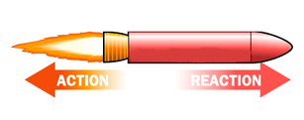
How does a rocket move in space?
Remember Newton’s 3rd Law – for every action force, there is an equal and opposite reaction force.

The rocket engines apply a force to the exhaust gases (action).
So the gases apply a force to the rocket (reaction).
This reaction force makes the rocket accelerate.
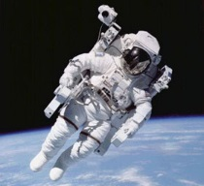
Example
An astronaut uses an MMU (Manned Manoeuvring Unit) on a spacewalk.
The thrusters of the MMU provide a force of 16 N.

a) If the astronaut and MMU have a total mass of 200 kg, calculate the astronaut’s acceleration.

b) How does the astronaut stop?

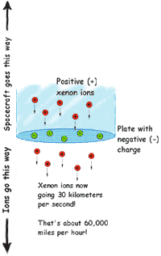
Space travel – the challenges
The universe is enormous. We have explored only the tiniest part of it. If we are going to travel huge distances, we need spacecraft that can reach very high speeds. How can we do this?
Ion drives
An ion drive contains a gas called xenon. The xenon atoms are ionised – they lose electrons and so are positively charged. Another part of the ion drive is a thin sheet of metal with many little holes in it. This metal screen is negatively charged, so it attracts the xenon ions. The ions are moving very fast, so they zoom right through the holes and out the other side of the screen. As they shoot out (the action), they push back against the spacecraft (the reaction) – Newton’s 3rd Law.

Worked example
The SPACE-1 probe has an ion drive engine that produces a thrust of 80 mN (0.08 N). The probe has a mass of approximately 400 kg.
a) Calculate the acceleration of the probe.
$$F_{un}=m×a$$
$$0.08=400×a$$
$$a= \frac{0.08}{400}=0.0002 m s^{-2}$$
b) Calculate the speed gained by the probe after it has accelerated for 1 hour. (3,600 s)
$$v=u+at$$
$$v=0+0.0002×3600$$
$$v=0.72 m s^{-1}$$
c) Calculate the speed of the probe after it has accelerated for 1 year.
One year = 365 x 24 x 60 x 60 = 3.15 x 10⁷ s
$$v=u+at$$
$$v=0+0.0002×3.15 x {10}^{7}$$
$$v=6,300 m s^{-1}$$
After 10 years, the rocket would be travelling at 63,000 m s⁻¹.
But with this acceleration, it would still take over 600 years to reach the next nearest star.

b) How does the astronaut stop?

Gravitational assists – the ‘slingshot’ effect
We can use the gravitational field of a fast-moving asteroid, a moon or a planet to increase the speed of a spacecraft without having to use any fuel.

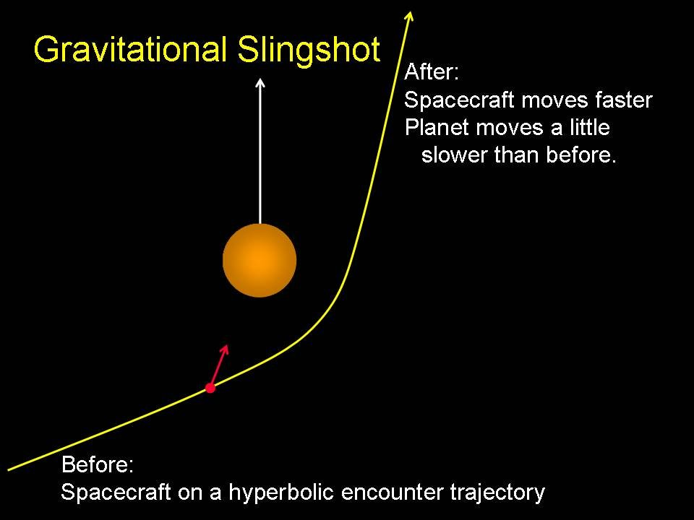
As the spacecraft passes close to the planet, it picks up speed. It keeps this ‘extra’ speed as it moves away from the planet.

It seems like the spacecraft has got ‘something for nothing’ here. Where do you think the extra energy comes from?

________________________________________________________________________________

________________________________________________________________________________

Providing the energy
Once a spacecraft reaches the right speed, there’s no need to use the engines – because there is no friction in space, it will continue at the same speed.

Whose Law is this? Which one?

________________________________________________________________________________

This is just as well – a spacecraft couldn’t carry that much fuel. But for long trips, we need to provide energy to keep life-support systems going.

How could we do this when the spacecraft is reasonably near to the Sun?

________________________________________________________________________________

What could we do as the spacecraft gets further and further away from the Sun?

________________________________________________________________________________

When you double your distance from a light source, you only receive one quarter of the light energy. If you go three times further way, you only receive a ninth of the energy – and so on.

This is called an inverse square law – if you go $n$ times further away, you only get $\frac{1}{n^{2}}$ of the light energy.
When a spacecraft is 200 million km from the Sun, it needs solar panels of area 12.5 m² to provide the energy required for life-support systems.

What area of panels will be needed if the spacecraft moves to a point 800 million km from the Sun?

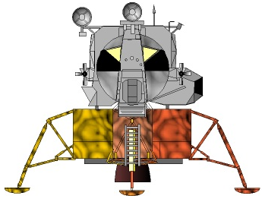
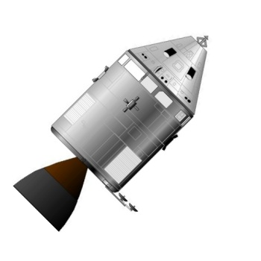
Manoeuvring a spacecraft
A spacecraft may have a mass of several thousand kilograms. Though it may be weightless in space, changing its direction or speed needs a force. But because there is no friction, once we start the spacecraft moving, it won’t stop.

A
B
C
D

This spacecraft module is attempting to dock with the lander craft.

The module has 4 small thruster engines – A, B, C and D.

Describe how the engines should be fired so that the module docks safely with the lander.

________________________________________________________________________________

________________________________________________________________________________

________________________________________________________________________________

________________________________________________________________________________

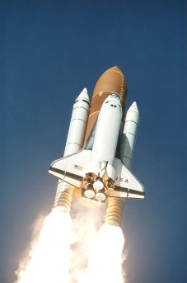
Space travel – the risks
Space travel is dangerous. About 20 people have been killed in space flight.

There are several key risk areas.

Fuel load on take-off
Rocket fuel is dangerous stuff – it’s designed to burn.

When a rocket takes off, it has a massive fuel load. If this is not properly controlled, the results can be devastating. In 1986, seven astronauts died in the Challenger disaster. The astronauts' deaths were caused by an external tank explosion: the space shuttle broke apart because gases in the external fuel tank mixed, exploded, and tore the space shuttle apart. The external fuel tank exploded after a rocket booster came loose and ruptured the tank.

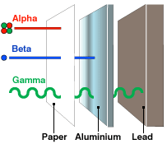
Potential exposure to radiation
The Earth’s atmosphere shields us from ionising radiation in space, including gamma radiation. Astronauts in space don’t have this protection. Long term exposure to radiation would increase an astronaut’s risk of developing cancer.

How do we protect ourselves from gamma radiation in the lab?

________________________________________________________________________________

Why can’t we use this approach in spacecraft?

________________________________________________________________________________

Pressure differential
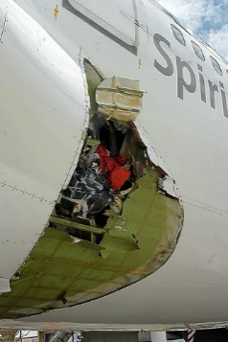
Space is a vacuum – there is no air pressure.

A manned spacecraft has normal air pressure so astronauts can breathe.

This means there is a big pressure difference between the inside and outside of the spacecraft. If there is any damage to the spacecraft – a small meteorite punching a hole in it, for example, the sudden change in pressure could blow the spacecraft apart. This is called a sudden decompression.

The same kind of things can happen with aeroplanes – like the Australian jet in the picture.

Re-entry through an atmosphere
A spacecraft re-entering the earth’s atmosphere does so at very high speed. Because of this, it’s vital that the spacecraft hits the atmosphere at the right angle – between 5º and 8º.

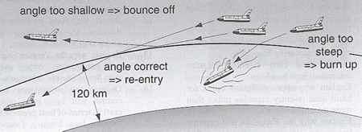

If a spacecraft hits the atmosphere at an angle less than 5º it will ‘bounce’ off the atmosphere – like skimming a stone off the surface of a pond. The spacecraft probably won’t have enough fuel left to turn round and try again

If the spacecraft hits at an angle greater than 8º, the heating caused by friction with the atmosphere will be so great that it will destroy the spacecraft.
Research task
Find out about one of these space exploration accidents. When did it happen? What happened? Why did it happen?

Challenger Columbia Soyuz 11 Apollo 1

Distances in space
Space is very big. Bigger than you can possibly imagine. This means it’s difficult to measure distances is space using metres or kilometres. We need a bigger ‘unit of measure’.
Astronomers use light years to measure distances in space.
A light year is…

How many metres in a light year?
Light travels at 300,000,000 m s⁻¹. (This is 3 x 10⁸ m s⁻¹.)
There are 365 x 24 x 60 x 60 = _____________________ seconds in a year.
Complete the calculation:
$$d=vt$$
$$d={(3×10}^{8}) × ___________________________$$
$$d= ____________________metres$$

You should be able to work out how many metres there are in a light year. But it’s also a good idea to remember that it’s approximately 9.5 x 10¹⁵ metres.
PROBLEM PRACTICE – page 68 of the N4/N5 D&S Problems booklet

Example
The star Vega is 20 light years from Earth. How far is this in metres?

Worked example
The nearest star to us (apart from the Sun) is 4.3 light years away. How far is this in metres?
1 light year = 9.5 x 10¹⁵ m.
So 4.3 light years = 4.3 x 9.5 x 10¹⁵ m
This is equal to 4.1 x 10¹⁶ m.
(Or we could do 365 x 24 x 60 x 60 x 3 x 10⁸ x 4.3 = 4.1 x 10¹⁶ m.)

The structure of our universe
How would you define each of these astronomical terms?
Add your definition to the second column - use the third column later to correct if necessary.
word | my definition | correct definition
planet
dwarf planet
moon
Sun
asteroid
solar system
star
exoplanet
galaxy
universe
Complete this passage, using words from the table on the last page. If two missing words have the same number – that’s because they are the same word.

The _______(1) is at the centre of our ____________ ___________(2)_. It is orbited by eight ____________(3) and a number of _________ ________________(4). Several of the _________(3) are orbited by __________ (5).
Between Mars and Jupiter we find the ________________ (6) belt. This is made up of the remains of primordial _____________ (3) which were shattered by the effect of Jupiter’s gravitational field.
Our _______________ ______________________ (2) is not the only one. There are many billions of __________ (7) and most of these have ___________ (3). A ____________ (3) outside our own ____________ __________________ (2) is called an ____________ (8).
__________ (7) group together in large collections of many billions called ______________ (9). Most of these are spiral or elliptical in shape.
There are many billions of separate _____________ (9). Together with interstellar dust and gases, they make up everything that there is – the _______________ (10).
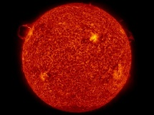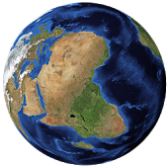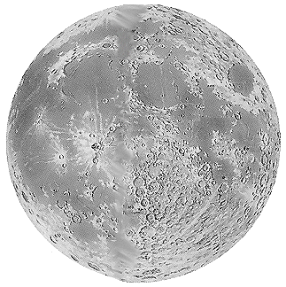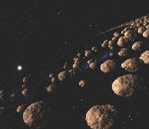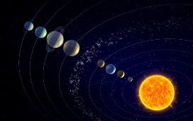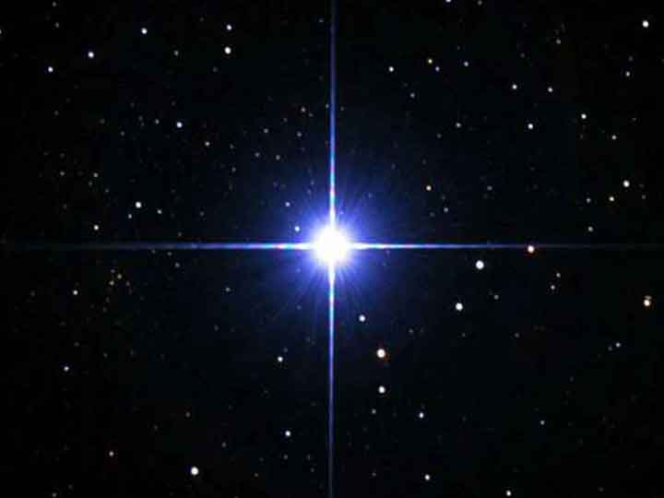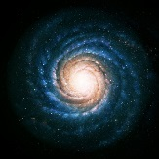

Big Bang theory
How old is the universe?
The universe is 13.8 billion years old. That is 13.8 × 10⁹ years old.
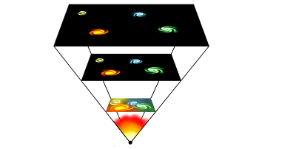
How do we know this?
In simple terms, we know that the universe is still expanding — the galaxies that we can observe are all moving away from us and from each other.
If they are all moving away from each other, then previously they must have been closer together.
If we ‘run the film backwards’, we can see that the galaxies must all have been at the same point some time in the past. Can we find out when that happened?
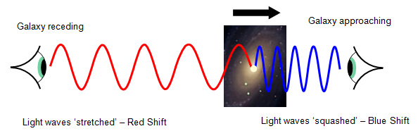
When galaxies move away from us, the light we receive from them is ‘redder’ than it should be – this is called red shift.

If we measure the amount of red shift, we can find the speed of the galaxies. If we know the speed at which the galaxies are moving and how far away they are, we can work out how long they’ve been moving for – the age of the universe.
And before the Big Bang?
Nothing. Time, space, matter – all began with the Big Bang. If there was no time – there can’t be a ‘before’.
And after the Big Bang?
From 10⁻⁴³ seconds after the Big Bang (the Planck Epoch) we know that the universe had a massive density (close to infinity), was expanding rapidly and all the fundamental forces acted as one. We know relatively little about this early stage of the universe’s life and virtually nothing about what the universe was like before this.
By the time that the universe was 10⁻¹² seconds old the four fundamental forces (electromagnetism, gravity and the strong and weak nuclear forces) separated. The universe was filled with an extremely hot and dense quark-gluon plasma. One second after the Big Bang, the universe had cooled enough for protons and neutrons to form. After about 10 seconds electrons started to appear in the universe.
When the universe was about 3 minutes old it was cool enough for the protons and neutrons to form into nuclei. This nuclear fusion lasted for about 17 minutes, producing a universe consisting of about 75% hydrogen and 25% helium with traces of a few heavier elements such as lithium and beryllium. Atoms still couldn’t form, though, thanks to the vast numbers of high energy photons.
Atoms started to appear once the universe was about 377,000 years old but it wasn’t until the universe is 150 million years old that the first stars started to form. 8 billion years after the Big Bang the Milky Way galaxy was formed and a billion years later (4.6 billion years ago) our own Solar System was created, forming the Sun. The dust and gas around the Sun eventually formed the planets, including our own.
Using information from the passage, place these events in the correct order.
Four fundamental forces act as one Creation of our solar system
Protons and neutrons combine into nuclei Dust forms the planets
Big bang Appearance of atoms
Formation of Milky Way galaxy Protons and neutrons form
First stars begin to form Separation of fundamental forces
Electrons form
1
2
3
4
5
6
7
8
9
10
11
Information from space – using the electromagnetic epectrum
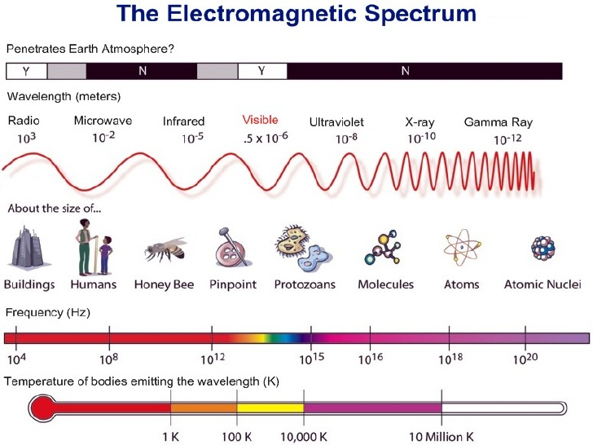
Visible light is not the only part of the electromagnetic spectrum. There are many other wavelengths that we cannot see but we can detect.

Astronomers can build telescopes that can pick up all parts of the EM spectrum.

Questions
Which types of telescope can be based on Earth? Why?
________________________________________________________________________________

________________________________________________________________________________

Why do X-ray telescopes need to be placed in space?
________________________________________________________________________________
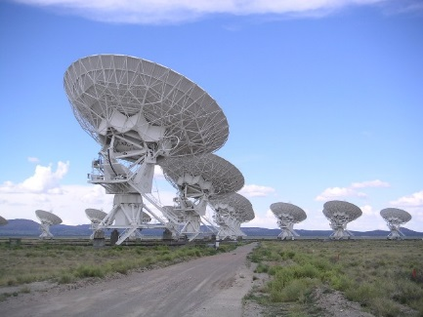
Detecting signals from space
The stars in the night sky don’t just give out the light that we see — they can also produce radio waves with very long wavelengths. The majority of the electromagnetic radiation hitting the Earth is absorbed by the Earth’s atmosphere and its magnetic field. However, there is a “window” of wavelengths that allows radio waves to be travel through the atmosphere.

Radio waves from space can be detected by an aerial or receiver. However, the radio waves are extremely weak. To solve this problem, we can make curved reflectors that are either as large as possible or put together in an array. These receivers are called radio telescopes. They do the same job that conventional telescopes do – it’s just that they ‘look at’ radio waves., but for radio waves.
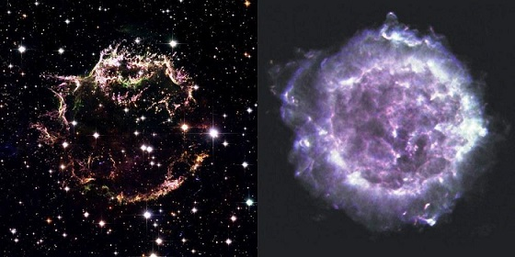

(An image of the Cassiopeia A supernova in visible light (left) and radio (right).)

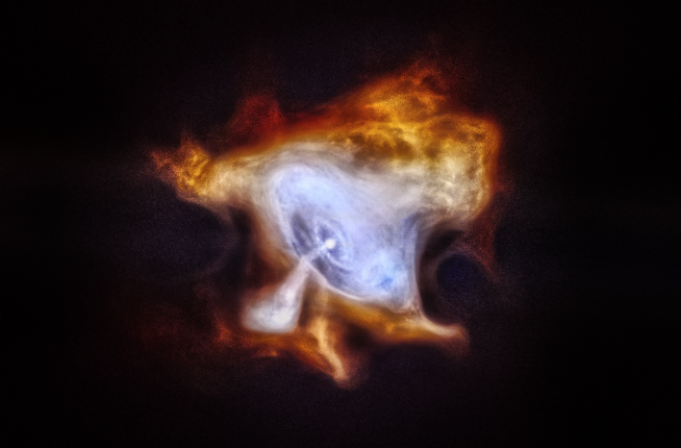
By putting telescopes in space, we can look at other parts of the EM spectrum as well. In 1999, the Chandra X-ray telescope was launched. This can ‘see’ the immensely energetic X-rays given off during supernova explosions and when matter is ‘sucked into’ black holes.
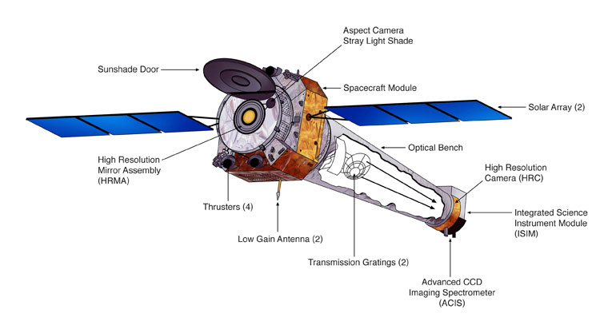
(The image shows a neutron star spewing out a stream of high-energy X-rays.)
Question
The Hubble Space Telescope looks at visible light – but it was still placed into space. Can you explain why?
________________________________________________________________________________

Exploring the spectrum
By looking at the emissions (visible light and other parts of the electromagnetic spectrum) of a star, we can tell its temperature, mass, size and composition. Light can be gathered by telescopes and analysed by spectroscopes.
Visible light can be split into its component parts using two methods - a prism and a diffraction grating.
The spectrum from a prism
You have probably seen this picture before:

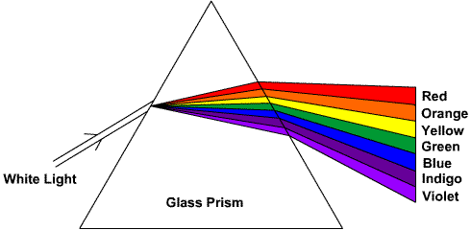
Because white light is made up of a range of colours, we can show the separate colours using a prism. Each colour is refracted by a different angle. How much it refracts depends on its wavelength.
This type of spectrum is known as a continuous spectrum.
Looking at the single spectra produced, we can see that the white light is split into its component colours.
1. Which colour is refracted the least?

2. Is this a long or short wavelength?

3. Which colour is refracted the most?

4. Is this a long or short wavelength?

Line spectra – what are stars made of?
When an electrical current is passed through a gas – or if the gas is very hot - energy is emitted in the form of light.
If we pass that light through a diffraction grating we see lines of different colours.
Only certain frequencies (colours) of light are produced – the actual frequencies depend on the element that makes up the gas.
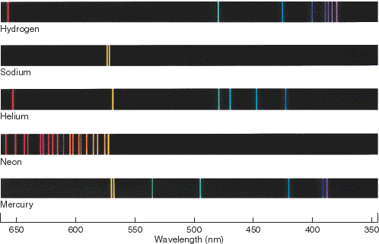
Here’s what we get for hydrogen, sodium, helium, neon, and mercury.

Each element produces a unique pattern of coloured lines – called a line spectrum. It’s as though each element has its own ‘fingerprint’.
So if we look at the line spectra we get from starlight, we can tell which elements the star is made from.
How much of each element?
As well as telling what elements a star is made from, we can also use line spectra to tell how much of each element there is.
How do you think we can do that?
________________________________________________________________________________
________________________________________________________________________________
Look at this spectrum, taken from a nebula – a cloud of gas around a star that has exploded. You can also see the line spectra for four different elements.
Can you work out which of the four elements the nebula contains?
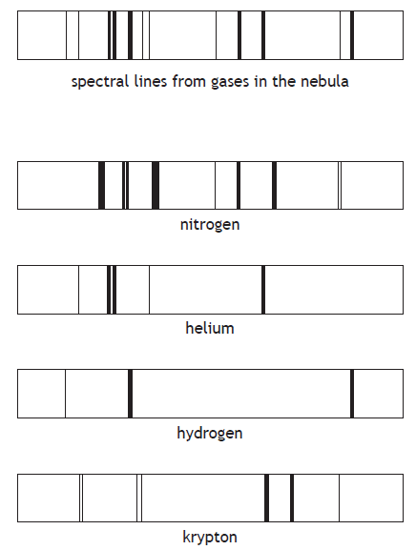
The nebula contains: _______________________________________________________________

Does the nebula contain any other elements? How do you know?
________________________________________________________________________________

Formula sheet for National 5
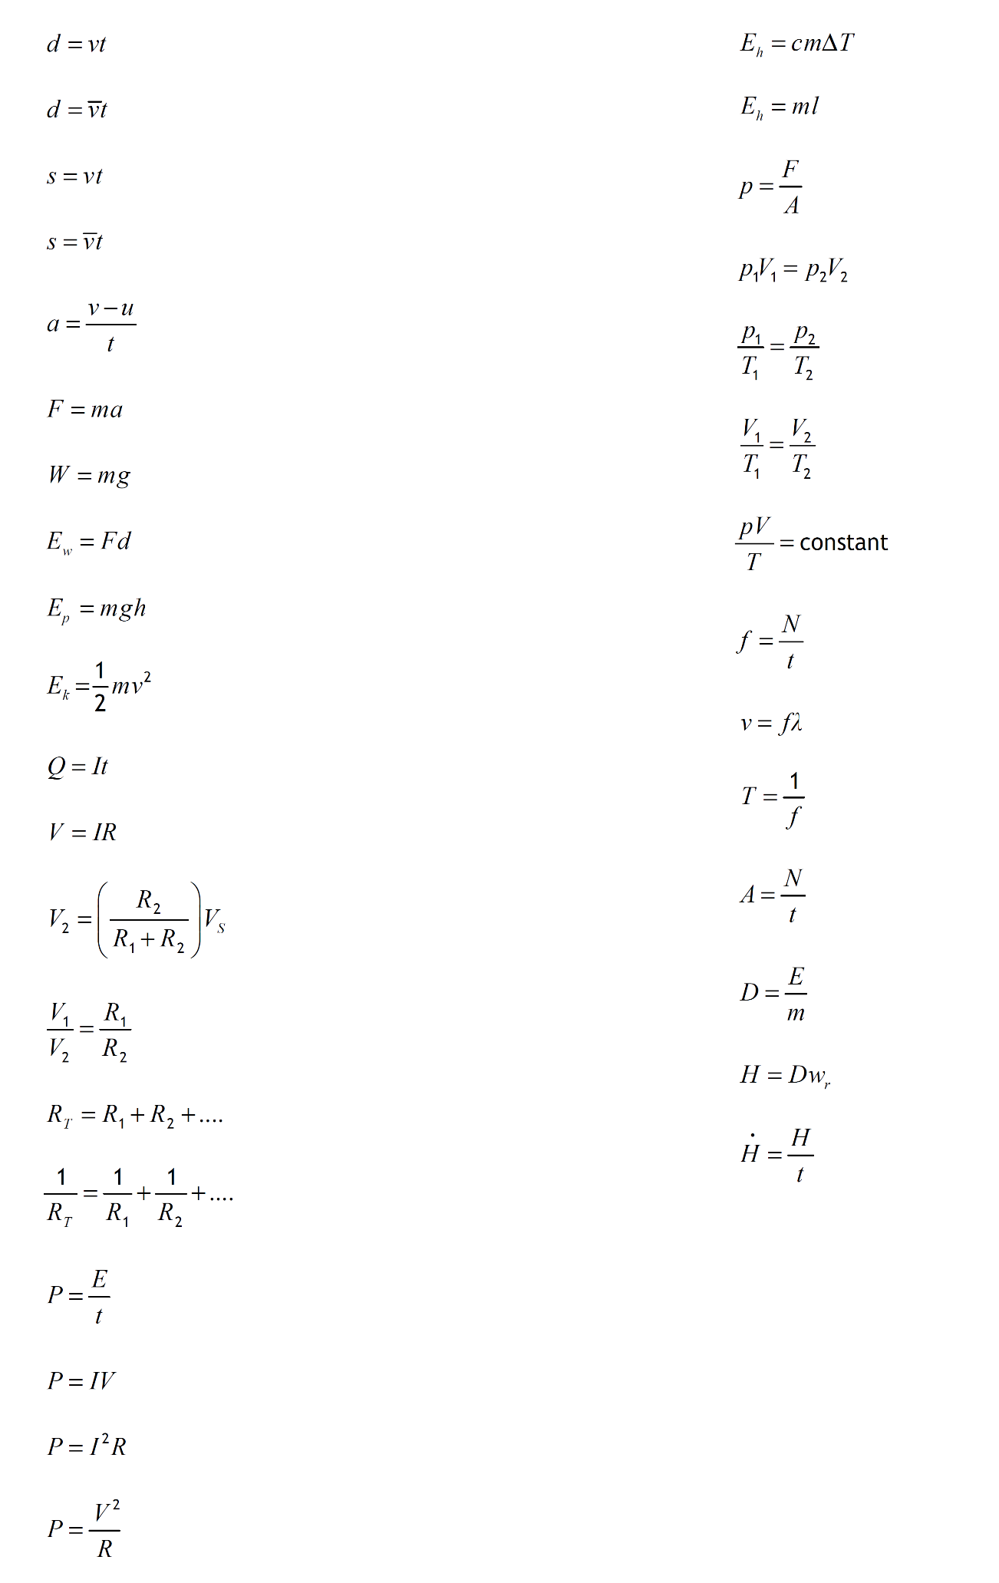
By the end of the course, you must know what each letter stands for and what its unit it.

Formulas for this unit

